Pediatric Preoperative Warming Protocol to Prevent Hypothermia
by

JILL GORMAN & AARON HARRINGTON

A research report in partial fulfillment of the requirements
for the degree of

DOCTOR OF NURSING PRACTICE

2022

Oakland University
Rochester, Michigan

Dedication and Acknowledgments

First and foremost, we would like to thank our better halves (Jordan and Haley), parents, siblings, and classmates for the sacrifices they have made. Without your unlimited amount of love, support, and compassion, this endeavor would not be possible.
Our deepest and most sincere gratitude goes out to our DNP Chair, Dr. McDonald, for your invaluable guidance and knowledge. Words cannot express how thankful we are for the countless amount of hours you have spent with us to perfect this project. It has been a great privilege that we will forever cherish.
Finally, we would like to thank all of the individuals at Children’s Hospital of Michigan for affording us the opportunity to carry out our project at your hospital. We would like to specifically thank Dr. Choromanski, Dr. Kaminski and Divya Mukhija for all of your time and dedication.

Abstract
Purpose: The purpose of this project was to discover the incidence of intraoperative hypothermia in pediatric patients undergoing spine surgery at Children’s Hospital of Michigan and create a preoperative warming protocol to reduce the incidence/time of intraoperative hypothermia.
Background: Intraoperative hypothermia (< 36°C) occurs in roughly two thirds of patients who undergo anesthesia. Thermoregulatory responses are impaired during a general anesthetic leading to complications such as morbid cardiac outcomes, delayed drug metabolism, increased surgical site infections, increase in surgical blood loss and the need for blood transfusions, prolonged post anesthesia recovery time and an increased length of stay. Pediatric patients are particularly at risk for hypothermia during anesthesia due to their higher body surface area to body mass ratio, increased radiant heat loss from large heads, and lower subcutaneous fat stores. Pediatric spine surgery patients are particularly vulnerable to hypothermia due to a surgical field that requires extensive exposure of body surfaces. The use of forced air warming has been utilized in the preoperative setting to warm patients prior to surgery and has been shown throughout multiple studies to reduce the incidence of intraoperative hypothermia.
Methods: A retrospective chart review was conducted on 44 pediatric spine surgery patients at Children’s Hospital of Michigan. The patient's temperature was collected in the preoperative area and every 15 minutes intraoperatively. The severity of temperature drop after induction of anesthesia as well as the duration of hypothermia was analyzed.
Results: Intraoperative hypothermia occurred in 90.1% of the cases. Patients dropped 0.8 °C immediately after induction and continued to become progressively hypothermic until 60 minutes post induction where they averaged 35.5°C. The average length of time patients remained below 36 degrees celsius was 150 minutes. A bootstrapped linear regression analysis revealed that the average length of hypothermia was increased based on the severity of post induction hypothermia.
Recommendation: After reviewing the literature and the incidence of hypothermia at Children’s Hospital of Michigan, it is our recommendation that the use of pre-operative forced air warming for at least 30 minutes prior to surgery would reduce the incidence of hypothermia in the pediatric spine surgery patient population.

Table of Contents
Dedication and Acknowledgments 2
Abstract 3
Background and Significance 7
Literature Review 8
Methods 8
Adverse Effects of Hypothermia 9
Warming Techniques 10
Effects of Prewarming on Infection 12
Other Effects of Prewarming 13
Pediatric Specific Studies 13
Preoperative Warming Times 15
Problem Statement 17
Framework 18
Project Methodology 20
Project design 20
Project Setting 21
Key Personnel/Stakeholders 21
Participants/Population 21
Procedures for Project Implementation 22
Potential Barriers to Implementation and Sustainability 22
Potential Benefits & Outcomes 23
Anticipated Resources, Budget & Funding Plan 24
Project Implementation 24
Results 25
Demographics 25
Surgery Details 25
Incidence of Hypothermia 27
Statistical analyses 30
Discussion 31
Limitations 33
Recommendations 34
Recommendation for sustaining intervention 36
Implications for Practice and Career Development 36
Contribution of Project in achieving DNP Essentials 37
Essential II: Organizational and Systems Leadership for Quality Improvement and Systems Thinking 37
Essential III: Clinical Scholarship and Analytical Methods for Evidence Based Practice 37
Essential VI: Interprofessional Collaboration for Improving Patient and Population Health Outcomes 37
Conclusion 38
References 39
Appendices 45
IRB Approval 45
Appendix A 48
Table 1: Evaluation Table 48
Appendix B 60
Table 2: Level of Evidence Synthesis Table 60
Table 3: Evaluated Primary Outcomes Synthesis Table 61
Table 4: Evaluated Secondary Outcomes Synthesis Table 62
Appendix C 64
Preoperative Warming Protocol for Patients Undergoing Spine Surgery 64
Appendix D 66
Data Collection Form 66

Pediatric Preoperative Warming Protocol to Prevent Hypothermia

Background and Significance
Intraoperative hypothermia, usually defined as a decrease in temperature below 36 degrees Celsius, is a well-known phenomenon that occurs when patients undergo anesthesia. Thermoregulatory responses are impaired during a general anesthetic, which can result in a patient becoming hypothermic and experiencing a host of associated complications. Other hypothermic contributing factors include vasodilation from anesthetic drugs, decreased metabolic rate, increased interthreshold compensatory ranges, cold operating rooms, and room temperature intravenous fluids. Reported consequences of hypothermia include an increase in the incidence of morbid cardiac outcomes, delayed drug metabolism, increased surgical site infections, increase in surgical blood loss and the need for blood transfusions, prolonged post anesthesia recovery time and an increased length of stay (Sessler, 2014). Pediatric patients are particularly at risk for hypothermia during anesthesia due to their higher surface area to body mass ratio, increased radiant heat loss from large heads, and lower subcutaneous fat stores (Mutchnick et al., 2020)
Given the effects of anesthesia on the patient’s ability to regulate body temperature, it is imperative that surgical staff, particularly anesthesia providers, intervene to maintain normothermia. Multiple studies found patients that were hypothermic intraoperatively had an increased chance of having a surgical site infection (Madrid et al., 2016; Melling, 2001; Mutchnick et al., 2020; Seamon et al., 2012; Silverton, 2016; Zheng et al., 2020). In response to the negative outcomes that were associated with hypothermia, the Surgical Care Improvement Project (SCIP-10) guidelines require all patients undergoing an anesthetic for > 60 minutes should be actively warmed and have a temperature of 36 degrees Celsius within 30 minutes before or 15 minutes after anesthesia time (Scott et al., 2015). Outside of recommendations for monitoring temperature and temperature targets, actual practice guidelines and interventions vary for maintaining normothermia during the perioperative period. Though a variety of interventions exist for combating hypothermia during the perioperative period, the incidence still remains high, suggesting there is room for improvement. The following literature review aims to answer the question: Does preoperative warming with a forced air warming device decrease the incidence of perioperative hypothermia in the pediatric surgical population?

Literature Review

Methods
A review of the literature was conducted using the Cumulative Index of Nursing and Allied Health (CINAHL), PubMed, Google Scholar, and Cochrane Central Registry of Controlled Trials databases. Key search terms included: “warming,” “preoperative,” “forced air warming,” “inadvertent perioperative hypothermia prevention”, “pediatric ,” “active prewarming,” “hypothermia,” and “effects of hypothermia”.
Inclusion criteria consisted of articles written in English, peer reviewed, published within eight years, involving only human subjects, and making direct comparisons between intraoperative hypothermia and preoperative warming. Articles were excluded if they were not a comparison study or consisted of lower levels of evidence (V-VII) according to Melnyk & Fineout-Overholt’s Hierarchy of Evidence diagram (2019).
Results
A complete database search yielded 102 potential articles: 39 from CINAHL, 25 from PubMed, 37 from Google Scholar, and 1 article from Cochrane. Seventy-three articles were initially rejected because they were low levels of evidence (level V or lower according to Melnyk & Fineout-Overholt), did not have relevant independent/dependent variables, duplications, or contained only an abstract. Qualitative studies can be beneficial, however, given the nature of this topic, quantitative studies were preferred because of the ability to cross-examine studies. Preference was given to the most up-to-date systematic reviews compared to older, lower levels of evidence. Twenty-nine articles were reviewed thoroughly for inclusion criteria. Of these 29 articles, 3 were eliminated for exceptionally small sample sizes, 4 were unclear in measured outcomes, and 6 had significant inconsistencies in independent or dependent variables. After condensing the potential articles, 16 were selected for this literature review.

Adverse Effects of Hypothermia
Hypothermia is associated with numerous systemic negative effects. The stress response induced by hypothermia can increase catecholamine levels and cause vasoconstriction, resulting in a documented three-fold increase in morbid cardiovascular complications (Bindu et al., 2017). Hypothermia can lead to a prolonged QTc on a patient’s electrocardiogram, which may lead to lethal rhythms such as ventricular tachycardia and fibrillation (Urits, 2019). According to Antoniou (2017) every 50 msec increment outside of the QTc normal range leads to a 20% increased risk for mortality. Post operative shivering has been estimated to increase oxygen consumption anywhere from 300-500 percent (Horvath et al., 1956), resulting in acidosis, hypoxemia, and increased intracranial or ocular pressures (Lopez, 2018). In some instances, as De Witte and Sessler (2002) report, patients have described the discomfort associated with feeling cold as worse than their surgical pain. Increased pain and discomfort in the recovery area can lead to prolonged stays for patients.
Hypothermia also causes decreased platelet function and clotting activity. A systematic review by Rajagopalan et al. (2008) concluded that mild hypothermia (<1°C) significantly increased blood loss by approximately 16% and increased the relative risk for transfusion by approximately 22%. Wallner et al. (2020) had similar findings confirming that clot formation time is increased relative to the degree of hypothermia. When vasoconstriction occurs in a hypothermic patient, this limits the humoral defense system as well as the amount of oxygen that is able to reach the tissues. As previously mentioned, this can result in delayed tissue healing and an increased risk for surgical site infections.

Warming Techniques
Active prewarming of patients involves the application of a warming device preoperatively in order to reduce the post-induction redistribution hypothermia (Torossian et al., 2015). Many methods of prewarming patients exist in the literature to combat the effects of hypothermia. These include radiant warming lights, self-warming blanks, liquid heating blankets, forced air warming devices and increased ambient temperature. Many of these prewarming methods come with inherent problems. Increasing ambient temperature in the operating room has been known to cause discomfort to staff members performing critical tasks. Warm cotton blankets have been found to prevent heat loss by minimizing the patient’s exposed skin, however, they fail to warm peripheral body temperature significantly compared to forced air warming (Diaz & Becker, 2010). Forced air warming devices are one of the most effective, efficient, and practical measures used in the operating room to combat hypothermia. In addition to being an optimal choice for prewarming patients, forced air warming devices have become the standard of care for warming in the operating room. Studies included in this literature review looked at strictly forced air warming devices (Lau et al., 2018; Thiel et al., 2020; Torossin et al., 2016; Trifferer, 2016), ambient temperature warming (Cassey et al., 2010), or a combination of warming interventions (Mutchnick et al., 2020; Rodgers et al., 2018).
Effects of Prewarming on Hypothermia
Variability exists on the degree of effectiveness of preoperative forced air warming in the literature. Multiple studies demonstrate the positive effect actively prewarming patients has on the incidence of intraoperative hypothermia (Lau et al., 2018; Mutchnick et al., 2020; Thiel et al., 2020; Torossian et al., 2015; Zheng et al., 2020). The literature suggests that use of a warming device in the preoperative period can result in a higher baseline temperature on arrival to the operating room (Lau et al., 2018; Mutchnick et al., 2020; Torossian et al., 2015). One study found that preoperative warming reduced the incidence of hypothermia during the perioperative period by 16% (Lau et al., 2018) while another pediatric study found their patients were 60% less likely to develop perioperative hypothermia with preoperative warming (Mutchnik et al., 2020). In these studies, the prewarmed patients also had significantly higher temperatures upon arrival to the PACU. Torrossian and colleagues (2015) conducted a similar study using a self-warming blanket compared to standard cotton blankets and found similar trends. The prewarmed group was 24% less likely to become hypothermic intraoperatively and the incidence of hypothermia on arrival to PACU was more likely to occur in the control group (38% vs. 60%). A quality improvement project implemented by Rogers et al. (2018) used forced air warming devices on major burn patients preoperatively, combined with intraoperative warming techniques, and found a decrease in the proportion of cases that experienced hypothermia from 24% to 13.77% after implementation. Finally, a RCT conducted in 2020, including 212 participants, looked at the instances of intraoperative hypothermia on patients who were warmed preoperatively compared to a control group (Thiel et al., 2020). They took measurements at four specific intervals and found that the prewarmed patients had a lower chance of developing hypothermia at each interval compared to the control group.

Effects of Prewarming on Infection
Avoidance of hypothermia and preoperative warming appears to have a favorable effect on preventing infection in surgical patients. A single intraoperative temperature below 35 degrees Celsius was found to double the risk for postoperative SSI by 16% (Seamon et al., 2012). Intraoperative hypothermia leads to peripheral vasoconstriction which impedes oxygen delivery to the tissues. Seamon et al. (2012) concluded that hypothermic patients were more likely to experience peripheral vasoconstriction compared to normothermic patients (78% vs. 22%). Melling et al. (2001) compared wound infections between individuals who were preoperatively warmed and those who received traditional intraoperatively warming techniques exclusively. This study concluded that infection rates dropped from 14% to 5% when preoperative warming techniques were utilized. A retrospective study at Henry Ford Health Center analyzed data from 1,525 patients who underwent hip fracture surgery and concluded that patients who developed intraoperative hypothermia were 3.3 times more likely to develop a deep surgical site infection (Silverton et al., 2016). Similarly, a Cochrane systematic review of 67 studies by Madrid et al. (2016) concluded that preoperative warming decreased infection and complications of surgical wounds. Seamon et al. (2012) who reported a single intraoperative temperature less than 35 degrees Celsius doubled the risk for postoperative SSI by 15.8%. Overall, it was concluded that patients were more likely to exhibit postoperative peripheral vasoconstriction (78% vs 22%) and more likely to develop postoperative SSI (19% vs 6%) than their normothermic counterparts. Finally, a systematic review by Zheng et al. (2020) found a 32% SSI reduction in the forced air warming group, and an even higher reduction of 48% in patients with more than one warming intervention (forced air warming plus liquid blankets, for example).

Other Effects of Prewarming
Other advantageous secondary effects of preoperative warming have been noted in the literature. A systematic review of 67 trials reported that 29 studies found a decreased risk of shivering in the warming group (Madrid et al., 2017). Reported pain and anxiety levels were similar between warming and controlled groups in the recovery area (Lau et al., 2018; Madrid et al., 2016). However, Torossian and colleagues (2015) found an increase in reported comfort levels in the warming group vs. the control group in both the preoperative and postoperative areas (p<.001).
Several studies demonstrate the negative impact of hypothermia on coagulation (Rajagopalan et al.,2008; Wallner et al., 2020). Pearce and Voepel-Lewis’ (2010) study demonstrated an increased estimated blood loss, increase in required blood products, and increased PACU stay in patients that were hypothermic vs. normothermic undergoing cardiac bypass procedures. It is important to note that hypothermia was induced for the procedure, but nonetheless highlights the potential detrimental effects of hypothermia in surgical patients. Finally, one study from Connelly’s 2017 literature review found that patients who were prewarmed with forced-air warming had higher core body temperatures (P = .001), less time to return to normothermia (P = .003), and a shorter time spent on a ventilator (P = .001).

Pediatric Specific Studies
Literature looking at hypothermia in pediatric patients in the perioperative area is sparse. A study on 120 pediatric neurosurgery patients compared the effects of preoperative warming with the standard care on the incidence of hypothermia (Mutchnick et al., 2020). The experimental group used a forced air warming device preoperatively, maintained an operating room temperature of 75 degrees Fahrenheit, and a radiant warming device that was used until draping and again postoperatively. The control group used only a forced air warming device in OR and intermittent radiant warming. The temperature was measured preoperatively and postoperatively via tympanic membrane, and every 15 minutes in the OR via esophageal probe. Overall, they found the warming group to have a reduced total hypothermic deficit (p < 0.001). and the control group patients were 2-3 times more likely to experience perioperative hypothermia (p < 0.001).
In another pediatric study, Cassey et al. (2010) preoperatively warmed pediatric patients using ambient temperatures of 26 degrees Celsius (compared to the 21 degrees standard temperature) for 30-40 minutes in the preoperative area and maintained this temperature in the operating room. They found that the children exposed to standard temperatures cooled faster and had a greater drop in temperature than the warming group (Cassey et al., 2010). In the prewarmed group, twelve patients had a drop of >0.5 degrees Celsius within 20 minutes of induction, whereas the control group had twice as many patients (24 patients) reach a similar drop in temperature. The average change in temperature 30 minutes into the procedure was -0.74 (0.43) degrees Celsius with the standard warming group compared to -0.44 (0.27) in the warmed group. The drop in temperature continued to decrease to a greater degree for the control group patients throughout the procedure, however, though statistically significant, the differences were minimal (a thermal advantage of 0.5 degrees Celsius).
The pediatric population is at a similar or increased risk for perioperative hypothermia compared to the adult population. There were limited studies that looked at preoperative warming and the effect on perioperative hypothermia in the pediatric population, emphasizing the need for further studies to further evaluate this relationship. However, the few studies that did examine this relationship demonstrated consistent positive results and are similar to results found in adult studies. These studies suggest that the incidence of perioperative hypothermia can be reduced if forced air warming can be implemented in the preoperative area.

Preoperative Warming Times
When it comes to determining the ideal preoperative warming time, the results are variable across the literature. Many studies use phrases such as “at least'' or “a minimum of” when outlining their study design because the time in the preoperative holding area fluctuates drastically depending on the operative room schedule. A literature review conducted by Connelly and colleagues (2017) looked at 14 studies to determine recommendations for optimal preoperative warming times and devices and concluded forced-air warming to be the most effective method to prevent perioperative hypothermia. Of the studies that found preoperative warming to be an effective intervention, preoperative warming times ranged from 10 to 60 minutes. The author concluded a minimum of 10 minutes to be effective, however, the average time was 30 minutes (Connelly, 2017). This was consistent with findings in this literature review, with multiple studies in the literature suggesting a minimum preoperative warming time of at least 30 minutes (Zheng et al., 2020; Torossian et al., 2015; Rogers et al., 2018; Lau et al., 2018). Anything greater than 30 minutes is potentially not feasible in a fast-paced environment, such as the preoperative area. As such, most studies chose 30 minutes as the designated warming time (Cassey, et al., 2010), from recommendations made in previous studies (Rogers et al., 2018), or for reasons simply not stated.

Temperature Measuring Devices
Measuring temperatures in the pediatric population can be a unique challenge, and many modalities exist for monitoring temperature with variability among devices. Popular peripheral temperature monitoring includes temporal artery, axillary, oral, or tympanic membrane. Core measurements include rectal, bladder, esophageal, or pulmonary artery catheters. Limitations, however, exist in the literature with regard to the accuracy of peripheral temperatures. A meta-analysis that analyzed guidelines for pediatric temperature monitoring, suggests using a peripheral site for measurement despite the known limitations of the precision of the peripheral temperature monitoring devices (Niven et al., 2015). Much of the literature was historical in nature for this data, which may be due to the lack of advancement in temperature monitoring devices.
Current thought on how to standardize temperatures involves adding 1 degree Celsius to a measured axillary temperature to give you an accurate core temperature measurement. Evidence that confirms this in the clinical setting exists in two large systematic reviews. In a study by Craig et al. (2002) the temperature measured at the axilla was compared with a rectal temperature and found axillary temperatures were 0.85°C lower. Niven et al. (2015) compared peripheral and central thermometers and found as much as 1 to 2 degree body temperature difference. There was a significant level of agreement with core temperature devices, but they found poor agreement between central, axillary, and tympanic membrane measurements. Despite the poor level of agreement with peripheral devices, the authors suggest using a tympanic membrane thermometer for measurement in children when core temperature monitoring is unavailable or not clinically appropriate (Niven et al., 2015). In a third systematic review, Craig (2002) found the mean differences between repeated ear temperature measurements to be minimal, but again, noted the lack of agreement between rectal and infrared ear thermometry. Both pediatric studies noted in this literature review used tympanic measurements in the preoperative area followed by esophageal monitoring in the operating room. Mutchnik and colleagues (2020) described their choice to use tympanic measurement in the preoperative area as an “adequate balance between invasiveness and precision in the pre- and post- operative patient phases of care” (p. 549). It is obvious that core temperature monitoring is superior in its accuracy among the literature, though it is not always clinically appropriate to use, especially in the pediatric population.
In summary, the few studies available regarding preoperative warming and the effect on perioperative hypothermia in the pediatric population found similar favorable results for implementation of prewarming to avoid hypothermia. Multiple variations of preoperative warming exist, but the main theme in the literature suggests that the best available evidence at this time supports the implementation of preoperative warming to decrease the incidence and degree of hypothermia. Multiple studies found statistically significant differences between prewarming and a control but the degree of clinical significance is still in question. However, it would be reasonable to implement prewarming into the pediatric population based on the evidence in the literature, given the lack of risk or negative outcomes from this intervention.

Problem Statement
Despite warming interventions, the incidence of hypothermia remains high, affecting up to two thirds of patients (Lau et al., 2018). Given the vulnerability of pediatric patients to the consequences of hypothermia, it is imperative to prevent a drastic decrease in temperature during the perioperative period. Though impairment of thermoregulation is well known, practices and guidelines vary to prevent its occurrence. A review of the literature demonstrated that preoperative warming has been shown to decrease the incidence and degree of hypothermia in the operating room. In phase I of the project, a retrospective chart review was completed at an inner-city children’s hospital to gain a better understanding of perioperative temperature management practices and evaluate the incidence of hypothermia in patients undergoing spine surgery. In phase II, evidence gathered from the literature review was incorporated into the formation of preoperative warming guidelines for pediatric spine surgical patients.

Framework
A thorough literature review was conducted to identify the best possible evidence available for implementation of preoperative warming to reduce the incidence of hypothermia. Much of the evidence varies in the method of warming, but active prewarming delivered consistent findings as a favorable intervention. The literature is sparse in terms of research and evidence tailored to the pediatric population on this topic. This led the researchers to perform a retrospective chart review to discover whether proposed benefits of preoperative warming may be warranted in this specialized population. Promoting Action on Research Implementation in Health Services (PARiHS) framework will be utilized to guide the implementation of evidence into practice for this project. The PARiHS framework serves as a template for implementing research into practice, by considering the interaction of three elements: evidence, context, and facilitation. The quality of the evidence, as well as the place of implementation and how the evidence is translated into practice, are all important factors that contribute to successful intervention (National Collaborating Center for Methods and Tools, n.d.).
Evidence of varying levels were gathered and reviewed for quality to identify best practice methods. High quality evidence demonstrates preoperative warming as a favorable intervention with positive outcomes for patients. Given the research is sparse for the pediatric population, development of the warming guidelines were guided by the evidence gathered from previous adult and pediatric studies and will be adapted to the pediatric population of interest, with similar outcomes assessed. Information regarding current practice and the benefits and risks of implementing the proposed project were thoroughly considered. The context is the environment where the suggested guidelines will potentially be implemented in the future (National Collaborating Center for Methods and Tools, n.d.). This framework suggests that innovation is more likely to be adopted when an intervention aligns with the organizational structure. Children’s Hospital of Michigan supports research and innovation that improves the well-being of children. This project coincides with values established at Children’s Hospital of Michigan. The project will involve multidisciplinary staff, from nurses to surgeons to research experts. The organization does not currently have a protocol for warming children preoperatively; therefore, this project aims to discover the incidence of hypothermia in their pediatric spinal population and discover the best possible practice for this organization.
Florence Nightingale’s Environment theory focuses on taking care of or adapting the patient’s environment to meet the basic health needs of the patient. One of the ten identified concepts of The Environmental Theory is ventilation and warming (Nightingale’s Environment Theory. n.d.). Current practices to obtain an optimal environment for patients in the operating room include warming ambient air, forced air warming devices, and warming of intravenous fluids. Given that the incidence of hypothermia in the pediatric population is high during the perioperative period, this basic need is not consistently being met with the current interventions and there remains room for improvement. Nightingale proposed in her theory that the absence of any of these basic needs can result in diminished health for the patient (Nightingale’s Environment Theory. n.d.). Considering that hypothermia is associated with negative consequences for patients, it is imperative as nursing providers that we intervene to prevent complications and meet the patient’s basic needs. The aim of this project was to maintain normothermia throughout the perioperative period by starting the warming process during the preoperative time frame in order to create an optimal environment and promote health for the patient, both ultimate goals of Nightingale’s theory.

Project Methodology

Project design
​​A retrospective chart review was completed and demographic and clinical data were collected on 44 patients who underwent spinal surgery between January 2018 and December 2019 from Children’s Hospital of Michigan. The minimum number of charts for review was determined to be 30 per a statistician. It was recommended (by hospital anesthesia staff) that the retrospective chart review start in 2019 and older because starting in 2020, preoperative warming was attempted by some practitioners on an irregular basis. The charts were reviewed from January of 2018 to December of 2019 in chronological order until at least 30 charts that met the inclusion criteria were gathered. Extra charts were included, in case of outliers during the analysis period. Quantitative data of temperatures throughout the perioperative period were collected and analyzed. Particularly important to the researchers was the frequency of hypothermia, the time spent hypothermic, as well as the degree of hypothermia. Next, a proposed set of preoperative warming guidelines were developed. They were developed from studies of a similar methodology and framework, and include the use of a forced air warming device for 30 minutes in the preoperative area. Both dissemination of the findings from the retrospective chart review, as well as sharing of the proposed warming guidelines was provided to the anesthesia staff at Children’s Hospital of Michigan. This dissemination session also included details regarding the purpose and potential positive outcomes of the prewarming guidelines.

Project Setting
This project took place at Children’s Hospital of Michigan, a level one Pediatric Trauma Center that performs over 14,000 surgical cases a year. The hospital does not currently have a standardized practice for preoperative warming for surgical patients, making it an optimal setting for the project.

Key Personnel/Stakeholders
Stakeholder support and engagement for any project within the facility is necessary for success. Key stakeholders in this project were the research coordinator and the anesthesiology department at Children’s Hospital of Michigan.

Participants/Population
A previous study found that children undergoing more invasive procedures of longer duration are at an increased risk of experiencing intraoperative hypothermia (Pearce, Christensen, & Voepel-Lewis, 2010). Therefore, this project aimed to determine the frequency of hypothermia experienced by pediatric spine surgical patients. Inclusion criteria for the retrospective chart review included patients undergoing any type of spinal surgery between January 2013-January 2020 who received general anesthesia (total intravenous anesthesia methods included), and who were normothermic in the preoperative area (36.0-37.5 degrees Celsius). Exclusion criteria included patients with metabolic disorders with the potential to impact temperature regulation (such as hypothyroid disorder), surgery times shorter than 1 hour in duration, and patient records with incomplete data.

Project Intervention Plan
A retrospective chart review on 44 patients undergoing spine surgery was completed to determine the incidence of hypothermia experienced by patients not exposed to a preoperative warming intervention. Guidelines for preoperative warming were developed using evidence gathered from the literature. These guidelines were created with the help of a stakeholder anesthesiologist.
Data Collection Instruments
Data was collected using the anesthesiology drive on the Citric platform. A master excel list was created, and a separate data collection form was created. Data was collected and stored on the excel table. All data was logged into IBS Statistical Package for the Social Sciences (SPSS) version 27 for data analysis.

Procedures for Project Implementation
Prior to implementation of this project, approval from Children's Hospital of Michigan and the Institutional Review Board (IRB) was obtained. A chart review was conducted at Children’s Hospital of Michigan and results of the chart review were analyzed.

Potential Barriers to Implementation and Sustainability
Resistance from stakeholders often arises for reasons such as comfort with current practice, reluctance due to the perceived burden on staff, and lack of knowledge of evidence based change practices (Melnyk & Fineout-Overholt, 2015, p. 319). Stakeholder support for a retrospective chart review was easily obtained. However, future implementation of warming guidelines may result in more resistance to change. Implementation of warming guidelines will not require new technology or resources, contributing to the feasibility of implementation in this organization. Another potential barrier for the success of this project would be availability of resources. Stocking of bair huggers in the preoperative area would have to be incorporated into the current workflow.
Ethical Considerations & Risks
A major ethical consideration includes the fact that the population of interest involves children, a vulnerable group; therefore, adherence to ethical standards is pivotal (Polit & Beck, 2017). Completion of vulnerable population training modules were completed prior to undergoing the retrospective chart review. All patient data that was collected was de-identified to protect patient confidentiality.

Potential Benefits & Outcomes
Practitioner awareness of hypothermia frequency is an opportunity to increase the standard of care, and implement new warming strategies. Avoidance of hypothermia has the potential to reduce complications associated with hypothermia, such as increased blood loss, increased rate of infections, and myocardial complications. Potential benefits of preoperative warming include reduced shivering and increased comfort during the postoperative period. Timeline
Initial planning of this project began in July of 2020. A literature review was conducted and has since been modified. A meeting with stakeholders at Children's Hospital of Michigan approval was conducted in April of 2021. Approval from the Institutional Review Board and Detroit Medical Center Research Process was approved in March of 2022. The retrospective chart review was conducted in March of 2022. Evaluation and presentation of the results began in April of 2022 and continued until dissemination was complete in July 2022.

Anticipated Resources, Budget & Funding Plan
No resources that were utilized for this project besides access to the electronic medical records. There are three main components to carrying out the preoperative warming protocol- a Bair Hugger warming unit, Bair Hugger warming blankets, and DeRoyal temperature probes. All of these resources are already used in every surgical patient as the standard of care and should not require any additional resources or funds for Children’s Hospital of Michigan, however, if patient devices cannot be easily transmitted throughout the perioperative period, additional devices may need to be purchased solely for the preoperative area.

Project Implementation
​​A retrospective chart review was completed and demographic and clinical data were collected on 44 patients who underwent spinal surgery between January 2018 and December 2019 from Children’s Hospital of Michigan. The minimum number of charts for review was determined to be 30 per a statistician. Extra charts were included, incase of outliers during the analysis period. Variables recorded included patient age, sex, weight, surgical procedure and type of anesthesia (see Appendix ). The temperature modality used to record preoperative, operative, and postoperative temperatures was recorded, or marked as unknown if not specified in the chart. Temperatures of patients were obtained upon arrival to the preoperative area , the first temperature within 15 minutes of induction of anesthesia, every 15 minutes throughout the remainder of the operative case, and immediately in the post-recovery area. All operative warming interventions, estimated blood loss, and the administration of autologous cell salvage or homologous blood transfusion were recorded.

Results
A total of 62 patients underwent spinal surgery with three different surgeons between January 2018-December 2019. Of those 62 patients, 44 of them met the inclusion criteria and 18 were excluded. Reasons for exclusion included age < 9 or >16 years (n=14), incomplete intraoperative charting of patient’s temperatures (n=2), and those experiencing hypothermia in the preoperative area (n=2).

Demographics
Of the 44 charts that met inclusion criteria, the average age of the patient was 13.3 years old. Females represented the majority of the patient population reviewed at 68%, while males represented 32 percent. The mean weight of patients was 54.4 kilograms (SD= 16.21).
Table 1
Demographics
 | Mean | Highest Value | Lowest Value | Median | Standard Deviation
Age (yrs) | 13.3 | 16 | 9 | 14 | 1.97
Weight (kg) | 54.43 | 106 | 25.9 | 54 | 16.21
Note. yrs= years; kg= kilogram

Surgery Details
Thirty-nine patients (88.6 %) underwent a posterior spinal fusion with thoracic and lumbar instrumentation, four patients (9.1%) underwent a spinal fusion revision, and one patient (2.3%) underwent a laminectomy with halo application. All patients received a general anesthetic with an inhalation mask induction followed by an endotracheal tube intubation. After intubation, all patients were converted to total intravenous anesthesia (TIVA) general anesthetic. Twenty-five percent of the patients received a spinal in addition to their general anesthetic. The mean anesthesia time was 7 hours and 54 minutes, while the mean surgical time was 5 hours and 55 minutes. Average estimated blood loss was 405 milliliters. Only 11% of patients (n=5) received a blood transfusion, while the majority of patients (n=36, 82%) received cell salvage. It is unknown whether blood was warmed prior to, or during, administration. Multiple warming strategies were attempted after the induction of general anesthesia, with forced air warming being utilized for most patients (93%). Other warming strategies included use of an IV fluid warmer (66%), heat and moisture exchanger (41%), OR warming (45%), and use of a warming mattress (18%). The majority of charts did not specify which temperature monitoring modality was used, however, those that clarified this information used core monitoring devices only (i.e., esophageal, nasopharyngeal, or bladder thermometers). This led the researchers to believe this was likely the standard practice in the facility, though many simply recorded patient temperatures. Axillary or temporal modalities were used to monitor temperatures in the pre- and post-operative phases.
Table 2
Surgery Details
 | Mean | Highest Value | Lowest Value | Median | Standard Deviation
Anesthesia Time (hrs) | 7.9 | 12.78 | 2.47 | 8.21 | 2.21
Surgical Time (hrs) | 5.91 | 10.5 | 1.75 | 6.09 | 2.03
Estimated Blood Loss (mls) | 405 | 1500 | 30 | 300 | 9.03
Note. hrs= hours; mls= milliliters

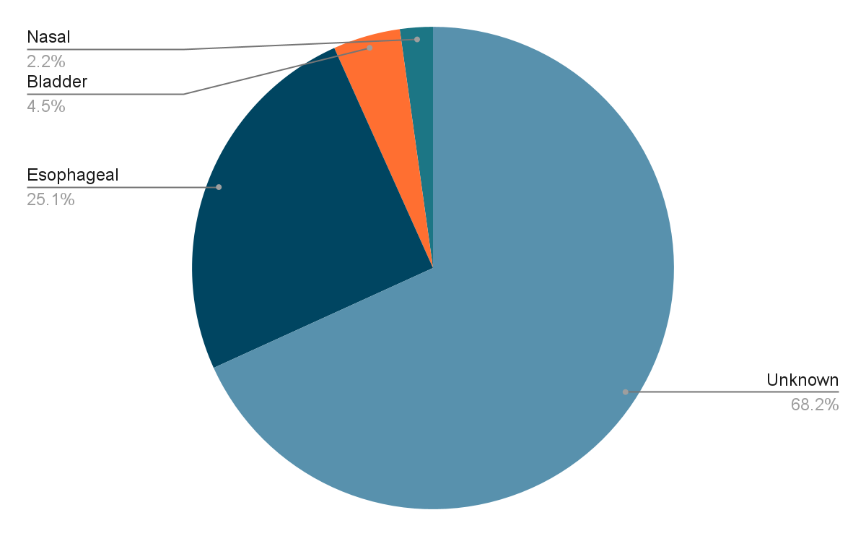
FIgure 1. Intraoperative Temperature Monitoring Devices

Incidence of Hypothermia
All patients were normothermic in the preoperative area with an average temperature of 36.7 degrees Celsius. The average post-induction (initial temperature <15 minutes after induction) temperature was 35.9 degrees celsius. Forty percent of patients (n=18/42) experienced post-induction hypothermia in the first 15 minutes of the case. Five patients were lacking temperature recordings in the first 15 minutes. Intraoperative hypothermia (less than 36 degrees celsius) occurred in 90.1% of the cases at some point during the operative period. Hypothermia was the most evident in the first 2-3 hours of a surgical case. The lowest recorded temperature was 33.9 degrees Celsius. When hypothermia occurred, the average length of time patients remained below 36 degrees celsius was 150 minutes. The average low temperature of all cases was 35.3 degrees celsius. The largest drop in temperature occurred between the induction of anesthesia and the first 15 minute interval, however, the lowest recorded temperature occurred at the 60 and 75 minute intervals.
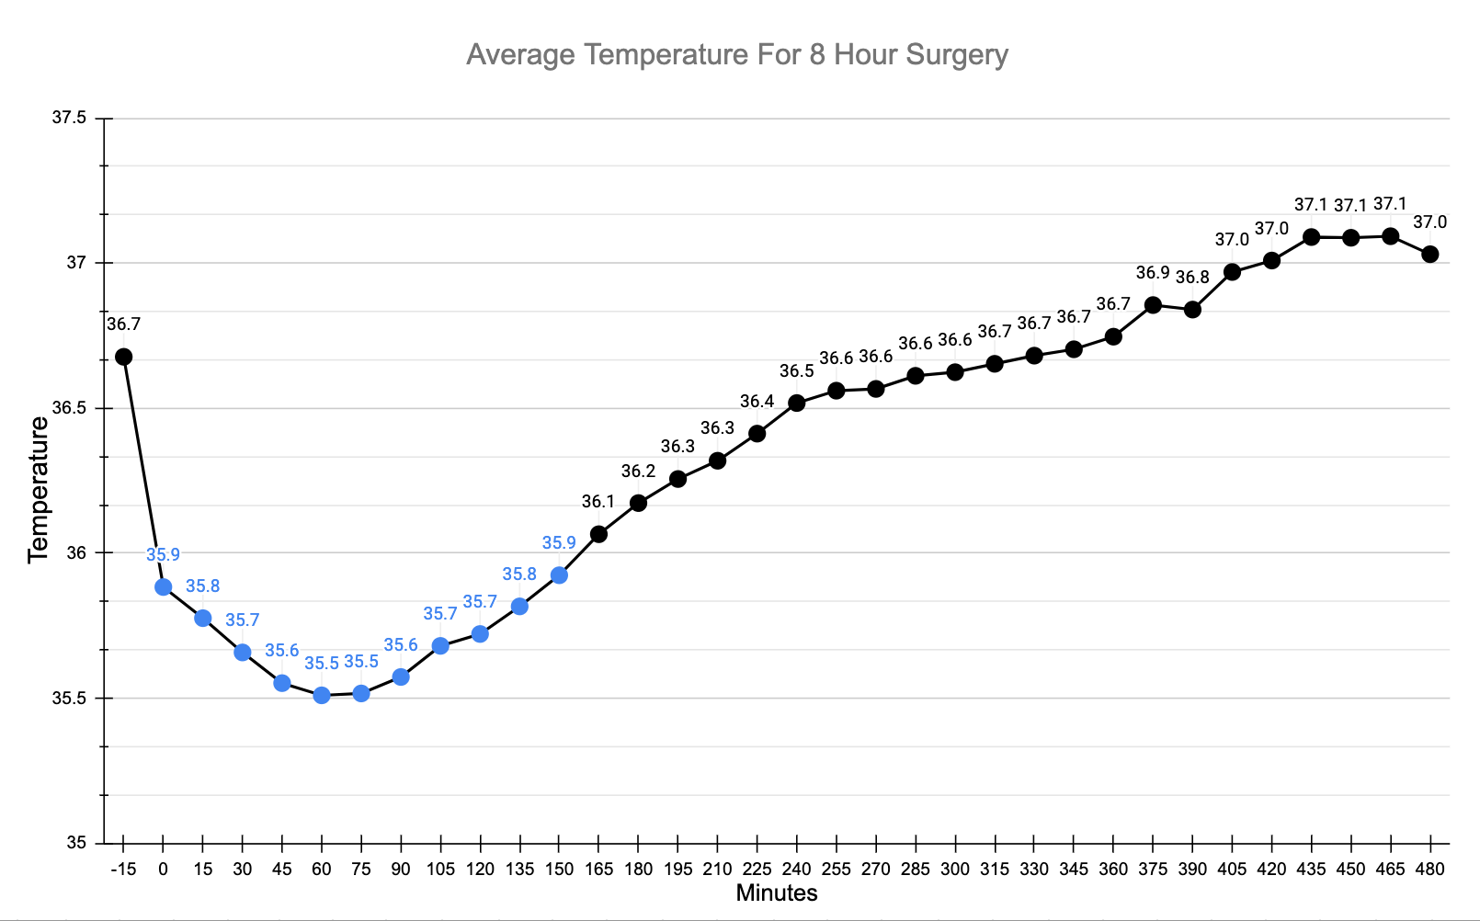
Figure 2. Average Temperatures for Eight Hour Surgery.
Note. Data points in blue represent hypothermia (below 36 degrees celsius). Negative 15 minutes represents pre induction temperature and zero minutes represents post induction temperatures.
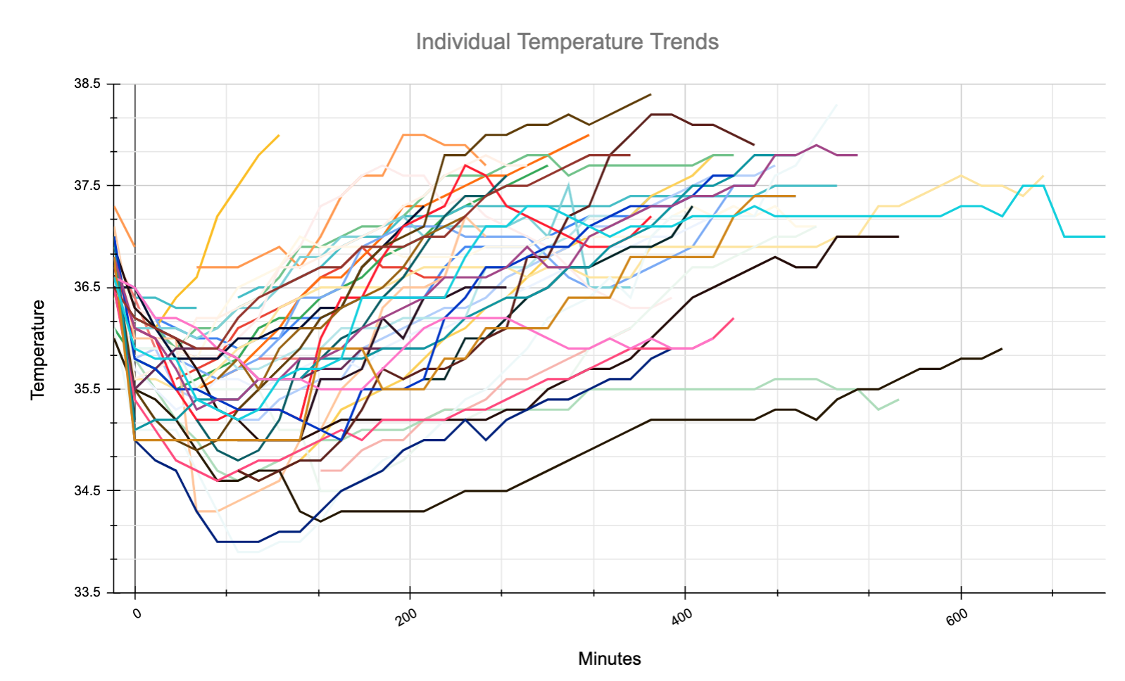
Figure 3. Individual Temperatures for Each Patient
Note. Data does not start at zero minutes to account for pre-induction temperatures. zero minutes represents post induction temperatures.
Table 3
Temperature Intervals
 | Mean (°C) | Highest Value (°C) | Lowest Value (°C) | Median (°C) | Standard Deviation (°C)
Pre Inductionª | 36.7 | 37.3 | 36 | 36.7 | 0.29
Post Induction^{b} | 35.9 | 36.9 | 35 | 35.9 | 0.46
15 min | 35.8 | 36.4 | 34.8 | 35.9 | 0.41
30 min | 35.7 | 36.4 | 34.7 | 35.8 | 0.43
45 min | 35.6 | 36.7 | 34.3 | 35.6 | 0.56
60 min | 35.5 | 37.2 | 34 | 35.6 | 0.66
75 min | 35.5 | 37.5 | 33.9 | 35.6 | 0.75
120 min | 35.7 | 37 | 34 | 35.8 | 0.80
180 min | 36.2 | 37.7 | 34.3 | 36.3 | 0.85
240 min | 36.5 | 37.9 | 34.5 | 36.6 | 0.90
300 min | 36.6 | 38.1 | 34.7 | 36.8 | 0.81
360 min | 36.7 | 38.3 | 35.1 | 36.9 | 0.77
420 min | 37.0 | 38.1 | 35.2 | 37.2 | 0.76
480 min | 37.0 | 37.8 | 35.3 | 37.2 | 0.78
Note. When the charts indicated temperature probe location, temperatures in the preoperative holding were axillary or tympanic and intraoperative temperatures (post induction and the remaining intraoperative temperatures) utilized core temperature methods such as esophageal or bladder temperature probes.
°C= Degrees Celsius; min= minute
ªPre Induction Temperatures were recorded in the preoperative holding room
^{b}Post Induction Temperatures were recorded within 15 minutes of induction of anesthesia.

Statistical analyses
After gathering the data, correlations between variables were assessed by using bootstrapped linear regression analyses. Statistical significance was considered p<0.05 for data analysis. The bootstrapped linear regression showed a predicted impact on the amount of time a patient experiences hypothermia, explaining F(3, 37) = 4.79, p = .007. R² =.297. The first initial temperature post induction (within 15 minutes) had a significant negative impact on the duration a patient experiences hypothermia, β = -5.89, t(37)=3.78, p <.001, CI[-9.56,-2.31]. Age did not have a significant impact on the time a patient experienced hypothermia, β = -.182, t(36) =-.410, p=.68, CI[-.81,.68]. Additionally, patients weight did not significantly impact the duration of time a patient experiences hypothermia, β = .007, t(37)=.126, p=.90, CI[-.094,.078]. Pre-operative temperatures (Mean =36.67, SD=0.29) was found to have significantly differed from post operative temperatures (Mean =36.64, SD=0.42), t(37) = 9.73, p <.001, CI[.42,.66].
Table 4
Bootstrap for Coefficients
 |  |  |  | Bootstrap
 |  |  |  |  | 95% Confidence Interval
 | B | Bias | Std. Error | Sig. (2-Tailed) | Lower | Upper
(Constant) | 2.16.172 | 4.382 | 64.858 | .023 | 88.566 | 343.532
Postinduction Temp | -5.895 | -.120 | 1.820 | 0.25 | -9.526 | -2.318
Weight (kg) | .007 | -.002 | .041 | .844 | -.094 | .078
Age (yrs) | -.182 | .002 | .349 | .614 | -.818 | .610

Table 5
Coefficientsª
 | Unstandardized B | Coefficients Std. Error | Standardized Coefficients Beta | t | Sig.
(Constant) | 2.16.172 | 57.062 | 64.858 | 3.788 | <.001
Postinduction Temp | -5.895 | 1.580 | -.546 | -3.732 | <.001
Weight (kg) | .007 | .053 | .022 | .126 | .900
Age (yrs) | -.182 | .445 | -.072 | -.410 | .685
Note. ª Dependent Variable: Hypothermic Time

Discussion
A loss of thermoregulatory control under general anesthesia leading to hypothermia has been associated with a host of negative consequences and poor surgical outcomes. Increased blood loss, surgical site infections, and patient discomfort are some of the frequently documented complications in the literature. The aim of this study was to gain further awareness of the incidence of hypothermia in pediatric surgical spine patients in order to facilitate and encourage the use of preoperative warming guidelines to help prevent the negative outcomes associated with hypothermia.
A key finding from our retrospective chart review was the high frequency of patients that experienced hypothermia. Our retrospective chart review revealed an incidence of hypothermia of 90.1%, which was greater than the reported incidence in similar pediatric surgical studies such as Mutchinick and colleagues (2020) who reported an incidence of hypothermia of 50% in pediatric neurosurgical patients. This higher occurrence could potentially be explained in part due to the larger area of surgical exposure for our patient population. Another notable observation was that the post-induction temperature had a statistically significant negative impact on the duration a patient experienced hypothermia demonstrated using a bootstrap linear regression model. This was done to ensure the reliability of the coefficients, given our smaller sample size. The lower the initial drop in temperature, the longer the patient stayed hypothermic. When hypothermia occurred, the average length of time patients remained hypothermic was 150 minutes. This elongated period of hypothermia is a significant finding, as hypothermia has negative consequences.
The largest drop in temperature for most patients occurred between the induction of anesthesia and the first 15 minute interval, whereas the average low temperature for all cases occurred at the 60 minute mark. The large drop in the first 15 minute interval can likely be explained by the redistribution of body heat from the core to the periphery secondary to vasodilation induced by induction of general anesthesia, which usually results in a decrease of 0.5-1 degree celsius (cite Sessler). The single lowest recorded temperature of 33.9 degrees Celsius occurred 75 minutes into the case. This is likely explained by the fact that the beginning of a large spine case usually involves inserting intravenous access, cleaning and draping of the patient, as well as turning the patient to the prone position which renders the patient exposed to the cool air. A study done by Cassey and colleagues (2010) found that prewarmed patients experienced a lesser drop in temperature after induction and concluded that preoperative warming is not as beneficial for long cases where warming will occur during the operative period, however, they suggested it as a favorable intervention for patients who will experience a prolonged time between induction and initiation of warming devices, as is the case with patients requiring insertion of extra monitoring devices (i.e., spinal surgery patients).
At the present time, forced air warming is the most effective and efficient method of perioperative warming, and is the standard of care in the operating room. In our review of anesthesia records, 100% of cases utilized some form of warming modality, 93% of which utilized forced air warming devices. A variety of other warming modalities were used in addition; however, the incidence of hypothermia was still high as described above. The incidence of hypothermia was similarly reflected in the control group of the studies in the literature review. Lau and colleagues (2018) found the incidence of hypothermia to be 63% in patients in the operating room using standard forced air methods, whereas patients who were pre-warmed with a forced air warmer preoperatively as well as in the operating room experienced hypothermia only 47% of the time. The authors further concluded that the combination of preoperative warming combined with intraoperative warming was greater than the use of warming intraoperatively alone. Results of this nature reaffirm that preoperative warming would likely yield similar benefits to our target population.

Limitations
Multiple limitations exist when evaluating the strength of this project. This data was collected from one institution and had a small sample size. This project would have benefited from data collection across multiple institutions and a larger sample size to allow for generalization of results. Although all data was collected by the same two researchers, data was extracted from handwritten anesthesia records, which were completed by multiple providers. the possibility of inaccuracy or inconsistency of anesthesia records when analyzing this data must be considered. Similarly, there were a range of temperature monitoring devices and methods used throughout this data and comparative studies. As discussed in above sections, these devices and methods are individually accurate, but may have discrepancies when compared amongst each other. A third limitation involves the limited literature regarding pediatric spinal surgeries and preoperative warming. Benefits of preoperative warming in these specialties are discussed in the literature separately; however, the combination of these two specialties has not been thoroughly explored.. A final limitation involves the complexity of pediatric spinal surgery and its ability to be compared to the separate specialties of pediatric surgery and spinal surgery. Differences in surgery duration, surgical techniques, and patient comorbidities may have skewed results when comparing our data to previous studies.

Recommendations
Given the elevated rate of hypothermia demonstrated in this retrospective chart review, initiation of preoperative warming in the pediatric spine surgery population would be a sensible intervention, as there is obvious room for improvement beyond the standard of care. Rather than rely on intraoperative practices to prevent and treat inadvertent hypothermia, implementation of preoperative warming may mitigate the risks and incidence of hypothermia, as demonstrated by studies in the literature. Though the changes in temperature may be minimal in some instances, there is no risk to the patient and only the potential for improved outcomes. Recommendations for the hospital in which the chart review was completed would be to prioritize implementing the warming guidelines that were created using evidence gathered from the literature (see Appendix). Evaluation of the outcomes would follow, and a practice change could potentially ensue. On a more macro level, there is an increased need for future studies addressing inadvertent hypothermia and preoperative warming in the pediatric population.
These warming guidelines (see Appendix C) involve the use of a forced air warming device applied to the surgical patient during the preoperative period for a minimum of 30 minutes prior to entering the operating room. Standard warming modalities in the OR can be continued, including forced air warming devices, ambient temperatures, and warming of intravenous fluids. Post induction temperatures will be monitored using esophageal probes and recorded every 15 minutes until the end of the case to monitor for the incidence of hypothermia.
The warming guidelines (see Appendix C) were created utilizing the best available evidence and mirrored methodologies in the literature. Patients with metabolic disorders with the potential to impact temperature regulation, such as hypothyroid disorder, were excluded. A literature review conducted by Connelly and colleagues (2017) looked at 14 studies to determine recommendations for optimal preoperative warming times and devices and concluded forced-air warming to be the most effective method to prevent perioperative hypothermia. Therefore, a forced air warming device was chosen as the sole method of preoperative warming. One author from Connelly and colleagues (2017) literature review found 10 minutes of preoperative warming, however, most studies found a minimum of 30 minutes to be effective (Zheng et al., 2020; Torossian et al., 2015; Rogers et al., 2018; Lau et al., 2018). Given that 30 minutes was the most studied time frame, we included a minimum of 30 minutes in our warming guidelines as well. While it is known that core temperatures are the most accurate, we chose an axillary temperature monitoring method in the preoperative period to decrease invasiveness. Although uncommon, the surgical team at Children’s Hospital pre-approved the utilization of a bair hugger during the induction period, prior to sterile draping. This helps to minimize the amount of time the skin is exposed to cool ambient temperatures. Core temperature monitoring via esophageal probe is encouraged once patients are under general anesthesia. Temperature monitoring is recorded every 15 minutes and other warming modalities are encouraged, as would normally be carried out by anesthesia providers. If the patient becomes hyperthermic (temperature > 38.0 degrees Celsius) during the case, the bair hugger should be discontinued or the warming temperature lowered according to the anesthesia team’s discretion. Immediately on arrival to PACU, an axillary temperature will be taken and recorded. Postoperative warming will be applied according to the present standard of care. If warming guidelines were implemented in the future, data gathered in the retrospective chart review could be used for comparison purposes to the post-intervention collection of data. If findings are deemed successful and favorable outcomes ensue in terms of decreasing the incidence of hypothermia, it would be reasonable to develop a formal protocol and implement it for future use.

Recommendation for sustaining intervention
Recommendations for sustaining a change in practice would be to monitor and audit the preoperative warming process regularly to ensure compliance. Preoperative warming is both financially feasible, and requires minimal education to achieve staff comfort with the process.

Implications for Practice and Career Development
The Surgical Care Improvement Project (SCIP) guidelines were first started in 2006 to create a standard of care for all surgical patients to reduce the incidence of negative outcomes. Since 2006, these guidelines have been refined and revised as medical knowledge continues to grow. The literature as well as this retrospective chart review reveal that intraoperative hypothermia is a problem for many surgical patients who undergo a general anesthetic. Pre-operative warming has shown promising results in reducing intraoperative hypothermia in multiple specialty surgical patient populations with minimal negative effects. As the literature progresses, it is our hypothesis that preoperative warming will become the new standard of care for the appropriate surgical patients.

Contribution of Project in achieving DNP Essentials

Essential II: Organizational and Systems Leadership for Quality Improvement and Systems Thinking
The DNP practitioner is capable of evaluating current practice systems and recognizing a need for improved care. A retrospective chart review was done to evaluate the incidence of hypothermia in a specialized population. Recognizing a need for improvement to the standard of care, practice guidelines to guide future care were created.

Essential III: Clinical Scholarship and Analytical Methods for Evidence Based Practice
The DNP practitioner is a leader in the nursing field, who uses the best available evidence to guide their practice in order to deliver the highest quality care and achieve better outcomes and improved safety for patients. Completion of a thorough literature review and critical appraisal of the research was done to incorporate the most up to date, highest quality evidence for the development of warming guidelines to meet the needs of current and future pediatric patients.

Essential VI: Interprofessional Collaboration for Improving Patient and Population Health Outcomes
The DNP practitioner effectively communicates with the interdisciplinary team and stakeholders to successfully elicit change. An initial meeting with the care and research personnel at the hospital was conducted to ensure collaboration and alignment of goals. Creation of preoperative warming practice guidelines were given to stakeholders for feedback before completion. Dissemination of findings of current organizational issues were delivered to hospital staff to encourage a change in practice.

Conclusion
This project determined that the incidence of hypothermia experienced in pediatric surgical spine patients remains high, despite usual warming practices. Preoperative warming is both a feasible, and evidence-based option to prevent or reduce the incidence of hypothermia and associated complications. The results of the study and knowledge of positive effects of warming were shared with staff in hopes of implementing and sustaining a change to improve current practice.

References
Albrecht, G. (2011). Forced-air warming blowers: An evaluation of filtration adequacy and
airborne contamination emissions in the operating room. American Journal of Infection Control, 39(4), 321–328. https://doi.org/10.1016/j.ajic.2010.06.011
Antoniou, C. K., Dilaveris, P., Manolakou, P., Galanakos, S., Magkas, N., Gatzoulis, K., & Tousoulis, D. (2017). QT prolongation and malignant arrhythmia: How serious a problem?. European Cardiology, 12(2), 112–120. https://doi.org/10.15420/ecr.2017:16:1
Bindu, B., Bindra, A., & Rath, G. (2017). Temperature management under general anesthesia:
Compulsion or option. Journal of Anaesthesiology, Clinical Pharmacology, 33(3), 306–316. https://doi.org/10.4103/joacp.JOACP_334_16
Butterworth, J. F., Mackey, D. C., & Wasnick, J. D. (2018). Thermoregulation & hypothermia.
Morgan & Mikhails Clinical Anesthesiology. Sixth Edition. (pp. 1214-1215). New York: McGraw-Hill Education.
Cassey, J., King, R., & Armstrong, P. (2010). Is there thermal benefit from preoperative
warming in children?. Pediatric Anesthesia, 20(1), 63-71. https://doi.org/10.1111/j.1460- 9592.2009.03204.x
Craig, J. V., Lancaster, G. A., Williamson, P. R., & Smyth, R. L. (2000). Temperature measured at the axilla compared with rectum in children and young people: Systematic review. BMJ (Clinical research ed.), 320(7243), 1174–1178. https://doi.org/10.1136/ bmj.320.7 243.1174
Craig, L. (2002). Infrared ear thermometry compared with rectal thermometry in children: A
systematic review. The Lancet (British Edition), 360(9333), 603–609. https://doi.org/10.1016/s0140-6736(02)09783-0
Connelly, C. (2017). The optimal time and method for surgical prewarming: A
comprehensive review of the literature. Journal of Perianesthesia Nursing, 32(3), 199–209. https://doi.org/10.1016/j.jopan.2015.11.010
Diaz, M., & Becker, D. (2010). Thermoregulation: Physiological and clinical considerations during sedation and general anesthesia. Anesthesia Progress, 57(1), 25-33. https://doi.org/10.2344/0003-3006-57.1.25
DeWitte, J., & Sessler, D. (2002). Perioperative shivering: Physiology and pharmacology.
Anesthesiology, 96(2), 467–484. https://doi.org/10.1097/00000542-200202000-00036
Horvath S.M., Spurr G.B., Hun B.K., Hamilton L.H. (1956) The metabolic cost of shivering.
Journal of Applied Physiology, 8, 595-602. https://doi.org/10.1152/jappl.1956.8.6.595
Lau, A., Lowlaavar, N., Cooke, E.M., West, N., German, A., Morse, D.J., Gorges, M., &
Merchant, R.N. (2018) Effect of preoperative warming on intraoperative hypothermia: A randomized-controlled trial. Canadian Journal of Anaesthesia, 65(9):1029‐1040. doi:10.1007/s12630-018-1161-8
Lopez, M. B. (2018). Postanaesthetic shivering – From pathophysiology to prevention.
Romanian Journal of Anaesthesia and Intensive Care, 25(1), 73-81. doi: http://dx.doi.org/10.21454/rjaic.7518.251.xum
Madrid, E., Urrútia, G., Figuls, M. R. I., Pardo-Hernandez, H., Campos, J. M., Paniagua, P.,
Maestre, L., Alonso-Coello, P. (2016). Active body surface warming systems for preventing complications caused by inadvertent perioperative hypothermia in adults. Cochrane Database of Systematic Reviews. doi: 10.1002/14651858.cd009016.pub2
Melnyk, B. M., & Fineout-Overholt, E. (2019). Evidence-based practice in nursing &
healthcare: A guide to best practice. Fourth edition. Philadelphia: Wolters Kluwer Health.
McSwain, J.R., Yared, M., Doty, J.W., & Wilson, S.H. (2015). Perioperative hypothermia:
Causes, consequences and treatment. World Journal of Anesthesiology, 4(3), 58-65. doi: 10.5313/wja.v4.i3.58
Melling, A. (2001). Effects of preoperative warming on the incidence of wound infection after clean surgery: A randomized controlled trial. The Lancet, 358(9285), 876–880. https://doi.org/10.1016/S0140-6736(01)06071-8
Mutchnick, I., Thatikunta, M., Braun, J., Bohn, M., Polivka, B., Daniels, M.W., Vickers-Smith,
R., Gump, W., & Moriarty, T. (2020). Protocol-driven prevention of perioperative hypothermia in the pediatric neurosurgical population. Journal of Neurosurgery: Pediatrics PED, 25(5), 548-554. https://doi.org/10.3171/2019.12.PEDS1980
National Collaborating Centre for Methods and Tools. (n.d.). PARiHS framework for
implementing research into practice. Retrieved from https://www.nccmt.ca/knowledge- repositories/search/85
Nightingale’s environment theory. (n.d.). Nursing theory. Retrieved November 15, 2020, from
https://nursing-theory.org/theories-and-models/nightingale-environment-theory.php
Niven, G. (2015). Accuracy of peripheral thermometers for estimating temperature: A
systematic review and meta-analysis. Annals of Internal Medicine, 163(10), 768–777. https://doi.org/10.7326/M15-1150
Pearce, B., Christensen, R., & Voepel-Lewis, T. (2010). Perioperative hypothermia in the
pediatric population: Prevalence, risk factors and outcomes. Journal of Anesthesia &
Clinical Research, 1(1). doi:10.4172/2155-6148.1000102
Rajagopalan, S., Mascha, E., Na, J., & Sessler, D. (2008). The effects of mild perioperative hypothermia on blood loss and transfusion requirement. Anesthesiology, 108(1), 71-77. doi:10.1097/01.anes.0000296719.73450.52
Rogers, A., Saggaf, M., & Ziolkowski, N. (2018). A quality improvement project incorporating
preoperative warming to prevent perioperative hypothermia in major burns. Burns, 44(5), 1279–1286. doi: 10.1016/j.burns.2018.02.012
Scott, A.V., Stonemetz, J.L., Wasey, J.O., Johnson, D.J., Rivers, R.J., Koch, C.G., & Frank, S.M. (2015). Compliance with surgical care improvement project for body temperature management (SCIP Inf-10) is associated with improved clinical outcomes. Anesthesiology, 123(1), 116-125. doi: https://doi.org/10.1097/ALN.0000000000000681
Seamon, M., Wobb, J., Gaughan, J.P., Kulp, H., Kamel, I., & Dempsey, D. (2012). The effects of intraoperative hypothermia on surgical site infection: An analysis of 524 trauma laparotomies. Annals of Surgery, 255(4), 789-795. https://doi.org/10.1097/SLA.0b013e31824b7e35
Scott, A.V., Stonemetz, J.L.,Wasey, J.O., Johnson, D.J., Rivers, R.J., Koch, C.G., & Frank, S.M. (2015). Compliance with surgical care improvement project for body temperature management (SCIP Inf-10) is associated with improved clinical outcomes. Anesthesiology, 123(1), 116-125. doi: https://doi.org/10.1097/ALN.0000000000000681
Sessler, D.I. (2014). Temperature regulation and monitoring. In: Miller, R.D., Ed., Miller’s Anesthesia (8th ed., pp. 1622-1646). Saint Louis: Elsevier.
Silverton, C. (2016). American Academy of Orthopedic Surgeons Annual Meeting. Hypothermia during surgery with increased risk for infection (p. na). Orlando, Florida
Thiel, B., Mooijer, B.C., Kolff-Gart, A.S., Kerklaan, B.M., Poolman, R.W., Haan, P.D., & Siepel, M.A. (2020). Is preoperative forced-air warming effective in the prevention of hypothermia in orthopedic surgical patients? A randomized controlled trial. Journal of Clinical Anesthesia, 61. doi: 10.1016/j.jclinane.2019.109633
Torossian, A., Van Gerven, E., Geertsen, K., Horn, B., Van de Velde, M., & Raeder, J. (2016). Active perioperative patient warming using a self-warming blanket (BARRIER EasyWarm) is superior to passive thermal insulation: A multinational, multicenter, randomized trial. Journal of Clinical Anesthesia, 34, 547–554. https://doi.org/10.1016/j.jclinane.2016.06.030
Triffterer, M. (2016). Forced-air warming during pediatric surgery: A randomized comparison of a compressible with a noncompressible warming system. Anesthesia and Analgesia, 122(1), 219–225. https://doi.org/10.1213/ANE.0000000000001036
Urits, I., Jones, M. R., Orhurhu, V., Sikorsky, A., Seifert, D., Flores, C., Kaye, A.D., & Viswanath, O. (2019). A comprehensive update of current anesthesia perspectives on therapeutic hypothermia. Advances in therapy, 36(9), 2223–2232. https://doi.org/10.1007/s12325-019-01019-z
Wallner B., Schenk B., Hermann, M., Paal, P., Falk, M., Strapazzon, G., Martini, W.Z., Brugger H., & Fries, D. (2020). Hypothermia associated coagulopathy: A comparison of viscoelastic monitoring, platelet function, and real time live confocal microscopy at low blood temperatures, an in vitro experimental study. Frontiers in Physiology, 11, 843. doi: 10.3389/fphys.2020.00843
Zheng, X.Q., Huang, J.F., Lin, J.L., Chen, D., & Wu, A.M. (2020). Effects of preoperative warming on the occurrence of surgical site infection: A systematic review and meta- analysis. International Journal of Surgery, 77, 40–47. doi: 10.1016/j.ijsu.2020.03.016

Appendices

IRB Approval
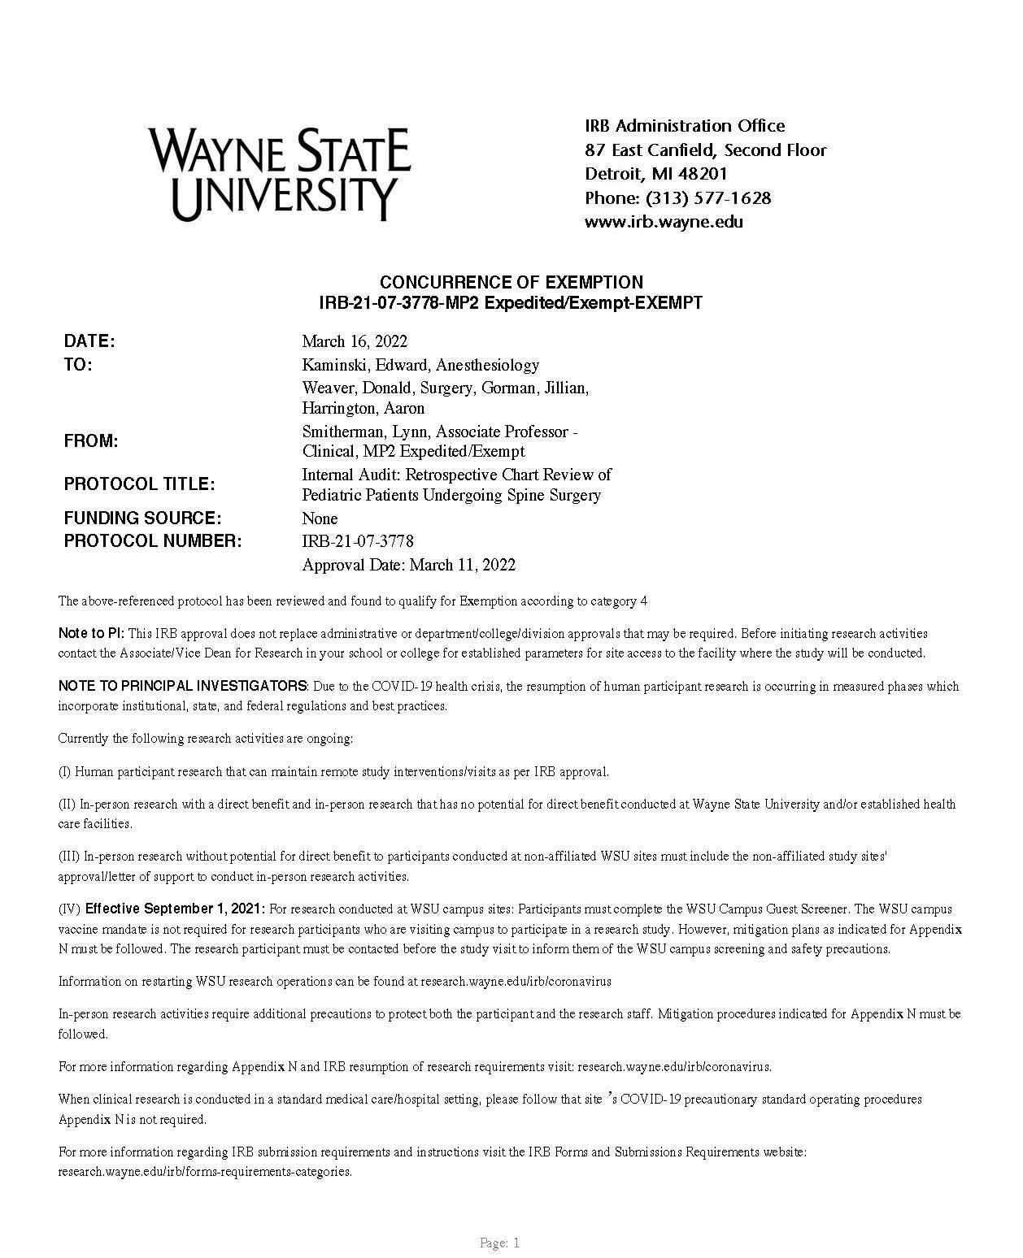
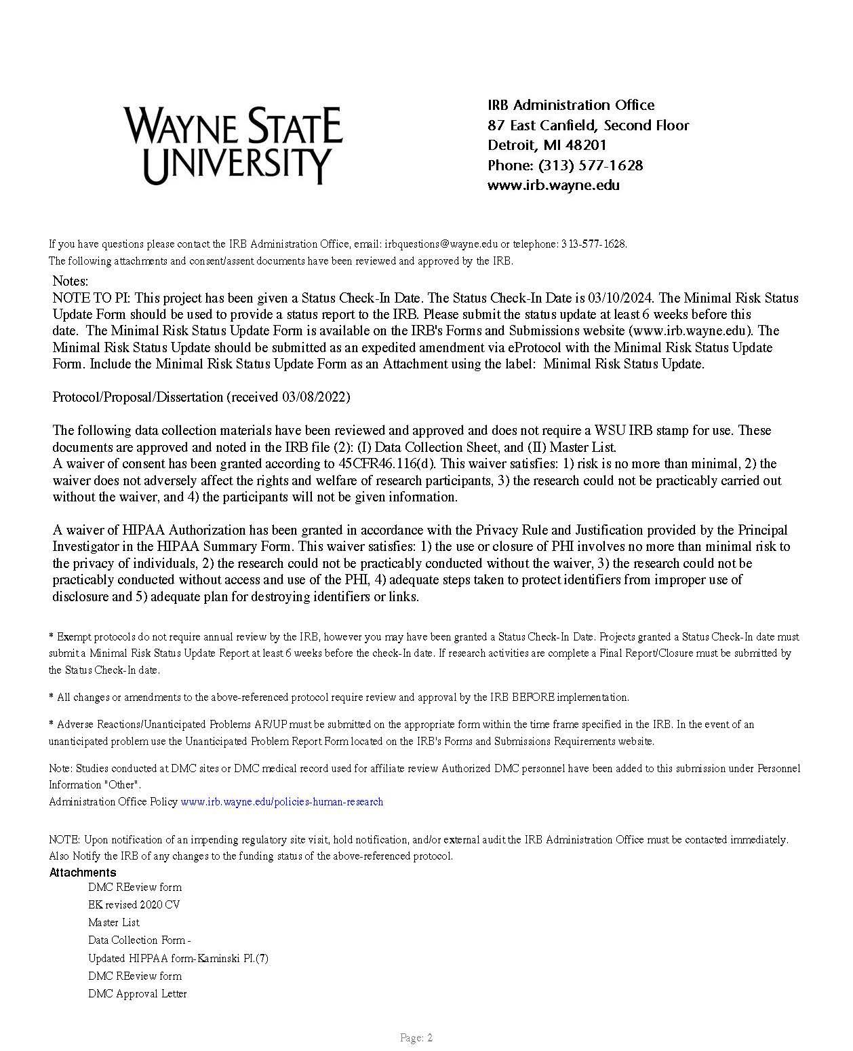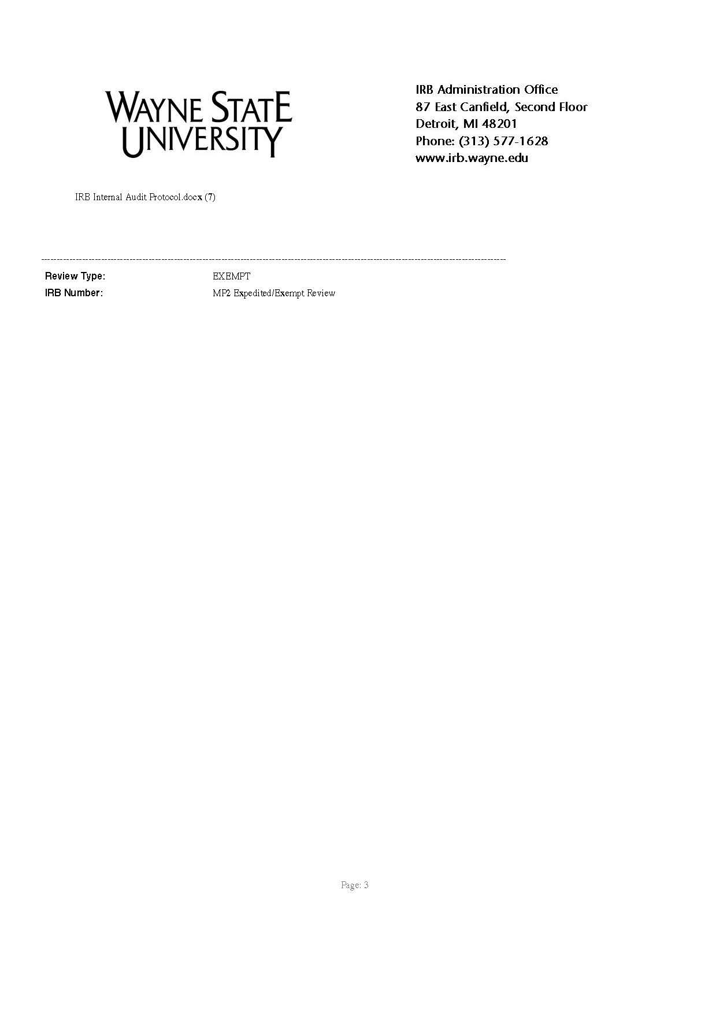

Appendix A

Table 1: Evaluation Table
Author  (Year) | Study Aim | Design/  Methods | Sample (n)  &  Setting | Outcomes Studied | Results | Recommendations/ Conclusion | Appraisal | Level of Evidence
1. Cassey et al. (2010) | Aim:  Aimed to quantify the impact of a raised preoperative ambient temperature (Tambient) on core temperature (Tcore) after induction of anesthesia in children. | Methods:  assess Tcore behavior in children randomized to either raised or standard ambient temperature as a prewarming technique prior to induction and until the operation commenced  children allocated to a Tambient of 26 or 21°C on the basis of a random number generator. | n=60, age range 6 weeks-15 years  30 raised periop ambient temperature group (26 degrees C)  30 standard ambient temperature (21 degrees C)  Esophageal monitor in OR  Tympanic  Minimum 30-40 minute warming | Temperature:  -on induction  -after induction,  -initiation of esophageal monitor, 10 minute intervals post induction, -completion case | Tympanic temperature during acclimatization,°C:  WG: +.60 (0.54) vs. CG: +0.04 (0.45)  Esophagus on induction, °C: WG: 36.9 (0.5) vs. CG: 36.5 (0.5)  Δ Tesophagus after 20 min, °C: WG: -.47(0.27) vs. CG: -..029 (0.39)  Δ Tesophagus after 30 min, °C: WG: -0.74 (0.43) vs. CG: -0.44 (0.27)  Subjects with Δ Tesophagus >0.5°C @20 min, WG: 24 vs. CG: 12  Time for Tesophagus to drop 0.5°C, (if this occurred), min: WG 19.83 (6.6) v. CG 19.67 (6.8)  All statistically significant | suggest preoperative warming when there is no effective intraoperative warming available or when there is going to be a prolonged time taken for insertion of monitoring devices or specialized blocks  children cool faster if they are anesthetized at ambient of 21°C rather than being preoperatively warmed in a Tambient of 26°C and (ii) this difference becomes greater with longer periods of anesthesia. However, irrespective of age and morphology, the ‘thermal advantage’ of preop- erative warming with regard to post induction change Tesophagus is small  Ambient warming has a likely <0.5 degree C advantage in short procedures <45 mins | Pros: strict warming technique and control of confounding variables  Power analysis for accurate sample size  Statistically significant changes in groups  Cons: all patients were male, except 1  Likely clinically insignificant changes (<0.5 C) | Level II: Randomized prospective clinical study
2. Connelly et al.  (2017) | Aim: to determine the ideal method and timing for prewarming a surgical patient to prevent perioperative hypothermia | Methods: 14 articles gathered from CINAHL and PubMed were reviewed  10 RCTs  1 Comparative research study  1 EBP study  2 randomized prospective study | Included surgery times >20 minutes-<4 hours  General anesthesia most common but included regional/spinal | Results  12/14 articles suggest FAW more effective than warm blankets  forced-air warming provided a significant difference in maintenance of normothermic temperature at 1, 2, and 3 hours into surgery (P < .001)  forced-air prewarming maintained a temperature of 1.28°C higher than patients without prewarming (P < .05)  One found that forced-air prewarming resulted in a significantly smaller decrease in intraoperative temperature (P < .05)  A fourth article found that patients who were prewarmed with forced-air warming had higher core body temperatures (P = .001), less time to return to normothermia (P = .003), and a shorter time spent on a ventilator (P = .001)  patients with forced-air prewarming vs warm cotton blankets before, during, and after surgery: significantly higher temperature at 30, 60, and 90 minutes into surgery in the forced-air warming group (P = .016) and significantly higher temperatures in PACU (P = .02)  Times ranged from 10-60 minutes  1 study recommended 30 minutes preop warming  1 study found no sig. Difference between prewarming of 10, 20, or 30 mins |  | prewarm surgical patients for 30 minutes, but at least for a minimum of 10 minutes with a forced-air warming system that allows for minimal heat escape  forced-air warming is the most effective method to prevent perioperative hypothermia in most surgical patients. | Pros: used critical appraisal tool to evaluate evidence  Included high level evidence articles in review  Cons: Exclusion criteria included pediatric studies | Level V: Literature Review
3.Lau et al.  (2018) | Aim: The purpose of this study was to evaluate the effects of preoperative forced-air warming on intraoperative hypothermia | Methods:  Minimum of 30 minutes  Of preoperative warming with bair paws forced warming systeme | n=200  CG=101  WG=99  2015-March 17, 2016  Randomized to warming or not via surgical schedule  CG: warm blanket prn in preop (standard of care)  WG: 30 min pre op bair paws warmer  Both: intraoperatively warmed  Spot temp core temp measured (non-invasive core temperature monitor) | -magnitude of intraoperative hypothermia as the area under the time-temperature curve for core temp <36 b/t induction & leaving OR  Secondary:  Pt anxiety (self report 0-10 scale)  Pt comfort (self report numeric scale)  SSIs (30 & 90 days post op via MD)  EBL  RBC transfusion  Opioid consumption post op  PACU  LOS  Temperature:  -baseline  -end of pre-warming  -preop  -postop  -discharge | 36.8 [36.5-36.9] °C, respectively; MD, 0.2°C; 95% CI, 0.0 to 0.3°C; P = 0.004)  On PACU arrival, pre-warmed participants were also warmer than control participants (36.4 [36.0-36.8] °C vs 36.0 [35.6-36.4] °C, respectively; MD, 0.4°C; 95% CI, 0.2 to 0.4°C; P < 0.001).  AUC intraop hypothermia exposure was significantly lower in the pre-warmed group compared with the control group (0.00 [0.00-0.12] °C􏰀hr-1 vs 0.05 [0.00- 0.36] °C􏰀hr-1, respectively; MD, -0.01°C􏰀hr-1; 95% CI, -0.04 to 0.00°C; P = 0.005)  The incidence of intraoperative hypothermia (core temperature \ 36°C) was lower in pre-warmed (n = 46) than control (n = 64) participants (47% vs 63%; OR, 0.50; 95% CI, 0.29 to 0.88; P = 0.02  At 60 min post-induction, the median [IQR] temperature in the pre-warmed group was higher than in the control group (36.3 [36.0-36.7] °C vs 36.0 [35.6-36.3] °C; MD, 0.3°C; 95% CI, 0.14 to 0.48°C; P \ 0.001  No significant differences in secondary outcomes | Conclusion a minimum 30-min preoperative full-body forced-air warming, compared with warmed flannel blankets on demand, and combined with intraoperative warming, can reduce intraoperative hypothermia incidence by 16% (P = 0.02)  Combined pre op & intraop warming is better than intraop alone | Cons:  Single center  Adult patients  Pros:  Statistically sig differences (not really clinically sig)  Randomized groups  Statistician blinded to the groups  Did not reach the clinically significant change of -2 degrees per author | Level II: Randomized Control Trial
4. Madrid et al.  (2016) | Aim:  To assess the effectiveness of pre- or intraoperative ABSW, or both, to prevent perioperative complications from unintended hypothermia during surgery in adults. | Methods:  Cochrane Central Register of Controlled Trials (CENTRAL; Issue 9, 2015); MEDLINE (PubMed) (1964 to October 2015), EMBASE (Ovid) (1980 to October 2015), and CINAHL (Ovid) (1982 to October 2015). | 67 trials with 5438 participants that comprised 79 comparisons.  45 RCTs compared ABSW versus control,  18 compared two different types of ABSW,  10 compared two different techniques to administer the same type of ABSW  41 trials under general anesthesia, under spinal/epidural anaesthesia in 16 trials, under regional anaesthesia in one, and in eight trials the participants received different types of anaesthesia | Beneficial effect with forced-air warming on major cardiovascular complications  Mortality  Blood loss during surgery  total fluids infused during surgery  Blood loss during surgery  total fluids infused during surgery  reduction in shivering  Different ABSW systems  Infection & complication of surgical wounds  Safety  Pain  Anxiety  Thermal Comfort | 1 study showed benefit  No benefit  Reduced, but irrelevant magnitude (20 studies)  No significant reduction in the number of participants being transfused or the average amount of blood transfused. (24 studies)  Yes, 29 studies (⅓ the risk compared to CG)  No superior system  except for extending systemic warming to the preoperative period in participants undergoing major abdominal surgery  Reduction 2 large trials (1 for preoperative warming)  No risk  No difference  No difference  Higher satisfaction 4  No difference- 6 | Forced-air warming (FAW), applied in the surgical pre- or intraoperative phases or both, seems to have a beneficial effect in terms of a lower rate of surgical site infection and complications, at least in people undergoing abdominal surgery with risk of infection, compared to not applying any active warming system. Intraoperative FAW also seems to have a beneficial effect in terms of lower rates of major cardiovascular complications when applied to people with documented substantial cardiovascular risk. It also improves patient comfort, as it maintains the core temperature within the normal range. The effects on blood loss and transfusion are not clear, as the observed reduction in blood loss does not result in a reduction in transfusion rates. The evidence for other types of active body surface warming systems (ABSW) is scant.  there was an indication from one trial at low risk of bias that results were better when systemic warming was extended to the period before the operation in people undergoing major abdominal surgery. | Pros:  Systematic Review  Cons:  Majority of the studies is the small sample size, which limits the likelihood of detecting any difference in the clinical outcomes  The quality of the evidence was low for surgical site infections and complications of the heart and circulation. This is because very few trials with few events reported on these outcomes | Level: I  Cochrane Systematic Review
5. Melling  (2001) | Aim:  To assess the use of a local warming device and a warm air blanket for the reduction of infection after clean wound surgery. | Methods:  RCT  randomly assigned to either a non- warmed (standard) group or one of two warmed groups (local and systemic). We applied warming for at least 30 min before surgery.  Systemic= whole body using a forced-air, warming blanket  Local= non-contact, radiant heat dressing to surgical site. | n= 421  Locally warmed: 139  Systemic Warmed:139  Non-warmed:138  Patients who were having breast, varicose vein, or hernia surgery. | Wound infection  Post operative antibiotics  Hematoma | Locally warmed: 4%  Systemic Warmed:6%  non-warmed:14%  Locally warmed: 7%  Systemic Warmed:7%  non-warmed:16%  Locally warmed: 3%  Systemic Warmed:1%  non-warmed:4% | 30 min period of warming, before surgery, reduces infection rates from 14% to 5%.  Did not show any differences in outcome between the two types of warming. Although local warming resulted in fewer infections than systemic warming, this difference was not significant. | Pros:  RCT  Ample sample size  Cons:  Selective patient population  Published 2001 | Level II: Randomized Control Trial
6. Mutchnick et al.  (2020) | Aim:  Evaluate efficacy of a PH prevention protocol in the pediatric neurosurgery population | Methods:  Baseline temp & immediate OR entry temp + q15 in OR  Preoperative tympanicmembrane temperature + q15 minutes with esophageal probe  Tympanic membrane temperature postoperative | n=120  Pediatric neurosurgery patients (avg. age 8 years)  38 WG w/ FAW preop + 75 degree OR 15 mins prior to induction + RWL  RWL maintained during induction  82 (CG) FAW or RWL w/ draping in OR (standard) | Temperature:  -on arrival to OR  -q15 minutes in OR  -in PACU  Hypothermic burden (AUC) | WG patients were significantly warmer on arrival to the operating room (OR) and were 60% less likely to develop PH(p < 0.001); intraoperative time 0: 36.8°C (WG) versus 36.25°C (CG) (p < 0.0010)  Lowest temp drop in WG: 36.5 vs. 36.25 (CG)  Every time interval: CG 2-3x more like to experience PH vs. WG  All patients, regardless of group, experienced a drop in core temperature until a nadir occurred at 30 minutes intraoperatively for the WG and 45 minutes for the CG. At every time interval, from preoperatively to 120 minutes intraoperatively, CG patients were between 2 and 3 times more likely to experience PH (p < 0.001) | intraoperative warming protocols reduce both the risk of any hypothermia and the total hypothermic deficit | Con: pediatric neurosurgery pts only  Not randomized Use of tympanic temps in preop; less than perfect method but most feasible for awake pediatric patients  Pro:  95% confidence interval  Pts matched for age, surgery, sex  Low resource cost  Statistically significant findings | Level III: Prospective non-randomized study
7. Niven  (2015) | Aim:  To determine the accuracy of peripheral thermometers for estimating core body temperature in adults and children. | Methods:  MEDLINE, EMBASE, Cochrane Central Register of Controlled Trials, and CINAHL Plus from inception to July 2015.  Prospective studies comparing the accuracy of peripheral (tympanic membrane, temporal artery, axillary, or oral) thermometers with central (pulmonary artery catheter, urinary bladder, esophageal, or rectal) thermometers. | 75 studies (8682 patients) from inception to July 2015 | Pooled mean difference  Axillary thermometer  Temporal artery thermometer  Oral thermometer  Bladder  Esophageal  Rectal | -1.61 to 0.49 °C  -0.77 to 0.67 °C  -1.38 to 1.15 °C  -0.120 to 0.120 °C  -0.310 to 0.310 °C  -0.24 to 0.04 °C | Peripheral thermometers do not have clinically ac ceptable accuracy and should not be used when accurate measurement of body temperature will influence clinical decisions.  When a central thermometer is best avoided or impractical, electronic oral thermometers (for use in adults) or tympanic membrane thermometers (for use in adults and children) that are calibrated before use seem to be the best alternative.  At extremes of body temperature, peripheral temperature measurements may be as much as 1 to 2 degrees higher or lower than actual body temperature. | Pros:  Systematic Meta Analysis  Cons:  Nasal temperature not included  Environment not exclusive to operating room | Level: I  Systematic Review Meta Analysis
8. Pearce et al.  (2010) | Aim:  To describe the current prevalence of hypothermia and evaluate its relationship to outcomes in a pediatric perioperative setting. A secondary aim was to evaluate the potential risk factors and short-term outcomes of perioperative hypothermia in children. | Methods:  This observational cohort study included the following electronically and prospectively recorded data from children fewer than 18 years of age undergoing general anesthesia: perioperative temperatures, warming interventions, patient characteristics, and surgical procedures, duration of anesthesia and perioperative outcomes. | n= 530  Birth to 18 years of age undergoing general anesthesia for a surgical or diagnostic procedure at the University of Michigan Health System. Children undergoing cardiopulmonary bypass with deliberate intraoperative hypothermia, those requiring direct admission to an intensive care unit after operation and procedures conducted offsite | Hypothermia incidence (in OR)  EBL ml/kg  Normothermic  Hypothermic  Received Blood Products  Normothermic  Hypothermic  PACU stay (min)  Normothermic  Hypothermic | 52%  0.49 ±1.89  2.96 ±8.33  >1%  8%  63.9 ± 35.4  71.7 ± 47.5 | Older age, longer duration of anesthesia, greater blood loss and transfusion rates were significantly associated with hypothermia in this subset of children.  Since skin monitors are consistently two degrees cooler than core measures in adults, consideration of a different definition of hypothermia during their use may be warranted. | Pros:  Pediatric Specific  Acknowledges challenges specific to children and temperature monitoring  Cons:  The results of this study come from a single institution  variation in methods used to monitor temperature  Smaller sample size | Level: IV  Observational cohort study
9. Rajagopalan et al.  (2008) | Aim:  To evaluate the hypothesis that mild perioperative hypothermia increases surgical blood loss and transfusion requirement. | Methods:  A systematic search of published randomized trials that compared blood loss and/or trans- fusion requirements in normothermic and mildly hypothermic (34–36°C) surgical patients. | Fourteen studies were included in analysis of blood loss, and 10 in the transfusion analysis  MEDLINE (1966 –2006), PubMed, and Cochrane library (2006) |  |  | Even mild hypothermia (<1°C) significantly in creases blood loss by approximately 16% and increases the relative risk for transfusion by approximately 22%  mild hypothermia significantly increased the relative risk for transfusion by approximately 22% (CI 3–37%). | Pro:  Systematic Review  Cons:  Not pediatric specific  Published 2008 | Level: I  Systematic Review
10. Rogers et al.  (2018) | Aim:  reduce the incidence of perioperative hypothermia to below 10% of cases in patients  with a major burn Total Body Surface Area >15%), within a one year period. | Methods:  reinforced intraoperative measures in current use, including preemptive  adjustment of the ambient temperature, underbody warming mattress use, warming blanket application over areas not operated, regular temperature monitoring  Preoperative forced air warming with a ‘Bair Hugger’ was used for 1 hour prior to OR  Temperature at 32 C  PDSA  November 2016-October 2017  Core temperature measured via nasopharyngeal or esophageal | n=53  American Burn Association verified burn center Burn patients with TBSA >15%  Adults  Bair Hugger placed at least 1 hr pre operatively  OR ambient temperature= 32 degrees celsius  Hyperthermic (> 37.5) excluded | Primary outcome:  - lowest temperature per case  -incidence of hypothermia (% cases) between pre- and post-intervention | After pre-warming intervention, proportion of cases was reduced to 13.77% (n=14/102)  Vs. baseline 24% (n=6/25) | Preoperative warming, when combined with consistently applied intraoperative protocol, can contribute to the maintenance of normothermia during the perioperative period with burn patients  Prospective studies needed for clarification on time for prewarming, and impact on morbidity/mortality | Pro:  Specific to burn population  Feasible to implement  Cons:  Results not generalizable  Small Sample Size  Small Control Sample  No secondary patient outcomes noted related too the benefits of avoiding hypothermia | Level VI:  Quality improvement project
11. Seamon et al.  (2012) | Aim:  Determine whether intraoperative hypothermia predisposes patients to postoperative surgical site infections (SSI) after trauma laparotomy. | Methods:  A review of all patients (July 2003–June 2008) who survived 4 days or more after urgent trauma laparotomy at a level I trauma center Patient characteristics, along with preoperative and intraoperative care focusing on SSI risk factors, including the depth and duration of intraoperative hypothermia, were evaluated. The primary outcome measure was the diagnosis of SSI within 30 days of surgery. Lowest intraoperative temperature measurements established the temperature nadir that best predicted SSI development. | n=524  Inclusion Criteria: between 18 and 88 years of age who underwent trauma laparotomy, regardless of injury mechanism, were eligible.  Exclusion Criteria: injury greater than 2 hours before emergency department arrival, preoperative temperature less than 35◦C, laparotomy beyond 2 hours after emergency department arrival, or death within 4 days | SSI group  Mean Body Temp Nadir  Non SSI group  Mean Body Temp Nadir | 35.0 C  35.4 C | Intraoperative hypothermia below 35◦C had a profound impact on SSI rates after trauma laparotomy.  A single intraoperative temperature measurement less than 35◦C during a trauma laparotomy doubled the risk for postoperative SSI  The predicted risk of surgical site infection correlated with the intraoperative temperature nadir depth.  The hypothermic (34.7◦ C ± 0.6◦ C) patients were more likely to exhibit postoperative peripheral vasoconstriction (78% vs 22%) and more likely to develop postoperative SSI (19% vs 6%) than their normothermic (36.6◦C ± 0.5◦C) counterparts. | Pros:  Substantial sample size  Cons:  retrospective experience of a single center.  Variables such as the choice of operative procedure, the management of perioperative antibiotics, and the diagnoses of SSI were left to the discretion of the attending trauma surgeon, not a study protocol. | Level: IV  Retrospective Observational Cohort Study
 |  |  |  | 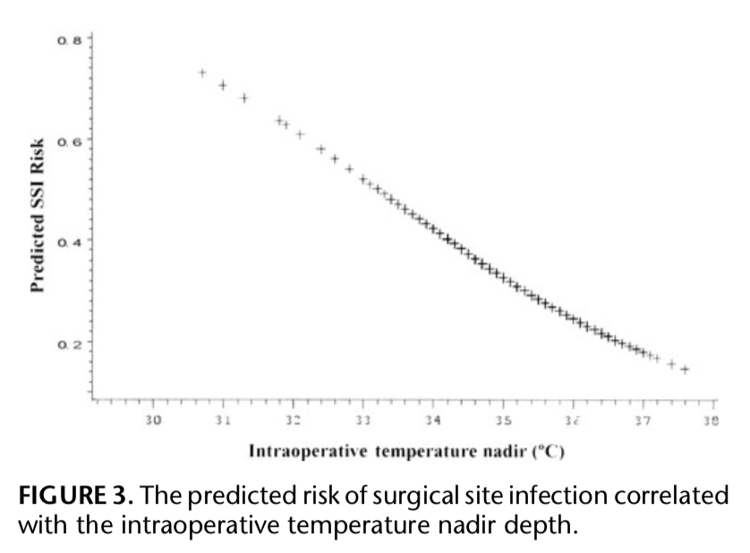 |  |  |  | Level: IV  Retrospective Observational Cohort Study
12. Silverton  (2016) | Aim: evaluate the incidence of hypothermia during hip fracture surgery and its relation to post-surgery complications | Methods:  Unable to locate article; presented at American academy of orthopedic surgeons | n=2397  Hip fracture surgery 2011-2013 |  | deep SSIs were 3.3 times higher in patients who developed hypothermia than those who did not |  | Pros: large population  Cons:  Unable to locate article; presented at American academy of orthopedic surgeons | Level III: Retrospective Study
13. Thiel et al.  (2020) | Aim:  compare forced-air perioperative warming with our standard of care consisting of thermal insulation and warmed cotton blankets.  assess differences in perioperative hypothermia-incidence, complications and patient satisfaction between patients receiving pre- operative active warming  using forced-air and patients receiving warmed disposable blankets | Methods:  patients were randomized to prewarming for 30 minutes using forced-air with a 3M Bair Paws flex gown model 81003 at the preoperative preparation room (Intervention group), or to receive a disposable warmed blanket (Standard of care group). | n=212  ASA I-III  Elective total knee or total hip arthroplasty | Hypothermia  C=Control  PW- Prewarming group  Induction  C  PW  Incision  C  PW  End of case  C  PW  PACU Arrival  C  PW  Complications (within 30 days)  C  PW  Patient Satisfaction | 10%  3%  29%  12%  12%  5%  21%  10%  20.4%  5.7%  No significant difference | A reduction of perioperative hypothermia, and complications caused by it, can be achieved by adding a simple intervention such as prewarming to local perioperative warmings protocols.  Forced-air seems to be effective in reducing hypothermia and post-surgical complications in patients un- dergoing total hip- and total knee arthroplasty. | Pro:  Moderate sample size  Cons:  No complication explanation | Level II: Randomized Control Trial
14. Torossin et al.  (2016) | Aim: compare self-warming blanket with passive thermal insulation and to investigate its feasibility as a perioperative warming strategy.  studied the effects on patients | Methods:  Randomized using web based generator system  30 minutes of preoperative warming | n=246  CG: warmed hospital cotton blankets (passive thermal insulation) throughout entire perioperative period n=124  Vs.  intervention group=BARRIER EasyWarm blanket at least 30 minutes before induction of GAand throughout the perioperative period n=122  FAW in both groups if temperature <35.5 C  Orthopedic, ENT, or gynecologic surgery  ASA Scores I-III and surgery | Primary:  Mean perioperative core temperature:  -before induction (infrared tympanic membrane)  -after induction  -every 15 mins after  Secondary:  Patients thermal comfort  (thermal comfort scale at OR arrival + PACU)  Patient overall satisfaction (satisfaction survey)  Change in temperature from preoperative-postoperative  Number of patients experiencing hypothermia  PACU LOS | Preoperative temperature:  WG: 36.9°C, SD ±0.3, vs. CG: 36.8°C, SD ±0.3, respectively; P = .010;  Mean periop core temp:  WG:(36.5°C, SD ± 0.4, vs CG: 36.3°C, SD ±0.3, respectively; P b .001)  Mean intraop core temp:  (36.5°C, SD ±0.4, vs 36.3°C, SD ±0.4, respectively; P b .001)  Mean postop core temp:(36.3°C, SD ±0.5, vs 36.0°C, SD ±0.5, respective- ly; P b .001).  Hypothermia incidence perioperative:  WG: 43% vs. CG: 68%, p<.001)  Hypothermia incidence at start of PACU: WG: 38% vs. CG: 60%  Rescue warming:  2 WG vs. 5 CG  Comfort levels:  60mm points preoperatively and 62 in PACU vs 52-mm points preoperatively and 53 in PACU, respectively; P < .001  No difference in LOS  No difference in overall hospital satisfaction stay (WG: 88 vs. 87 points) | Conclusion:  pre- warming the patient with the novel BARRIER EasyWarm blanket 30 minutes before anesthesia reduced the risk of perioperative hypothermia compared to thermal insulation with standard hospital cotton blankets and resulted in improved patient thermal comfort without any severe adverse effects. | Pro: randomized groups with generator system  Reasons for dropout listed  Multi-center study  Results stat sig in favor of active warming  Con: not a bair hugger -- self warming blanket  patient/nurses not blinded  Statistically significant, but perhaps not clinically significant | Level II: Randomized Prospective controlled trial
15. Triffterer  (2016) | Aim: to determine if a non-compressible forced air warmer was superior to preventing hypothermia compressible forced air warmer in the operating room | Methods:  rectal temperature + 4 skin temperatures (upper thigh, upper arm, abdomen, lower back)  Temperature recorded q5 minutes intraoperative  All devices set to high (43 degrees C)  core temperature ≥37.5°C occurred in any patient, forced-air temperature was reduced. All incidences of reduction or stopping of warming devices were recorded. | n=80 pediatric surgical patients  Patients randomized using computer generator | primary outcomes: differences between slopes (°C/min) and incidences of necessary temperature down- regulation of devices  secondary outcomes: skin temperatures  Fluid balance, EBL, OR temperature, duration warmer, use of additional warming methods, skin reaction to warming noted | Measurement of temperature <35.5 6 compressible BH group vs. 4 in noncompressible mattress group  BH compressible device temp increased significantly (difference: +1.48°C/h; 95% confidence interval [CI], 0.82–2.15°C/h; P = 0.0001)  need for temperature downregulation to avoid hyperthermia occurred more often in the BH group, with 22 vs 7 incidences (RR, 3.14; 95% CI, 1.52–6.52; P = 0.0006) | Both the compressible and the noncompressible forced-air mattress systems are feasible choices for active, perioperative pediatric patient warming  The increase of core temperature was steeper in the compressible mattress group (BH)  a more stable core temperature course was observed in non-compressible mattress (less adjustments of temperature) | Pros: pediatric surgical patients and different forced air warming devices  Cons: does not include preoperative warming  Many results not statistically significant | Level II: Randomized Control Trial
16. Zheng et al.  (2020) | Aim:  To determine whether preoperative warming can reduce the risk of surgical SSI after surgery. | Methods:  A systematic review was conducted using Medline, EMBASE, and the Cochrane Library to identify RCTs that evaluated the risk of SSI after surgery with and without the use of a preoperative warming protocol. | 249 studies identified,  7 RCTs representing 1086 patients were included in the present meta analysis.  FAW group  Mixed Group: FAW & other heating measures such as liquid heating blankets | SSI within 10–90 days of surgery | FAW SSI reduction: 32%  Mixed SSI reduction: 48% | suggested that prewarming 15 –30 min in advance may be superior to 2 h in advance to reduce the incidence of intraoperative/postoperative hypothermia  Preoperative warming can reduce the rate of SSI occurrence. And combined (Mixed warming) use of a variety of heating methods is superior to the use of a single heating method. Preoperative warming is a convenient and economical means of maintaining normothermia, which can effectively reduce post- operative morbidity and mortality. | Pros:  Systematic review  Broke up studies from pro/post 2003  Cons  Lack of collective quantitative data in published article  Unable to account for individual SSI risk factors e.g smoking, diabetes, etc. | Level I: Systematic Review
Key:
ABSW= Active Body Surface warming system
AUC=area under the time temperature curve
CG=control group
EBL=estimated blood loss
FAW=forced air warmer
GA=general anesthesia
LOS=length of stay
OR= operating room
PACU=post anesthesia care unit
PH=postoperative hypothermia
RCT= Randomized Controlled Trial
RWL=radiant warming light
SSI=surgical site infection
WG=warming group

Appendix B

Table 2: Level of Evidence Synthesis Table

 | 1 | 2 | 3 | 4 | 5 | 6 | 7 | 8 | 9 | 10 | 11 | 12 | 13 | 14 | 15 | 16
Level I: Systematic review or Meta-analysis |  |  |  | X |  |  | X |  | X |  |  |  |  |  |  | X
Level II: Randomized Control Trial | X |  |  |  | X |  |  |  |  |  |  |  | X | X | X
Level III: Controlled trial without randomization |  |  | X |  |  | X |  |  |  |  |  | X
Level IV: Case-control or Cohort study |  |  |  |  |  |  |  | X |  |  | X
Level V: Systematic Review of qualitative or descriptive studies |  | X
Level VI: Qualitative or descriptive study |  |  |  |  |  |  |  |  |  | X
Level VII: Expert opinion or consensus
1. Cassey et al. (2010); 2. Connelly et al. (2017); 3.Lau et al. (2018);4. Madrid et al. (2016); 5. Melling, (2001);6. Mutchnick et al. (2020); 7. Niven (2015); 8. Pearce et al. (2010); 9. Rajagopalan et al. (2008); 10. Rogers et al. (2018); 11. Seamon et al. (2012); 12. Silverton (2016); 13. Thiel et al. (2020); 14. Torossin et al. (2016); 15. Triffterer (2016); 16. Zheng et al. (2020)

Table 3: Evaluated Primary Outcomes Synthesis Table
Warmed  Not Warmed | Increase: ↑  Decrease:↓  No Change:↔

 | 1 | 2 | 3 | 4 | 5 | 6 | 7 | 8 | 9 | 10 | 11 | 12 | 13 | 14 | 15 | 16
Incidence of Hypothermia (overall) | ↑ ↓ |  | ↑ ↓ |  |  | ↑ ↓ |  | ↑ ↓ |  | ↑ ↓ |  |  | ↑ ↓ | ↑ ↓ | ↓
Induction Temperature | ↓↑ |  | ↓↑ |  |  | ↓↑ |  |  |  |  |  |  | ↓↑ | ↓↑
Intraoperative Temperature | ↓↑ |  | ↓↑ |  |  | ↓↑ |  |  |  |  |  |  | ↓↑ | ↓↑
Post Operative Temperature | ↓↑ |  | ↓↑ |  |  | ↓↑ |  | ↓↑ |  |  |  |  | ↓↑ | ↓↑
1. Cassey et al. (2010); 2. Connelly et al. (2017); 3.Lau et al. (2018);4. Madrid et al. (2016); 5. Melling, (2001);6. Mutchnick et al. (2020); 7. Niven (2015); 8. Pearce et al. (2010); 9. Rajagopalan et al. (2008); 10. Rogers et al. (2018); 11. Seamon et al. (2012); 12. Silverton (2016); 13. Thiel et al. (2020); 14. Torossin et al. (2016); 15. Triffterer (2016); 16. Zheng et al. (2020)

Table 4: Evaluated Secondary Outcomes Synthesis Table

Warmed  Not Warmed | Increase: ↑  Decrease:↓  No Change:↔

 | 1 | 2 | 3 | 4 | 5 | 6 | 7 | 8 | 9 | 10 | 11 | 12 | 13 | 14 | 15 | 16
Comfort Levels |  |  | ↔↔ | ↔ ↑ |  |  |  |  |  |  |  |  | ↔↔ | ↓↑
Infection |  |  |  | ↓↑ | ↓↑ |  |  |  |  |  | ↓↑ | ↓↑ |  |  |  | ↓↑
Hematomas |  |  |  |  | ↔↔
PACU Length of Stay |  |  | ↔↔ |  |  |  |  | ↓↑ |  |  |  |  |  | ↔↔
EBL |  |  | ↔↔ | ↓ ↔ |  |  |  | ↓↑ | ↓↑
Received Blood Products |  |  | ↔↔ |  |  |  |  | ↓↑ | ↓↑
Overall Complication |  |  |  |  |  |  |  |  |  |  |  |  | ↓↑
Postoperative Opioid Requirements |  |  | ↔↔
Cardiovascular Complication |  |  |  | ↓↑
Mortality |  |  |  | ↔↔
Reduction in Shivering |  |  |  | ↓↑
Pain |  |  |  | ↔↔
Anxiety |  |  | ↔↔ | ↔↔
Postoperative Antibiotics Requirements |  |  |  |  | ↓↑
1. Cassey et al. (2010); 2. Connelly et al. (2017); 3.Lau et al. (2018);4. Madrid et al. (2016); 5. Melling, (2001);6. Mutchnick et al. (2020); 7. Niven (2015); 8. Pearce et al. (2010); 9. Rajagopalan et al. (2008); 10. Rogers et al. (2018); 11. Seamon et al. (2012); 12. Silverton (2016); 13. Thiel et al. (2020); 14. Torossin et al. (2016); 15. Triffterer (2016); 16. Zheng et al. (2020)

Appendix C

Preoperative Warming Protocol for Patients Undergoing Spine Surgery
Patient Selection:
Inclusion criteria:
- Patients (ages 9-16) undergoing any spinal surgery
- Receiving general anesthesia (including total intravenous anesthesia methods)
- Normothermic in the preoperative area (36.0-37.5 degrees Celsius)

Exclusion criteria:
- Patients with metabolic disorders with the potential to impact temperature regulation (e.g hypothyroidism)
- Surgery times shorter than 1 hour in duration
- Patient/Family refusal

Definitions:
HYPERthermia: Temp > 38 C on two consecutive measures
HYPOthermia: Temp < 36 C on two consecutive measures
Normothermia: Temp maintained within a range of 36 C to 37.5 C

Preoperative Warming Phase:

Normothermia Device
- Application of Bair Hugger device for minimum of 30 minutes prior to entering operating room

Temperature Monitoring Intervals
- Prior to application of Bair Hugger device
- At preoperative checkout time prior to entering operating room

Temperature Monitoring Modality
- Axillary temperature

Intraoperative Warming Phase:

Normothermia Device
- Maintain underbody Bair Hugger device during induction
- Standard warming modalities in the OR can be continued, including forced air warming devices, ambient temperatures, and warming of intravenous fluids

Temperature Monitoring Intervals
- Post induction, after esophageal temperature monitor placement
- Every 15 minutes after post-induction temperature

Temperature Monitoring Modality
- Esophageal temperature

If temperature is > 38.0 during the case, the bair hugger should be discontinued or the temperature lowered based off of the anesthesia teams judgment

Postoperative Warming Phase:

Normothermia Device
- May be discontinued prior to OR, or maintained in PACU according to present standard of care

Temperature Monitoring Intervals
- On arrival to PACU

Temperature Monitoring Modality
- Axillary temperature

Appendix D

Data Collection Form
(first image is complete table, following images are sections of same table)

