Increasing Diversity in the Nurse Anesthesia Profession by Implementation of a Diversity-Based Educational Workshop for Michigan High School Students
by
SHIVANI THAKORE and ROSS ZOET
A research report submitted in partial fulfillment of the
requirements for the degree of
DOCTOR OF NURSING PRACTICE
2023

Oakland University
Rochester, Michigan

Abstract
Background / Purpose: In the United States, our society continues to diversify, yet our healthcare profession is not keeping up with the demographics of the U.S. population. The nursing profession is falling short in relation to having a diverse workforce, as persons of color represent only 16.8% of all nurses, and, only 11% of Certified Registered Nurse Anesthetists (CRNAs) (AANA, 2019). The gap in racial and cultural representation in the health care system is evident: there is not a diverse CRNA healthcare workforce. The current representation of the nurse anesthesia workforce for the individuals and communities they serve emphasizes the need for change in our healthcare system to better patient outcomes and care.
Method: This was a proof-of-concept workshop to educate a diverse group of high school students on all aspects of the nurse and nurse anesthesia profession through a lecture-type informational presentation, hands-on simulation / skills lab experience, and participation in a CRNA led discussion panel. A resource tool kit was provided for each student encompassing information on financial aid and scholarship information, contacts for in-state nurse anesthesia programs, local and national diversity-focused nursing organizations, and a time-framed guide called, “My Path to Becoming a CRNA” that lists the steps from high school to entering a nurse anesthesia program.
Results: Statistical analysis was performed through comparison of pre- and post-event surveys. A total 34 surveys were completed by the workshop participants and utilized as part of the sample size. Basic descriptive statistics, frequencies, means and standard deviations were calculated. In addition, a t-test was used to compare the means of pre-and post-test data. There was statistical significance found (p<0.01) for 9 out of 10 questions asked. The survey results indicated that upon completion of the workshop, students felt they had a better understanding of the role of a CRNA and had an increased awareness of scholarship and financial resources that are available in nursing. Additionally, 79% of students (n=27) agreed that they were interested in a career in nursing and 73% of students (n=25) agreed that they were interested in a career in nurse anesthesia.
Discussion / Conclusion: This workshop was successful in enlightening diverse high school students about the careers of Nursing and Nurse Anesthesia. We were able to not only describe and show some of the skills related to nursing and nurse anesthesia, we were also able to give valuable resources to guide those interested in how to pursue this career path. If repeated in other areas of the state and country, workshops like this can help to decrease the cultural gap we have in the CRNA profession within the next 7 – 10 years.

Table of Contents
Abstract……………………………………………………………………………………………2
Background and Significance………………………………………………………………..……5
Literature Review………………………………………………………………………………….6
Framework……………………………………………………………………………………….17
Project Methodology…………………………………………………………………………..…18
Evaluation Plan…………………………………………………………………………………..28
Project Implementation………………………………………………………………………......29
Results……………………………………………………………………………………………32
Discussion………………………………………………………………………………………..33
Recommendations and Limitations………………………………………………………………36
Recommendations for Sustaining Intervention…………………………………………………..36
Implications for Practice and Career Development……………………………………………...38
Contribution of Project in Achieving DNP Essentials, Personal Goals………………………….39
References…………………………………………………………………………………….….40
Appendix A………………………………………………………………………………………43
Appendix B………………………………………………………………………………………45
Appendix C………………………………………………………………………………………46
Appendix D………………………………………………………………………………………47
Appendix E………………………………………………………………………………………49
Appendix F………………………………………………………………………………………54
Appendix G………………………………………………………………………………………55

Background and Significance
In the United States, our society continues to diversify, yet our healthcare profession is not keeping up with the demographics of the U.S. population. The nursing profession is falling short in relation to having a diverse workforce, as black, indigenous, and persons of color (BIPOC) represent only 16.8% of all nurses, and only 11% of Certified Registered Nurse Anesthetists (CRNAs) (AANA, 2019). These statistics signify the issue of an overly homogenous workforce and the lack of diversity that permeates the nursing profession, and more specifically, advanced practice prepared Certified Registered Nurse Anesthetist.
Currently, CRNAs in the United States identify as 87.2% Caucasian, 4.7% Black Non-Hispanics, and 4.3% Asian Non-Hispanics, according to Data USA (Data USA, n.d.). Another reputable source, Diversity CRNA (Diversity CRNA, 2019), states there are only an estimated total of less than 12% CRNAs of color; with a demographic made up of 2% African American, 3% Hispanic, 3% Asian/Pacific Islander, 0.7% Native American, and 87.5% Caucasian. Furthermore, the United States Census Bureau estimates that the population of the country is comprised of 13.4% Black-Non-Hispanics, 18.5% Hispanic/Latino, 6% Asian Non-Hispanics, and 60% White Non-Hispanics (United States Census Bureau, 2021).
The importance of having a diverse healthcare labor force is multidimensional. In 1999, The U.S. Institute of Medicine (IOM) Report found significant variations in the healthcare services received by the U.S. population based on race, insurance status, income, age, and severity of health conditions, which still hold true today (Institute of Medicine, 1999; AANA, 2019). The findings revealed racially and ethnically diverse people receive substandard healthcare compared to non-diverse populations, and among the recommendations was to increase the number of healthcare providers from racially and ethnically diverse backgrounds for the following reasons: (1) diverse healthcare providers are more likely to serve in minority and underserved communities; (2) being cared for by someone who looks and speaks like them leads to increased satisfaction with care among patients (AANA, 2019). In addition, the lack of workforce diversity has the potential to increase communication breakdown, creates limited perspectives in providing care, increases the risk for bias, and potentiates the lack of future diversity (Provo College, 2020). Benefits of a diverse workforce include increased employee morale, culturally oriented care for diverse patient populations, higher employee retention, better problem solving, improved patient satisfaction and outcomes (Provo College, 2020).
Literature Review
Oakland University databases were used to access CINAHL (Cumulated Index to Nursing and Allied Health Literature), PubMed, and Cochrane Review databases. Additionally, Google Scholar was referenced during the initial literature review, along with non-profit organizational sources, and online web-news and article content. The following search terms were used to understand more about barriers for racially and ethnically individuals to entering the profession of nurse anesthesia: CRNA, nursing, nurse anesthesia, diversity, minority, barriers, diverse, ethnic, and disparities in various combinations. To note, full searches included a combination of aforementioned words along with the Boolean operator “AND.”
Inclusion criteria included peer-reviewed journals, news articles, and published non-profit organization and online media content from 2012 to 2022. The selected resources included at least one: a) purpose and representation of ethnic minority and healthcare disparities, b) initiatives related to increasing diversity in the nursing and nurse anesthesia professions, c) diversity issues in the CRNA profession and graduate nursing programs, d) educational and clinical barriers/challenges to entry of nursing or CRNA programs, e) statistics to support the purpose of the project, and f) evidence based practices that currently exist in healthcare settings and/or recommendations for inclusive recruitment strategies.
Exclusion criteria included articles: greater than 9 years old (prior to 2012), not available in full text, relating to general anesthesia care challenges, personal blogs or biographies denoting challenges not signifying ethnic minority groups. In addition, concepts including broad racial, ethnic, and minority healthcare disparities were related to this topic but excluded due to attempts in focusing on a narrowed aspect of this greater phenomena. Out of twenty, fourteen viable sources were selected.
Due to a lack of current literature available regarding a specific lack of diversity in nursing and nurse anesthesia, a variety of sources brought into light several common themes and takeaways. The first and most notable theme that permeated through all the articles and research studies was the variety of evidence levels that exist. Relevant literature sources consisted of an integrative review, and qualitative and observational cohort studies. Many of these sources included information from objective data and subjective data. It is important to consider the qualitative nature of this phenomena which exemplifies the dire need for increased awareness of identifying the barriers that ultimately create a gap in racial and cultural diversity throughout the profession of nursing. The purpose of this literature search was to identify the common challenges experienced by diverse nursing students and nurses that serve as a barrier to entering the profession of nurse anesthesia.
Loftin et al., (2012) performed an integrative review of literature between 1996 and 2011 to identify barriers to successful program completion faced by underrepresented minority nursing students including lack of financial support, inadequate emotional and moral support, as well as insufficient academic advising, program mentoring, technical support, and professional socialization. A majority of the reviewed studies (16 of 17) utilized a qualitative methodology employing open-ended interview, focus groups, or questionnaires to explore and describe the students' experiences in a prelicensure nursing program. Of the various themes identified, financial struggles seemed to be the most difficult barrier, in which students felt new financial resources seemed to be unobtainable. Support for technical and computing competence concerns was mentioned in only two of the studies. Data from the reviewed studies suggested that nursing faculty play an influential role in the educational experience of diverse students and can negatively impact student outcomes. Evidence suggested the development of formal mentoring and professional socialization programs could provide safe avenues that students can utilize to reach out to all available faculty mentors and advisors. A substantial gap, noted in this reviewed body of literature, is that none of the studies included participants who had been unsuccessful or left their nursing program prior to graduation. The literature focused solely on barriers faced by successful students (Loftin et al., 2012).
Kilburn et al., (2019) conducted a 2-tier study in which individual- and social-level recruitment strategies were implemented over three 12-month periods, targeting candidates of color nearing eligibility for applying to nurse anesthesia programs at 2 points: colleges and workplace. Strategies included developing information sessions and workshops, partnering with diversity organizations, and strategic recruiting. The sample consisted of 407 students over four application cycles to compare racial demographic data for preintervention and postintervention studies. Results showed a statistically significant change (p < 0.01), an increase of 100% over the previous year, and increases in subsequent candidate pools in racial and ethnic diversity over baseline data after recruitment strategies were employed to target candidates of color. Over the duration of the study, there was a 61% increase in total applications, and representation of candidates of color in the applicant pool increased from 14.4% to 27%. Overall, the number of applications from candidates of color increased 87.5% and percentage of accepted students of color increased from 6% (n = 1) from baseline data. A limitation of the study is that it represents candidates for a single graduate program and therefore can only be generalizable to the study institution and specific program. However, strategies and interventions offered can serve as an easily replicable model for increasing racial diversity in candidate pools and admitted student cohorts at other universities and nursing graduate programs (Kilburn et al., 2019).
Another important study conducted by Iheduru-Anderson (2020) examined African American nurses' perceptions of the barriers to career advancement in the nursing profession in the United States. Participants included 30 African American nurses, aged 25 to 65 years old, from health care settings across five states in the United States who were recruited through purposive sampling. The researchers used a focused ethnographic design with semi-structured interviews and surveys to elicit responses about participants’ perceptions and experiences of seeking leadership and faculty positions. Thematic analysis revealed seven main themes: maintaining white comfort, distrust, isolation, paving the way, worthy of representation, leadership roles not expected of African American nurses, and an advanced degree does not equal advanced opportunities. The findings suggested that African American nurses faced significant challenges in entering leadership positions including racial discrimination, lack of access to mentorship, and support which discourages sufficiently qualified and experienced nurses from applying for high-level positions. The relevance of this study found that a sheer lack of African American nurses in leadership roles negatively impacted many of the participant’s motivation to pursue career advancement opportunities. According to Iheduru-Anderson (2020), “Given the small number of BN [African American nurses] leaders and faculty, it is incumbent on nurses of all races and ethnicity to proactively work with students, new nurses, and seasoned nurses within their institutions to reduce the barriers associated with racism which hinder the advancement of the BNs in the profession…BNs have the skills and academic qualifications to sit at the decision‐making table, are prepared to actively participate in the decision‐making process, and share the perspective of diverse stakeholders they represent.” (Iheduru-Anderson, 2020). Although this study does not directly address challenges advancing to field of nurse anesthesia specifically, it correlated to the same degree of discriminatory barriers that African American nurses would face in advancing their education and career to a doctoral level. Limitations of this study included biases, values, and ideas that may influence certain factors of the study. Further research is warranted to explore factors contributing to success and the development of innovative, evidence-based strategies and resources to remedy the barriers that hinder career advancement opportunities of African American nurses and other ethnic minorities in the United States (Iheduru-Anderson, 2020).
Gould (2021) provided a historical account of the background and significance of disparities within the nurse anesthesia profession and faculty workforce. In the 1930s, ethnically and racially diverse nurses were not formally accepted into professional nursing organizations and not hired as faculty members in majority white schools of nursing, including membership into the AANA and nurse anesthesia programs, until 1944, full recognized AANA membership included Black nurse anesthetists (Gould, 2021). In 1951, a Black woman and nurse anesthetist, Goldie Brangman, was the founding program director for the Harlem Hospital School of Anesthesia of which this program consistently accepted and graduated underrepresented marginalized and international nurses with hiring of nurse anesthesia faculty of similar racial and ethnic backgrounds. However, due to racism and racial workforce discrimination, underrepresented marginalized nurse anesthetists were not allowed to gain valuable clinical experience or work in hospitals serving white communities (Gould, 2021). Between the 1970s and 1990s, minority nursing professional organizations were established to address the health care needs of diverse communities with evidence-based research including: The National Black Nurses Association (1971), National Association of Hispanic Nurses (1975), Philippine Nurses Association of America (1979), Asian American Pacific Islander Nurses Association (1992), and National Alaska Native Indian Nurses Association (1993) (Gould, 2021). During the formative years of professional membership growth amongst these nursing organization, the composition of underrepresented marginalized nurse anesthetists nationally comprised of 6% in the profession (Gould, 2021). The AANA just recently started to formally collect data on the racial ethnic composition in the profession of nurse anesthesia in the past twenty years (Gould, 2021). Additionally, Gould discussed the need for diversity and described the value of diversity mentor program initiatives and their impact on recruitment and retention. Particularly, this article details the purpose of “The Diversity in Nurse Anesthesia Mentorship Program (DNAMP)”, a non-profit volunteer professional socialization mentoring program primarily targeting ethnically diverse nurses. The aim of the DNAMP is to share information with nurses and nursing students of color about career opportunities in nurse anesthesia; expand enrollment of underrepresented, marginalized nurses into graduate nurse anesthesia programs; and lastly, increase the doctorate nurse anesthesia faculty pipeline (Gould, 2021).
Finally, Durbin (2020) conducted a formal qualitative study designed to examine barriers and assistors to African American nurse anesthetists when applying to and during a nurse anesthesia educational program. The researchers conducted personal interviews and divided the results into themes to make recommendations for increasing professional diversity. The major qualitative themes identified from Durbin (2020) include financial barriers, limited awareness about CRNA profession, social isolation, and lack of mentorship. The recommendations from the themes included the necessity for: the development of formal mentorship programs, increasing representation of people of color in advertising, and the development of training modules dealing with bias and diversity (Durbin, 2020).
Financial Constraints
One of the major barriers identified by individuals was financial, with many reporting the need to work as few as 1–12 hours per week a roadblock to their academic success (Loftin et al., 2012). Expensive tuition, lack of financial support/stability, paying for additional certification skills (Advanced Cardiac Life Support, Pediatric Advanced Life Support), and a knowledge deficit of budgeting and applying for financial aid were the biggest financial challenges that many individuals faced (Kilburn et al., 2019). At the graduate level, entry into a CRNA program is considered especially competitive, and the rigors of the training process does not allow for full-time or even part-time work for many individuals, which in turn, heightened the financial barrier to program entry compared with other graduate level nursing programs (Kilburn et al., 2019). Other contributing factors to CRNA program entry included the rising cost of tuition at universities; little to no information on financial aid, scholarship, and grants for potential students; and most considered loans to be their only avenue for financing their education (Loftin et al., 2012).
Lack of Awareness
Diverse nurses and nursing students not being aware of the option of becoming a CRNA also played a role in disabling early planning and saving opportunities, as well as not knowing the extent of admission requirements and competitiveness, hindering the motivation to begin the application process (Durbin, 2020). Although many students of color have outstanding grade point averages and standardized test scores, they are more likely to experience educational and socioeconomic disadvantages than others. Quantitative admission measures that include only GPA and standardized test scores may hinder acceptance of otherwise highly qualified applicants (Kilburn et al., 2019). Durbin (2020) made a point of noting that the assertion that minoritized candidates require lower standards to successfully matriculate into a program is both unfair and untrue. Generally, the same academic researchers commonly also serve as nursing and nurse anesthesia program admissions committee faculty, and when the bias is held that diversity necessitates reducing enrollment standards, harmful stereotypes persist, and these biases may serve to impact admission rates for students from diverse backgrounds (Durbin, 2020). Expanding eligibility criteria that can account for achievements beyond GPA and standardized test scoring is necessary while also adhering to a rigorous standard. As one of the interviewees stated, “If a prospective applicant does not understand the importance of earning solid grades, particularly in science courses, they may derail their chance at an anesthesia career before they even start the process” (Durbin, 2020).
Social Isolation and Discrimination
Evidence supports that financial constraints, inadequate emotional and moral support, deficient mentoring, and a lack of guidance about program requirements are all hurdles to both recruitment and retention of diverse nurses to join nurse anesthesia programs (Kilburn et al., 2019). Social isolation, such as feelings of discrimination, shortage of minority faculty, and having to “prove” competency from consistent microaggressions, were common feelings that many ethnic minorities described throughout various points in their nursing career. The problem is pervasive and can be seen in all phases of a nurse’s career (Iheduru-Anderson, 2020). Iheduru-Anderson (2020) indicated nurses of color felt “discriminated against, discouraged, disrespected, undervalued and unsupported by their white colleagues” (p. 611), while facing significant challenges towards attaining tenure due to limited resources, lack of support, and mentoring as compared to their white counterparts (Iheduru-Anderson, 2020). Interestingly, according to Durbin (2020), four of the twelve participants mentioned segregation in intensive care units as a potential barrier, in which racial/ethnic minorities are less likely to be hired into intensive care unit settings or leadership positions. This would be an extreme barrier because intensive care unit experience is the standard enforced by the accrediting body of nurse anesthesia educational programs, which programs are not permitted to waive as a requirement (Durbin, 2020). In addition, ethnic minority nurses experienced discrimination, marginalization, and unequal career advancement opportunities.
Microaggressions and distrust from managers and peers in the workplaces and in the classroom have led to further feelings of discrimination, incapability of performing job duties, and lack of job security, and unequal career advancement opportunities (Gould, 2021). Participants often felt like they had to work harder than their white peers to earn the same recognition and were treated as less knowledgeable due to minority status and foreign accents (Iheduru‐Anderson, 2020). Furthermore, Loftin et al., 2012 took into various subjective accounts of nursing students describing their environment as “adversarial and non-supportive”, others recounted being misunderstood by white faculty, “they didn’t even know our names” and felt they were viewed as “lazy or dumb”; students described a “weeding out” process in which faculty members targeted minority students for failure (Loftin et al., 2012).
Lack of Mentorship
Sources conducted from the literature search (Iheduru‐Anderson, 2020; Durbin 2020; Loftin et al., 2012; Kilburn et al., 2019) suggested that social and racial barriers to career progression for minorities can be proceeded by exposure to mentors in the field and in a leadership role to whom the ethnic minority nurses can relate, improve their self-confidence, and serve a strong motivating factor. Students reported believing that a mentor would help them to be more successful in their academic success and identified minority faculty members as easier to approach (Loftin et al., 2012). This finding is crucial in the enhancement of diverse registered nurses to progress to the field of nurse anesthesia. Durbin (2020) and Gould (2021) introduced the idea of formal mentorship programs to increase cultural sensitivity and dismantle inequities among underrepresented racially diverse marginalized nurse anesthesia and faculty workforce (Durbin, 2020; Gould, 2021). Additionally, community outreach and mentorship programs were reported to be effective in recruitment for minority individuals by providing motivational support, information, and increasing awareness and overall perspective about strategies to improve academic performance and advancement opportunities. Unfortunately, the ease of access and availability to such limited resources are a current challenge (Durbin 2020; Loftin et al., 2012; Kilburn et al., 2019).
In conclusion, the identification of the main barriers similarly faced by many ethnic/racial minorities can be the first step to dismantle the overwhelming gap in racial and cultural representation in the health care setting, and especially in the field of nurse anesthesia. Exploring the literature for the existing barriers faced by racial and ethnic minorities is the first step to dismantling this multifaceted issue of lack of diversity in the field of nurse anesthesia. By identifying and narrowing down the challenges faced by many ethnic and racial minorities in the United States, we utilized this information on a smaller scale and created a proof-of-concept inclusive project development intervention to increase awareness of a career in nurse anesthesia in Michigan and begin to break down the hurdles for future nursing providers.
Problem Statement
The gap in racial and cultural representation in the health care system is evident: there is not a diverse Certified Registered Nurse Anesthetist (CRNA) healthcare workforce. Persons of color represent only 16.8% of all nurses, and only 11% of CRNAs (AANA, 2019). Therefore, the current representation of the nurse anesthesia workforce for the individuals and communities they serve emphasizes the need for change in our healthcare system to better patient outcomes and care.
Purpose and Objectives
This doctoral project served three main goals. First, we identified common barriers to the field of nurse anesthesia that have been encountered by current diverse students and nurses in the United States. The literature search established the top four barriers including: financial constraints, lack of awareness, social isolation and discrimination, and lack of mentorship. The identification of these barriers through the literature review served as the foundation for cultivating the objectives to be met by the proposed educational workshop.
The second goal was to create an educational workshop about the nursing and CRNA profession for diverse students currently enrolled in Michigan high schools. The objectives for our educational workshop included three portions: (a) an informational presentation that entailed the purpose of the profession, a “day-in-the-life” of a nurse anesthetist, prerequisites to entering an accredited nurse anesthesia program, and the significance of having a diverse nurse anesthesia work force for the patients and communities they serve, (b) a simulation lab skills exercise that allowed students for a hands-on experience at different workstations with nursing and nurse anesthesia equipment, as well as an immersive “operating room experience” by performing an induction sequence with a facilitator, and finally (c) an opportunity for discussion and questions with diverse mentors already in the nurse anesthesia field. In addition, a resource tool kit was provided for each student encompassing financial aid and scholarship information, contacts for Michigan nurse anesthesia programs, local and national diversity-focused nursing organizations, and a time-framed guide called, “My Path to Becoming a CRNA” that listed the steps from high school to entering a nurse anesthesia program (see Appendix A).
After the event was carried out, an implementation guide for this educational workshop was made available for other nurse anesthesia programs to replicate the workshop with ease. This program implementation guide was intended to allow other nurse anesthesia programs in the United States to enhance recruitment of diverse students at an early age and promote awareness and interest of the career path.
Framework
Madeleine Leininger’s Culture Care Theory is an evidence based and unique theory addressing social issues and ethics within an appropriate cultural framework to provide culturally congruent nursing care. This framework is the basis of the nurse-patient relationship, where care modalities are repatterned to formulate actions and decisions using new culturally competent knowledge to provide meaningful and satisfying holistic care to individuals, groups or institutions (Lancellotti, 2008). Leininger proposed that there are three modes for guiding nurses' judgments, decisions, or actions to provide appropriate, beneficial, and meaningful care: preservation and/or maintenance; accommodation and/or negotiation; and re-patterning and/or restructuring.
The Culture Care Theory provided a useful framework for confronting and transforming racism in nursing education. According to Lancellotti (2008), many nursing institutions in the United States unknowingly emphasize education in a “White” or Eurocentric background through the use of standardized objective tests and learning that is incongruent with the needs of our diverse society (Lancellotti, 2008). Research has shown that minority students have a lower NCLEX-RN pass rate due to socioeconomical disadvantages, language barriers, racial discrimination, and lack of mentorship (Lancellotti, 2008). These challenges, as a whole, preserve the overrepresentation of White women in nursing.
Healthcare workers and nursing leaders can benefit from implementing the Culture Care Theory to implement culturally congruent care in clinical and educational settings by restructuring concepts and values within this unique nursing framework to transform nursing care and education in our society. Understanding of culture is essential to competent nursing care, as it substantiates a metaphorical force between healthcare and patient outcomes. Lancellotti (2008) further highlighted the use of this theory to facilitate recruitment and retention rates among students, and in turn, raised awareness among students of social issues, social justice, and culturally appropriate advocacy (Lancellotti, 2008). The utilization of this theory assisted with providing both the framework and understanding of the urgent need and importance in increasing diversity in the CRNA profession.
Project Methodology
Project Design
This DNP project design was an educational workshop with development and evaluation components. The design entailed a proof-of-concept workshop that educated diverse high school students on all aspects of the nurse anesthesia career through various learning modalities including a lecture-type informational presentation, hands-on simulation lab experience, and an opportunity to participate in a discussion panel and network with diverse mentors already in the nurse anesthesia profession. This type of program targeted Southeast Michigan diverse high school students in hopes of increasing their awareness and feasibility towards planning their future in a career of nursing to CRNA. The effectiveness of this seminar was evaluated based on feedback from attendees in the form of pre- and post-event surveys that were pre-numbered and kept anonymous. In addition, a resource tool kit was provided for each student encompassing financial aid and scholarship information, contacts for Michigan nurse anesthesia programs, local and national diversity-focused nursing organizations, and a time-framed guide called, “My Path to Becoming a CRNA” that lists the steps from high school to entering a nurse anesthesia program. The aim of this tool kit was to offer resources and options for students who may pursue this career path to encourage early planning and motivation.
After the event was successfully carried out, an implementation guide for this educational workshop will be available to other nurse anesthesia programs to replicate with ease (see Appendix B). This program implementation guide is intended to allow other nurse anesthesia programs in the United States to enhance recruitment of diverse students at an early age and promote awareness and interest of the career path.
Project Setting
The educational workshop, titled “Oakland University Nursing and Nurse Anesthesia Diversity Day” took place at Beaumont Hospital in Royal Oak, Michigan on Saturday, November 19, 2022. This hospital is located in Southeast Michigan and is a major academic and referral center with Level I adult trauma and Level II pediatric trauma status (Beaumont Professional Education, n.d.). The hospital houses the Applebaum Simulation Learning Institute. The institute is one of the most advanced medical simulation facilities in North America. The $4.5 million educational facility is designed with state-of-the-art equipment and cements Beaumont's reputation as a leader in medical education and high-quality patient care. The Applebaum Simulation Learning Institute helped to enhance student education by providing hands-on educational opportunities with real-world medical and operating room simulation instruments and supplies.
Personnel and Stakeholders and Participants
The success of this project centered around the program’s student participants and the volunteers needed to lead the various breakout-educational stations. Students with racially and ethnically diverse backgrounds were recruited from various high schools located in Dearborn, Pontiac, Plymouth/Canton, Southfield, and Detroit, Michigan. These cities were selected for having substantially diverse populations in the state of Michigan.
The key personnel for this project included Shivani Thakore, Principal Investigator and Host; Ross Zoet, Principal Investigator and Host; Andrea Bittinger DNP, CRNA and DNP Project Chair; Julie Kruse PhD, RN, Project Committee Member. Student Registered Nurse Anesthetist (SRNA) and CRNA volunteers were recruited from Beaumont Hospital, Royal Oak, Michigan and Promedica Hospital, Toledo, Ohio to participate as mentors and facilitators for the event.
Recruitment Strategies
Strategies to recruit high school aged students to participate in our program included targeted recruitment by partnering with school leadership and faculty (i.e. guidance counselors, office staff, assistant principals, etc.) in efforts to advertise our workshop directly to students. Digital and print marketing materials (posters, flyers, and e-vites), included inclusive language, RSVP information, and highlighted the objectives and opportunities offered in the four-hour educational workshop (see Appendix C). An excel spreadsheet was used to keep track of high school faculty and administrative contact lists to guide recruitment success and responses, as well as a registration list for interested students.
Strategic partnering with organizations such as Beaumont Hospital and Promedica Toledo Hospital were used to recruit volunteers and support personnel to facilitate the simulation lab portion and mentorship panel. Formal requests via email database and informal requests via colleagues and networking were made to attract current diverse nurse anesthetists to serve as mentors and volunteers for our event.
Project Intervention and Plan
Oakland University Nursing and Nurse Anesthesia Diversity Day was a four-hour, specialized educational workshop that promoted interest and increased awareness for high school students about the nurse anesthesia profession. The educational workshop was hosted on Saturday, November 19, 2022 and included three parts. The event began with having students sign-in and fill out a pre-event survey (randomized and numbered in advance); the surveys were kept anonymous and only asked for student demographic information. A welcome and informational presentation was given by the principal investigators/hosts that entailed the purpose of the profession, a “day-in-the-life” of a nurse anesthetist, and prerequisites to entering an accredited nurse anesthesia program. The presentation also included the importance of having a diverse nurse anesthesia workforce for the patients and communities they serve (see Appendix D).
Next, students had the opportunity for a simulation lab skills exercise that allowed students a hands-on experience at different workstations with nursing and nurse anesthesia equipment. Students were divided up into breakout sessions and rotated among four stations including one nursing equipment station with IVs, glucometer testing, manual blood pressure cuffs; one nurse anesthesia airway station with airway blades, handles, simulation intubating heads, endotracheal tubes, laryngeal mask airways, oral airways, etc.; one nurse anesthesia regional station with epidural and spinal equipment with simulation backs; and finally an immersive “operation room experience” station where students assisted in performing an induction sequence with a facilitator on a simulation man that acted as a real patient going for surgery. A CRNA volunteer acted as the surgeon in the room and another CRNA volunteer operated the simulation man to exhibit real patient symptoms. The students followed the lead of the facilitator and performed an induction sequence and intubation and manipulated the mechanical ventilator to attain a glimpse into the world of a nurse anesthetist.
Once every student group completed each station, they rejoined as a large group and participated in a discussion panel and networking with mentors who were interested in providing guidance to the students. These mentors, as previously mentioned, were composed of voluntary current and post nurse anesthesia program graduates with diverse backgrounds.
In addition, a resource tool kit was provided for each student which encompassed financial aid and scholarship information, contacts for Michigan nurse anesthesia programs, local and national diversity-focused nursing organizations, and a time-framed guide called, “My Path to Becoming a CRNA” that listed the steps from high school to entering a nurse anesthesia program (see Appendix A). The purpose of this tool kit was to offer resources and options for students who may pursue this career path to encourage early planning and motivation. Finally, before students were dismissed from the event, they filled out a post-survey (matching the randomized, pre-numbered pre-event survey) for event and objective evaluation. (see Appendix E).
Data Collection Instruments
A pre-survey was taken by attendees in the introductory portion of the event and at the conclusion portion of the event, students were instructed to take a post-survey before leaving (see Appendix E). These surveys were the evaluation tools and were authored by the principal investigator/hosts to measure the efficacy of the objectives expressed in the implemented educational workshop. Committee member, Dr. Julie Kruse, has extensive knowledge base and experience in developing surveys and research methodology, and provided feedback on the content and formatting.
The surveys were randomized and pre-numbered before being handed out to students. Other than requesting basic student demographic information including age, grade, gender identification, and race/ethnicity, the surveys did not require personal information and were kept anonymous. The surveys followed an evidenced based, Likert-scale format that allowed students to rank each statement on a numerical scale of 1-5, with “1” corresponding to “strongly disagree”, “2” corresponding to “disagree”, “3” corresponding to “somewhat agree”, “4” corresponding to “agree”, and “5” corresponding to “strongly agree”. Each statement was to evaluate each objective the educational workshop was intended to meet.
The first ten questions were the same on both the pre- and post-surveys and the last four questions on the post-survey inquired about the learning environment, recommending the workshop to someone else, and suggestions for improvement.
Procedures for Project Implementation
The Applebaum Simulation Learning Institute at Beaumont Hospital in Royal Oak, Michigan was reserved approximately ten months in advance, and this is where the educational workshop took place in November 2022. This space was a conducive social and learning environment with respect to current CDC regulations regarding COVID-19 health and safety standard precautions. IRB approval was obtained by Oakland University with exempt status granted.
In July 2022, the resource tool kit for all attendees was constructed. The different components of this tool kit included financial aid and scholarship information, contacts for Michigan nurse anesthesia programs, local and national diversity-focused nursing organizations, and a time-framed guide called, “My Path to Becoming a CRNA” that listed the steps from high school to entering a nurse anesthesia program. Online research was performed by utilizing “.gov, .edu., and .org” webpages and content to provide the information required to develop all elements of the tool kit. Furthermore, the informational presentation was created to encompass the purpose of the profession, a “day-in-the-life” of a nurse anesthetist, prerequisites to entering an accredited nurse anesthesia program, and the significance of having a diverse nurse anesthesia work force for the patients and communities they serve. This presentation was in a lecture style and included entertaining audio and visual digital technology to captivate the audience. Original content as well as online research were incorporated to finalize the presentation (see Appendix A).
In August 2022, active recruitment took place. This was in follow-up to the brief communication that took place earlier in the year to allow schools to be aware of the event that would occur in the fall. Targeted recruitment strategies directed at digital and print marketing materials such as a flyer, poster, and e-vite were comprised of inclusive language, RSVP information, which highlighted the objectives and opportunities offered in the four-hour educational workshop (see Appendix C). Tactful selection of visual images, easy to read style and formatting, and plain language were used to spur interest and excitement among high school students. Early recruitment strategies to recruit high school aged students to participate in our program included targeted recruitment by partnering with school leadership and faculty (i.e. guidance counselors, office staff, assistant principals, etc.) in efforts to advertise our workshop directly to students. An excel spreadsheet was used to keep track of high school faculty and administrative contact lists to guide recruitment success and responses, as well as a registration list for interested students. Communication and advertisement was facilitated via email and technological modalities. A major effort executed through strategic partnering with organizations such as Beaumont Hospital and Promedica Toledo Hospital was used to recruit volunteers and support personnel to facilitate the simulation lab portion and mentorship panel. Formal requests via email database and informal requests via colleagues and networking were made to attract current diverse nurse anesthetists to serve as mentors and volunteers for our event.
In September 2022, the principal investigators/hosts finalized and secured station and simulation equipment and supplies and performed a test-run with the simulation coordinator. Confirmation of attendance of the simulation lab coordinator and mentors who have volunteered to facilitate the event were also finalized at this time.
In October 2022, confirmation of attendance of all students was performed. The RSVP deadline was set on October 8, 2022. A final schedule of the event was sent to all participants and attendees as well as a complete delegation of roles and tasks to the volunteers.
Finally in November 2022, the principial investigators/hosts purchased light refreshments and snacks that were provided for all participants in the event and finished last-minute preparations for the event to be hosted on Saturday, November 19, 2022.
Potential Barriers to Implementation and Sustainability
Potential barriers to implementing the Oakland University Nursing and Nurse Anesthesia Diversity Day workshop included: (a) COVID-19 health and safety restrictions may limit the cumulative amount of participants and volunteers we host in the simulation lab, (b) ethical risks and considerations (see below), and (c) recruitment hurdles such as response rate from high school institutions, permission to advertise event and invite students, lack of awareness or interest, and other uncontrollable socioeconomic factors (i.e. transportation).
Ethical Considerations and Risks
High school students are considered minorities and therefore Beaumont Hospital may require parental permission to participate. However, because of the voluntary nature of attendance this did not occur.
Potential Benefits and Outcomes
A major benefit of this doctoral project and intervention is that it served as the first milestone to dismantle the gap between racial and ethnic representation of diverse members of the community and the nursing and nurse anesthesia workforce. There were many short-term outcomes to follow. The first part of the project, comprising the literature search, identified common barriers current diverse students and nurses in the United States encounter which prohibit them from entering the field of nurse anesthesia. The educational workshop (the intervention) served its purpose to address these challenges for diverse high school attendees who may want to pursue a career in nursing and nurse anesthesia. Short term outcomes were: (a) increased awareness and interest about the field of nurse anesthesia, b) knowledge about the pathway to becoming a nurse anesthetist, c) understand how to access and utilize financial aid and scholarship opportunities, d) learn about diversity-based nursing organizations that can serve as a future resource, e) network and receive mentorship from current and post nurse anesthesia graduates who come from diverse backgrounds via a question and answer panel, and f) identify the significance of diversifying the nursing and nurse anesthesia workforce. As mentioned above, this doctoral project was the first step to dismantling a much broader, multidimensional issue in our health care system. Long term outcomes could not be directly measured by the principal investigators due to the aim and time constraints of this project. As found in the literature search, long term benefits of closing the gap in racial and ethnic representation include increased employee morale, culturally oriented care for diverse patient populations, higher employee retention, better problem solving, improved patient satisfaction and outcomes.
Anticipated Resources, Budget, and Funding Plan
Budgeting and funding remained minimal, as venue and volunteer-based recruitment did not require any additional cost. Anticipated resources included technological services and assuring equipment from ancillary testing for the station and simulation lab portion. The principal investigators/hosts and Chairperson accrued the minimal personal costs of purchasing individually packaged light snacks such as granola bars, assorted chips, and water bottles for attendees. All participants were required to manage transportation on an individual basis. Hand sanitizing products as well as masks were also required for the safety of all attending. All attendees were instructed to eat a good breakfast before they arrive.

Evaluation Plan
The efficacy of our educational workshop was evaluated by a pre- and post-survey based on the program objectives. A pre-survey was taken by attendees in the introductory portion of the event. In the conclusion portion of the event, students were instructed to take a post-survey before leaving. These surveys were the evaluation tools and were authored by the principal investigator/hosts to measure the efficacy of the objectives expressed in the implemented educational workshop. Committee member, Dr. Julie Kruse, has extensive knowledge base and experience in developing surveys and research methodology, and has provided feedback on the content and formatting.
The surveys were randomized and pre-numbered before being handed out to students. Other than requesting basic student demographic information including age, grade, gender identification, and race/ethnicity, the surveys did not require personal information and were kept anonymous. The surveys followed an evidenced based, Likert-scale format that allow students to rank each statement on a numerical scale of 1-5, with “1” corresponding to “strongly disagree”, “2” corresponding to “disagree”, “3” corresponding to “somewhat agree”, “4” corresponding to “agree”, and “5” corresponding to “strongly agree”. A 5-point Likert type ordinal scale used by respondents can rate the degree to which they agree or disagree with a statement. Evidence proven research has shown that parametric tests can be used with ordinal data and are sufficiently robust to yield largely unbiased answers that are acceptably close to “the truth” when analyzing Likert scale responses (Sullivan & Artino, 2013). Each statement is to evaluate each objective the educational workshop was intended to meet.
The first ten questions were the same on both the pre- and post-surveys and inquired as follows: (a) “I am interested in a career in nursing.”; (b) “I am interested in a career in nurse anesthesia.”; (c) “I am aware of what a nurse does.”; (d) “I am aware of what a nurse anesthetist does.”; (e) I am aware of the prerequisites of applying to a nurse anesthesia program.”; (f) “I know how to access scholarships and financial resources available to me for college.”; (g) “I am aware of diversity-based nursing organizations that can provide networking opportunities for me.”; (h) “I know someone who can be a mentor to me and provide guidance to achieve a career in nurse anesthesia.”; and (i) “I understand why increasing diversity is important in health care.” The last four questions on the post-survey inquire about the learning environment, recommending the workshop to someone else, and suggestions for improvement.
In addition, a resource tool kit was provided for each student encompassing financial aid and scholarship information, contacts for Michigan nurse anesthesia programs, local and national diversity-focused nursing organizations, and a time-framed guide called, “My Path to Becoming a CRNA” that lists the steps from high school to entering a nurse anesthesia program. The purpose of this tool kit was to offer resources and options for students who may pursue this career path to encourage early planning and motivation (see Appendix A).
After the event was carried out, an implementation guide for this educational workshop was made available for other nurse anesthesia programs to replicate with ease. This program implementation guide was intended to allow other nurse anesthesia programs in the United States to enhance recruitment of diverse students at an early age and promote awareness and interest of the career path.
Project Implementation
Diversity Day 2022 began at 9:00AM at the Beaumont Health Royal Oak Marcia and Eugene Applebaum Surgical Learning Institute. A flyer with directions was provided to all participants and signs were posted around the facility to help guide students to the Diversity Day location. The high school students arrived to the registration table and checked in, providing their name, high school, and an emergency contact name and number. They were then led to the conference room to begin the initial welcome presentation. We were thankful to have Dr. Kruse’s Health Resources and Services Administration (HRSA) Nursing Workforce Diversity ASPIRE students help volunteer with the registration process.
After our brief introduction to student participants in the classroom, students were instructed to fill out the pre-event survey. We then provided students with the schedule for the day, the learning objectives as well as an educational session that included information on: the role of a nurse and nurse anesthetist, the path to becoming a nurse anesthetist, benefits of the profession, and the implications of promoting a diverse nursing and nurse anesthesia workforce. We also provided a question-and-answer session, allowing time for discussions on personal experiences that students wanted to share. During our welcome presentation for the student participants in the classroom, the CRNA volunteers went to the simulation lab and self-selected which nursing station they preferred to teach. They were given time to familiarize and set up their stations as they pleased. Additionally, they had time to enjoy breakfast and socialize with each other, as we created a CRNA lounge outside the simulation lab, including food and coffee, for the CRNA volunteers to show our appreciation for their time and effort.
Next, students were divided into groups A, B, C, and D to rotate through the simulation lab stations. Group A was the “Airway” station, group B was the “Nursing Skills” station, group C was the “Regional Anesthetic” station, and group D was the “Mock OR” station. Housekeeping rules were also discussed as a means of safety and wellbeing for the attendees, such as letting volunteers know if they felt lightheaded or nauseous, bathroom locations, water and snacks availability throughout the day, and keeping on masks at all times.
From 10:00 AM to 11:30 AM, students were engaged at each station with the CRNA volunteers. Each station was led by 2-3 diverse CRNA volunteers. Each group was allotted 20 minutes per station with a 5-minute warning as a “wrap up call”. Participants then had 2-3 minutes to rotate to the next station. CRNAs were given the freedom to educate and lead discussions to their preference with each group, however, we also created objectives to discuss and provided visual references if the CRNA chose to utilize them to initiate discussion topics. At the airway station, students were able to understand various airway adjuncts and manipulate the intubating heads. At the nursing skills station students learned how to perform glucometer checks, insert IVs on mannequin arms with real-time “blood” (red dye water) flash response, and practice visualizing anatomical structures such as veins and arteries with an ultrasound machine. The regional anesthesia station consisted of diverse colored mannequins, along with kits, to learn the basics of spinal and epidural procedures and the tactile neuroanatomical process. Lastly, the mock operating room station allowed students to experience what a patient undergoing surgery would like from an anesthetic perspective. The participants were able to communicate with the simulated mannequin that exhibited life-like patient symptoms and responses. The CRNAs also performed a live induction sequence, intubation, and discussed components of the anesthesia machine, and the importance of patient positioning and various adjuncts to anesthesia care.
At 11:30 AM, all groups were brought back to the classroom to participate in a 30-45-minute question and answer panel with the diverse CRNA volunteers. This allowed a valuable opportunity for students to engage in an open floor discussion and address any questions or concerns they may have regarding the nursing and nurse anesthesia career field. Light snacks and water were provided for the participants to enjoy while this session was taking place.
Finally, the workshop concluded with the primary investigators briefly reviewing the resource tool kit that was provided to each student. It was also at this time that participants were allowed a few moments to complete the post-event survey. Students were provided a 'Certificate of Attendance' at the end of the workshop (see Appendix F) which concluded at approximately 12:30 PM.
Results
The efficacy of our program development informational workshop was evaluated with evidence-based pre-event and post-event surveys (see Appendix E). The surveys were randomized and pre-numbered before being distributed to the students.
Method of Analysis
Statistical analysis was performed through comparison of our pre- and post-event surveys using Statistical Package for Social Sciences (SPSS). All student participants completed both a pre- and post-event survey (n=34, 100%). Basic descriptive statistics, frequencies, and a t-test were conducted on the pre-and post-test data.
Objective Presentation of Findings
Our data was statistically significant (p < .001) for 9 out of 10 questions with only Question B: “I am interested in a career in nurse anesthesia” not reaching statistical significance (p=.015). The survey results indicated that, upon completion of the workshop, students felt they had a better understanding of the role of a CRNA and had an increased awareness of scholarship and financial resources that are available in nursing. Additionally, 79% of students (n=27) agreed that they were interested in a career in nursing and 73% of students (n=25) agreed that they were interested in a career in nurse anesthesia (see Appendix G).

Discussion
Overall, the Diversity Day 2022 educational workshop proved to be efficacious and successful in promoting interest in the nursing and nurse anesthesia profession amongst these diverse high school students. During the educational workshop, all attendees were able to: (a) learn about the professions of nursing and nurse anesthesia and the admissions processes, (b) experience a hands-on opportunity in a simulation lab, (c ) obtain valuable tips from current students and nurse anesthetists, (d) receive a tool kit which included a list of resources about financial aid, scholarships, and diversity-based nursing organizations, and (e) understand the importance of increasing diversity in the nursing and nurse anesthesia professions.
Analysis of Findings
Student participants expressed an increased awareness and understanding of the nurse anesthesia profession, about the availability of scholarship and financial resources, of opportunities to network with diverse CRNAs during the event. Although not required from the CRNAs, some of the volunteers chose to offer their contact information to interested students as a means of future guidance. There was also an open-ended question for students to provide feedback for the event on the survey, which were primarily positive, expressing gratitude for the event, and how beneficial students felt it was. Below are a few student comments about Diversity Day:
“I really liked that I was able to hands on practice at each station.”
“I enjoyed how the theme of diversity transferred over to the clinical mannequins.”
“…I feel that I have a lot of information about CRNAs to prepare myself for admission.”
“I really enjoyed the Q&A panel with the diverse group of CRNAs.”
Support with Literature
The gap in racial and cultural representation in the healthcare system is evident: there is not a diverse Certified Registered Nurse Anesthetist (CRNA) healthcare workforce currently in existence. Persons of color represent only 16.8% of all nurses, and only 11% of CRNAs (AANA, 2019). Therefore, the benefits of a diverse CRNA workforce for the patients and communities they serve are unconvincing at best.
There were three main purposes of this DNP project. First, we wanted to identify barriers to nurse anesthesia educational programs that have been encountered by current diverse nurses and Student Registered Nurse Anesthetists. Exploring the literature for the existing barriers faced by racial and ethnic minorities is the first step to dismantling this multifaceted issue of increasing diversity in the field of nurse anesthesia. By conducting a thorough literature search, we identified the primary most commonly faced barriers or challenges faced by diverse individuals including financial limitations, lack of awareness of the profession, social isolation and discrimination, and lack of mentorship. We utilized this information on a smaller scale to create an educational workshop (our second purpose) to promote awareness, expand the opportunity of the profession, and break down hurdles for diverse students currently enrolled in Michigan high schools to enhance diversity in the CRNA workforce. After the event was carried out, an implementation guide (our third purpose) for this educational workshop was made available for other nurse anesthesia programs to replicate the workshop with ease (see Appendix E). This program implementation guide was intended to allow other nurse anesthesia programs in the United States to enhance recruitment of diverse students at an early age and promote awareness and interest of the career path.
Discussion of Facilitators and Barriers
Facilitators of the educational workshop included early and active recruitment of high school students and CRNA volunteers. Strategies to recruit high school students included targeted recruitment by partnering with the high schools’ leadership and faculty. Communication and advertisements were facilitated via email and technological modalities. Digital and print marketing materials (posters, flyers, and e-vites), utilized inclusive language, RSVP information, and highlighted the objectives offered in the workshop. Strategic partnering with organizations such as Beaumont Hospital and Promedica Toledo Hospital were used to recruit CRNA volunteers for the simulation lab portion and discussion panel. Another major facilitator was Dr. Bittinger’s involvement in obtaining support from the Beaumont administration as well as reserving the Applebaum Simulation Learning Institute for the event. The only notable barriers that were potentially out of our control included transportation to the event for students and implementing COVID safety protocols including masks and limiting availability for interested students.
Unintended Consequences
The educational workshop was conducted in a timely manner per the schedule and we smoothly transitioned 34 students from one session and simulation to the next. Only one unintended consequence occurred. Despite preliminary email reminders for students to eat breakfast and stay hydrated before coming to the event, one student failed to do so and suffered mild dizziness and nausea during the simulation lab portion. The student was immediately escorted to a chair and offered juice and snacks after admitting she did not eat breakfast or drink water. The student’s emergency contact was called and was made aware about the situation. In the meantime, the student remained stable and was attended to until the student’s mother picked her up.
Recommendations and Limitations
The post-event survey allowed for student feedback, including suggestions for improvement. The most common requests that were found consisted of more time to practice at each station (> 20 minutes), smaller groups, more in-depth explanations, and more CRNA volunteers to help out. The students seemed to enjoy the hands-on simulation lab experience and the question-and-answer panel with the CRNAs the most, as these were the most stimulating parts of the event.
Limitations that were encountered to carry out this intervention included limiting availability to students due to COVID-19 safety protocol adherence, lack of budget for food and beverages, and inability to follow up with students due to program time constraints and obtaining personal information as participants are considered of a minority age group. See Limitations of Project Findings section.
Future recommendations to carry out this workshop include condensing the event into 2 hours versus 4 hours or providing a lunch break in between, doing the presentation during lunch or after the simulation lab, and perhaps not discuss the resource tool kit packet at all, since most students were able to read through this on their own and were losing their attention span near the end of the event. Other recommendations include expanding our recruitment strategies by utilizing Michigan Association of Nurse Anesthetists (MANA) platform to reach more diverse CRNAs in Michigan who would be interested in volunteering in the future.
Recommendations for Sustaining Intervention
Applications in Other Settings/Populations
Diversity Day was an educational workshop that can potentially be replicated by other nurse anesthesia programs that want to increase the number of diverse applicants, based on a few contingent factors. First, an adequate setting for the workshop to take place, such as a simulation lab or classroom with simulation equipment, should be available so that the diverse students can truly be immersed and exposed to the skills of a nurse and nurse anesthetist. The most popular feedback we received from students was their favorite part being the “hands-on experience” in the simulation lab, therefore making this the most attractive feature when recruiting student participants from high schools. Second, the program should have the ability to recruit and facilitate an outreach strategy to nearby diverse communities, preferably within a 30-mile radius. Lastly, in order for a successful educational workshop to take place, adequate support from diverse CRNA volunteers must be obtained based on how many student participants are attending the event. For example, we had 30 students with 10 CRNA volunteers total; there were 2-3 CRNAs split among the 4 stations, with each group consisting of 7-8 students. Although this seemed appropriate, some of the feedback we received from students on the surveys mentioned smaller group sizes or more CRNA volunteers in order to gain a more fulfilling experience in at the simulation stations. We recommend strategically partnering with large healthcare organizations to recruit volunteers. Obtaining support informally from colleagues and “word of mouth” is a practical way to advertise, and later, formally through a larger platform such as a state-level nursing or nurse anesthesia organization.
Limitations of Project Findings
Limitations that were encountered to carry out this intervention included limiting availability to students due to COVID-19 safety protocol adherence, lack of budget for food and beverages, and inability to follow up with students due to program time constraints and obtaining personal information, as participants are considered a minority age group. Adhering to COVID-19 safety protocols limited our sample size to 30 participants, although the simulation lab was able to accommodate a larger group. Initially we had over 50 students who were interested in attending but were required to limit the attendee size. In the future, the ideal goal is to expand this intervention to other nurse anesthesia programs and allow for more students to engage in the educational workshop. Next, there was a lack of budget for food and beverages, as we did not have any sponsors or donations. Thankfully our program chair, Dr. Bittinger, was our sponsor and provided a variety of snacks and water bottles for students. This aspect may seem minor, but deemed a vital necessity, as one of the students did experience symptoms from not having a breakfast before attending the event, despite email reminders to do so. If repeated, we would hope to get more sponsors and donations to provide breakfast and/or lunch for the students or allow for a lunch break instead of a continuous session. Lastly, due to program time constraints and participants being minors, we were unable to obtain personal information and conduct a long-term follow up to see if students continued to pursue a career in nursing and nurse anesthesia. Consents and IRB approval would potentially be required if this is a goal for the future.
Implications for Practice and Career Development
The implications of increasing diversity in the field of nurse anesthesia are multidimensional. Benefits of a diverse workforce include increased employee morale, culturally oriented care for diverse patient populations, higher employee retention, better problem solving, improved patient satisfaction and outcomes (Provo College, 2020). In addition, the lack of workforce diversity has the potential to increase communication breakdown, creates limited perspectives in providing care, increases the risk for bias, and potentiates the lack of future diversity (Provo College, 2020). Dismantling the barriers that diverse individuals face from entering the profession of nursing and nurse anesthesia is key in allowing the profession to diversify, and therefore, represent the patient population they serve in the United States.
Contribution of Project in Achieving DNP Essentials, Personal Goals
The DNP Essentials that were met by achieving this doctoral project include Essential II, Essential III and Essential VIII. Essential II was met by assessing the current and future needs of our patient population based recent literature and enforcing a quality improvement, educational program to improve the quality of health care and patient safety for diverse populations. At the event, we were able to use various means of advanced communication skills/processes to lead an educational based workshop that was aimed at dismantling a larger problem surrounding a lack of diverse health care members and the effects on the patient populations we care for.
Essentials III and VIII were met by reviewing current literature that demonstrated the gap in racial and cultural representation in the health care system. These included barriers faced by diverse individuals in or from entering the health care profession. Our educational workshop was a form of an evidenced based intervention aimed to dismantle some of the barriers we highlighted, especially lack of awareness and providing mentorship and guidance for students interested in the nursing field. In addition, we were able to create an implementation guide for the educational workshop that served as guideline of how to replicate the workshop and improve the recruitment of diverse applicants for other nurse anesthesia programs. Personal goals achieved were a executing a successful educational workshop and given the opportunity to educate and impact the lives of a few diverse youth members, and hopefully, the faces of future nurse anesthetists in our community.

References
Bakken, S. (2020). Toward diversity, equity, and inclusion in informatics, health care, and society. Journal of the American Medical Informatics Association, 27(11), 1639–1640. https://doi.org/10.1093/jamia/ocaa265
Beaumont Professional Education. (n.d.). Applebaum simulation learning institute | Beaumont. Retrieved December 4, 2021, from https://www.beaumont.edu/other-education/applebaum-simulation-learning-institute
Cass Technical High School. (n.d.). Our school / overview. Retrieved December 4, 2021, from https://www.detroitk12.org/domain/6413
Data USA- Deloitte. (n.d.). Nurse anesthetists. Datausa.io. Retrieved June 5, 2021, from https://datausa.io/profile/soc/nurse-anesthetists
Diversity in Nurse Anesthesia. (2019). DiversityCRNA. Retrieved June 6, 2021from https://diversitycrna.org/
Durbin, Terrica M., "You’ve Got to be Two, Three Times Better Than Anybody Else: Experiences of Black Nurse Anesthetists in Nurse Anesthesia Education. " PhD diss., University of Tennessee, 2020. https://trace.tennessee.edu/utk_graddiss/5817
Gould, W. (2021). Historical underpinning to diversifying nurse anesthesia programs: a model of success. Teaching and Learning in Nursing, 16(2), 175-180.
Iheduru-Anderson, K. (2020). Barriers to career advancement in the nursing profession: Perceptions of black nurses in the united states. Nursing Forum, 55(4), 664–677. https://doi.org/10.1111/nuf.12483
Institute of Medicine. (1999) Unequal Treatment: Understanding Racial and Ethnic Disparities in Healthcare. Retrieved from https://www.nap.edu/catalog/10260/unequal-treatmentconfronting-racial-and-ethnic-disparities-in-health-care

Kilburn, F., Hill, L., Porter, M. D., & Pell, C. (2019). Inclusive Recruitment and Admissions Strategies Increase Diversity in CRNA Educational Programs. American Association of Nurse Anesthetist, 87(5), 379–389.
Loftin, C., Newman, S., Dumas, B., Gilden, G., & Bond, M. (2012). Perceived Barriers to Success for Minority Nursing Students: An Integrative Review. International Scholarly Research Notices, 2012. https://doi.org/10.5402/2012/806543
Lancellotti, K. (2008). Culture Care Theory: A Framework for Expanding Awareness of Diversity and Racism in Nursing Education. Journal of Professional Nursing, 24(3), 179-183.
Newman, J. & Valdes, J. (2019, September). Teaching Anesthesia and Diversity. AANA NewsBulletin. https://www.aana.com/docs/default-source/pr-aana-com-web-documents-(all)/teaching-anesthesia-and-diversity-aana-newsbulletin-september-2019.pdf?sfvrsn=36aafa68_4
Provo College. (2020, June 17). The importance of diversity in healthcare and how to promote it. https://www.provocollege.edu/blog/the-importance-of-diversity-in-healthcare-how-to-promote-it/
Sullivan, G. & Artino, A. (2013). Analyzing and Interpreting Data From Likert-Type Scales. Journal of Graduate Medical Education, 5(4), 541-542.
United States Census Bureau. (2021). U.S. Census Bureau Quickfacts: United States. Census Bureau QuickFacts. Retrieved June 5, 2021, from https://www.census.gov/quickfacts/fact/table/US/PST045219
USFHealth. (2018, December 4). Does Responsibility of Building Diversity in Health Informatics Fall to Universities? EOEJournal. https://eoejournal.com/building-diversity-in-health-informatics/

Appendix A
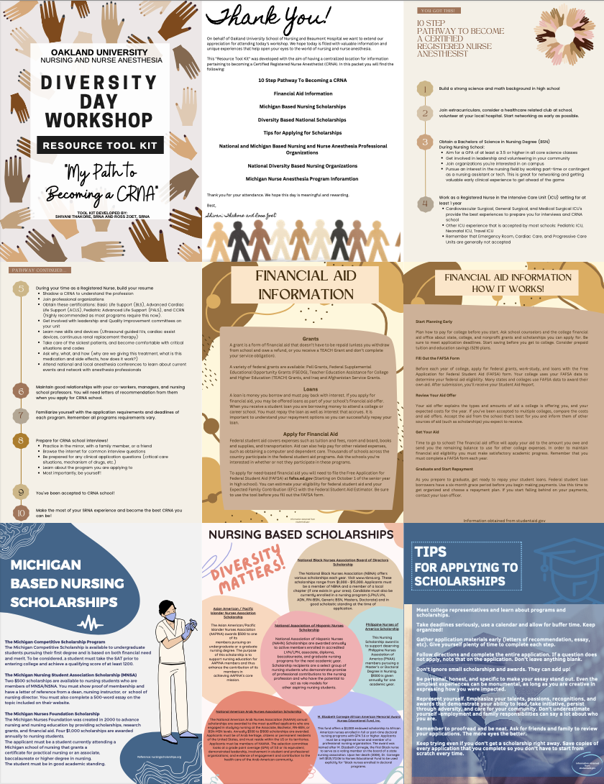

Appendix A

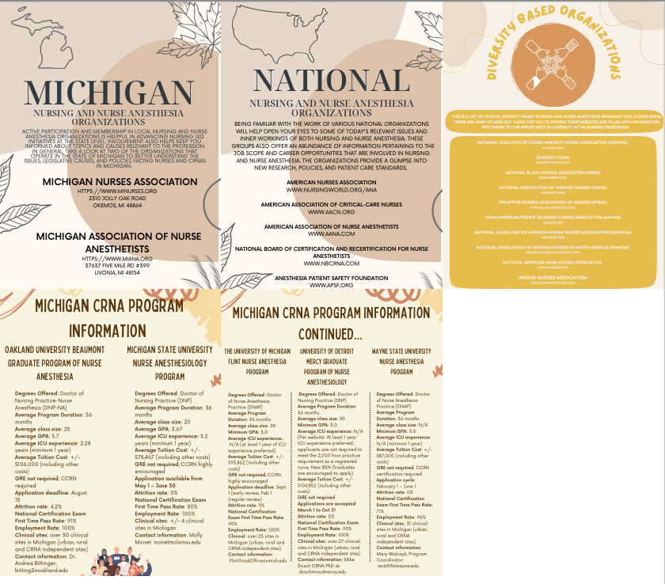

Appendix B

Appendix C

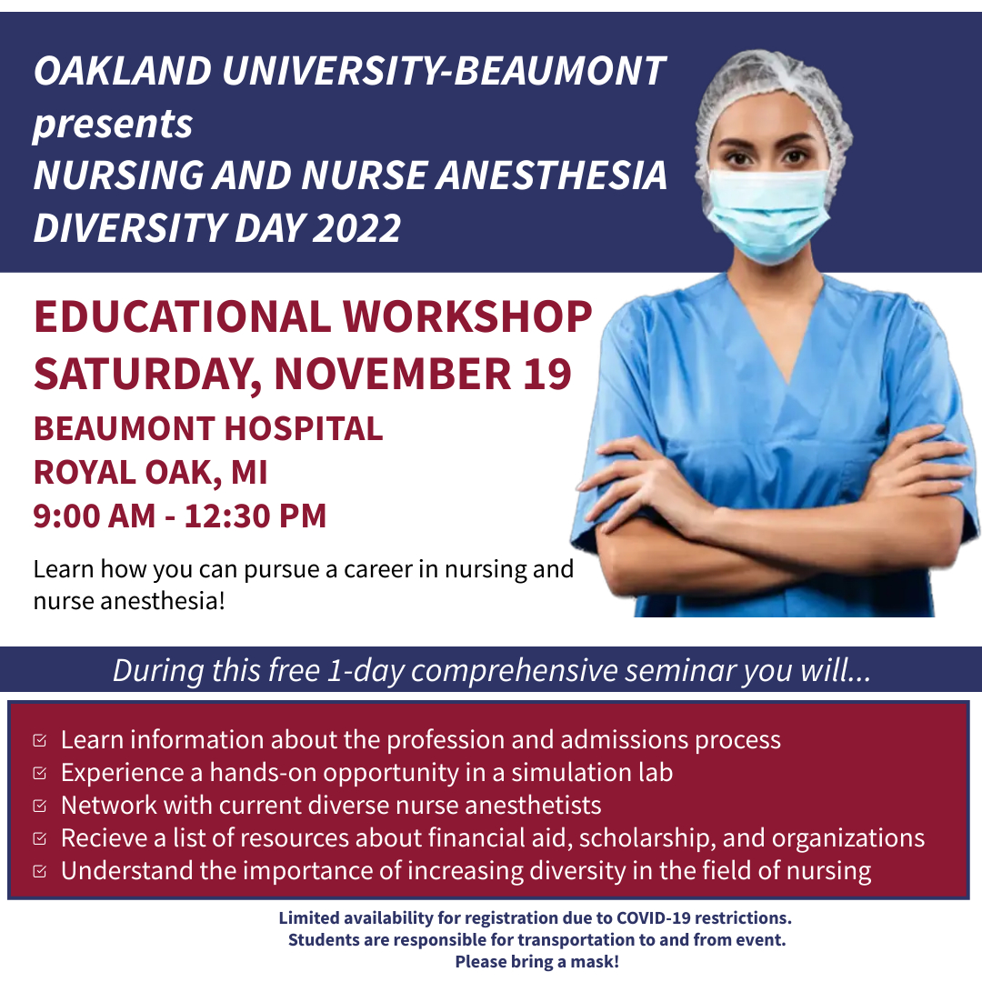

Appendix D

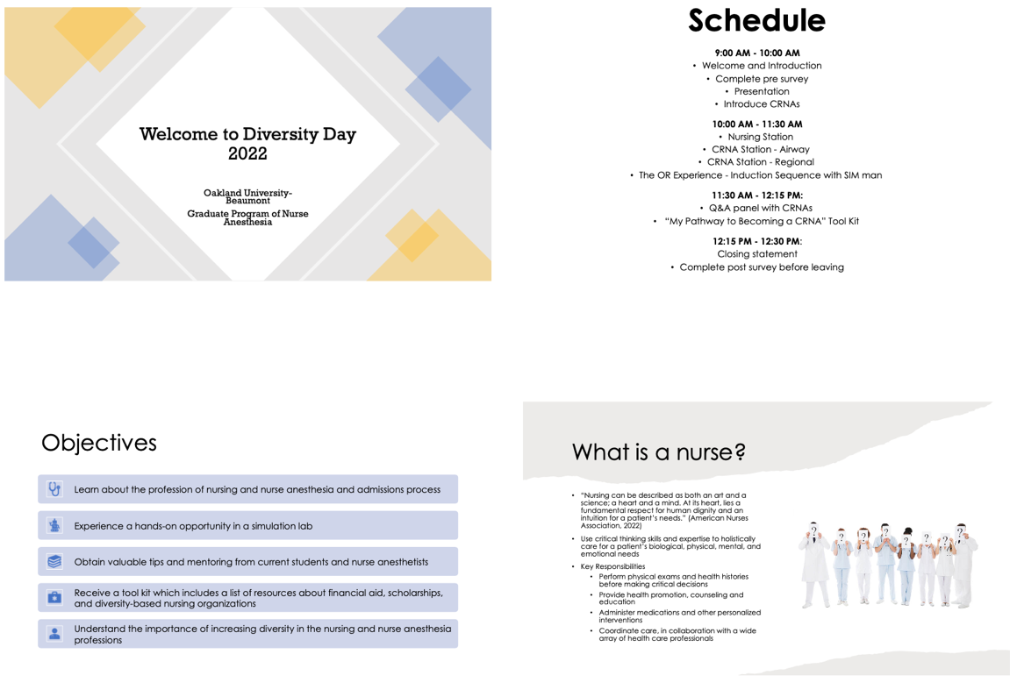
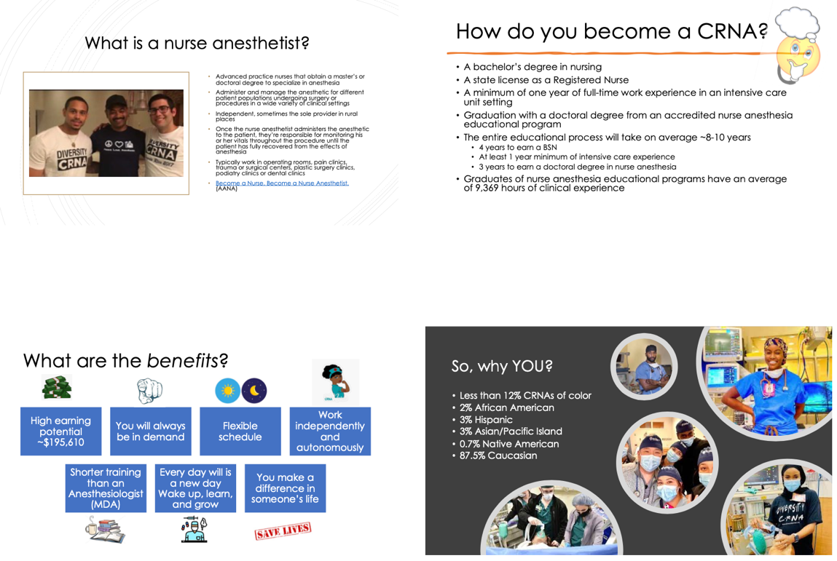
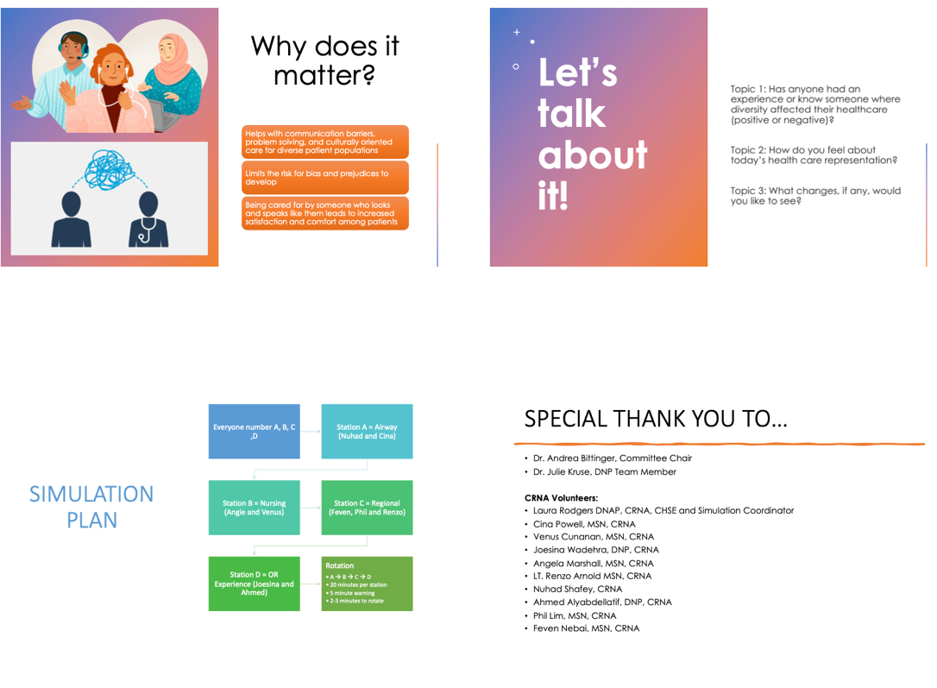
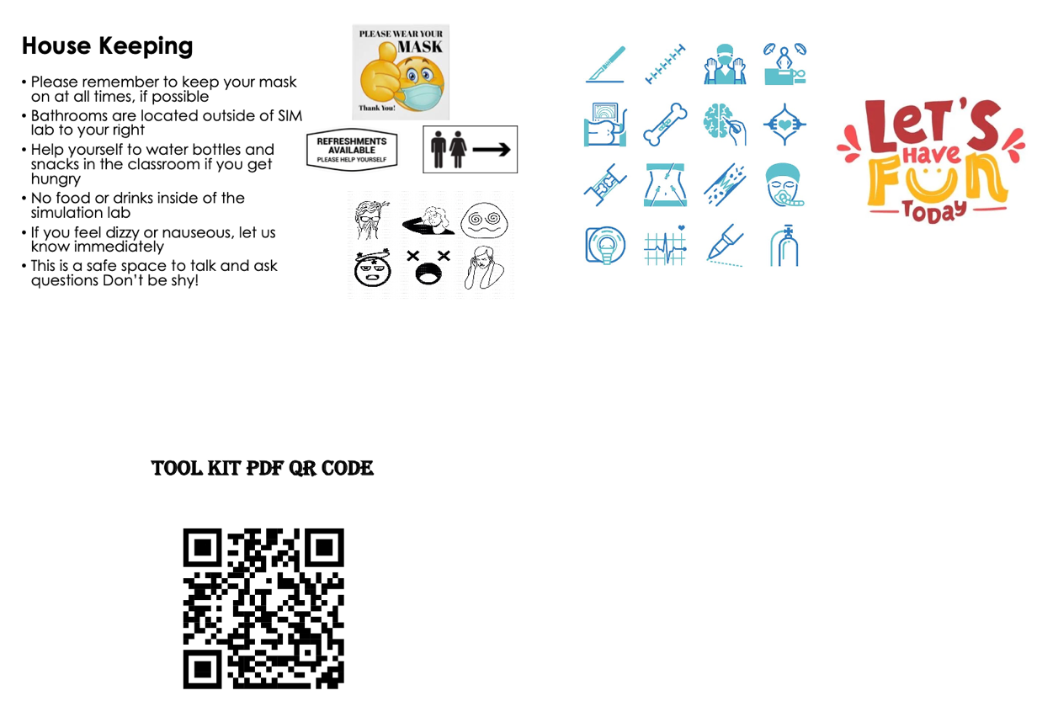

Appendix E

Diversity Workshop Pre-Survey Questionnaire

Age: _____

Grade (circle one): Freshman Sophomore Junior Senior

Identified Gender: M / F / Non-binary

Race/Ethnicity: _____________

Please rank the following questions on a scale of 1-5.
Circle your response to each question.

1 = Strongly disagree
2 = Disagree
3 = Somewhat agree
4 = Agree
5 = Strongly Agree

—-----------------------------------------------------------------------------------------------------------

- I am interested in a career in nursing.
1 = Strongly disagree
2 = Disagree
3 = Somewhat agree
4 = Agree
- = Strongly Agree

- I am interested in a career in nurse anesthesia.
1 = Strongly disagree
2 = Disagree
3 = Somewhat agree
4 = Agree
- = Strongly Agree

- I am aware of what a nurse does.
1 = Strongly disagree
2 = Disagree
3 = Somewhat agree
4 = Agree
- = Strongly Agree

- I am aware of what a nurse anesthetist does.
1 = Strongly disagree
2 = Disagree
- = Somewhat agree
4= Agree
5= Strongly Agree

- I am aware of the prerequisites of applying to a nurse anesthesia program.
1 = Strongly disagree
2 = Disagree
3 = Somewhat agree
4 = Agree
- = Strongly Agree

- I know how to access scholarships and financial resources available to me for college.
1 = Strongly disagree
2 = Disagree
3 = Somewhat agree
4 = Agree
- = Strongly Agree

- I am aware of diversity-based nursing organizations that can provide networking opportunities for me.
1 = Strongly disagree
2 = Disagree
3 = Somewhat agree
4 = Agree
- = Strongly Agree

- I know which five nurse anesthesia programs are based in Michigan.
1 = Strongly disagree
2 = Disagree
3 = Somewhat agree
4 = Agree
- = Strongly Agree

- I know someone who can be a mentor to me and provide guidance to achieve a career in nurse anesthesia.
1 = Strongly disagree
2 = Disagree
3 = Somewhat agree
4 = Agree
- = Strongly Agree

- I understand why increasing diversity is important in health care.
1 = Strongly disagree
2 = Disagree
3 = Somewhat agree
- = Agree
- = Strongly Agree

Diversity Workshop Post-Survey Questionnaire

Please rank the following questions on a scale of 1-5.
Circle your response to each question.

- I am interested in a career in nursing.
1 = Strongly disagree
2 = Disagree
3 = Somewhat agree
- = Agree
5= Strongly Agree

- I am interested in a career in nurse anesthesia.
1 = Strongly disagree
2 = Disagree
- = Somewhat agree
4= Agree
5= Strongly Agree

- I am aware of what a nurse does.
1 = Strongly disagree
2 = Disagree
3 = Somewhat agree
- = Agree
5= Strongly Agree

- I am aware of what a nurse anesthetist does.
1 = Strongly disagree
2 = Disagree
3 = Somewhat agree
4 = Agree
- = Strongly Agree

- I am aware of the prerequisites of applying to a nurse anesthesia program.
1 = Strongly disagree
2 = Disagree
- = Somewhat agree
4= Agree
5= Strongly Agree

- I know how to access scholarships and financial resources available to me for college.
1 = Strongly disagree
2 = Disagree
3 = Somewhat agree
- = Agree
5= Strongly Agree

- I am aware of diversity-based nursing organizations that can provide networking opportunities for me.
1 = Strongly disagree
2 = Disagree
- = Somewhat agree
4= Agree
5= Strongly Agree

- I know which five nurse anesthesia programs are based in Michigan.
1 = Strongly disagree
2 = Disagree
3 = Somewhat agree
- = Agree
5= Strongly Agree

- I know someone who can be a mentor to me and provide guidance to achieve a career in nurse anesthesia.
1 = Strongly disagree
2 = Disagree
3 = Somewhat agree
4 = Agree
- = Strongly Agree

- I understand why increasing diversity is important in health care.
1 = Strongly disagree
2 = Disagree
3 = Somewhat agree
4 = Agree
- = Strongly Agree

- The environment was conducive to my learning.
1 = Strongly disagree
2 = Disagree
3 = Somewhat agree
4 = Agree
- = Strongly Agree

- I would recommend this educational workshop to a friend.
1 = Strongly disagree
2 = Disagree
3 = Somewhat agree
4 = Agree
- = Strongly Agree

- What did you like or dislike about today’s educational workshop?

- List at least one suggestion for improvement regarding this workshop.

Appendix F

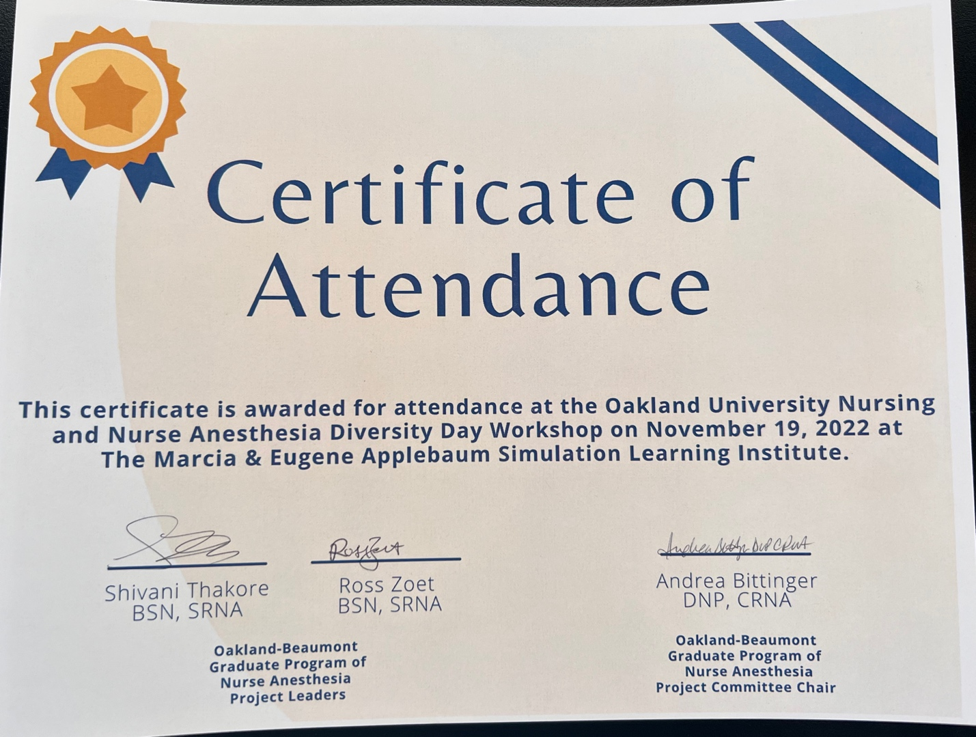

Appendix G

