LOCAL ANESTHETIC SYSTEMIC TOXICITY EDUCATION THROUGH A WEB-BASED MODULE

By

LEANNE VANGILDER, BSN, RN, SRNA AND SYDNEY MOSTYN, BSN, RN, SRNA

A research report submitted in partial fulfillment of the requirements for the degree of

DOCTOR OF NURSING PRACTICE

2023

Oakland University
Rochester, Michigan

______________________________________________
DNP Project Chair Date

_________________________________________________
DNP Project Team Member Date

Acknowledgements
We would like to express our deepest appreciation to our DNP Project Chair, Dr. Linda McDonald, DNAP, CRNA, for her guidance, valuable critique, and commitment to helping us create a successful DNP project. In addition, we would like to thank the faculty of Oakland University-Beaumont Graduate Program of Nurse Anesthesia for their continued support throughout the creation of this project. We would also like to give a special thank you to the Lumis Corporation Team Members Doug Nelson, Alexandra Gales, and Ryan Torbic for allowing us to utilize their InSight Platform and for their time and assistance in creating our web-based module. We would like to thank Oakland University’s Nursing Librarian, Mariela Hristova, for her assistance with our literature search. We would also like to extend our gratitude to the Michigan Association of Nurse Anesthetists and Certified Registered Nurse Anesthetists who completed our web-based module, including our pre- and post-module survey. Lastly, we would like to thank our families for their unwavering love and support. We could not have completed this journey without them.

Abstract
Local anesthetic systemic toxicity (LAST) is a rare, but life-threatening event resulting from an inadvertent vascular injection or absorption of a toxic dose of a local anesthetic that can lead to respiratory arrest and cardiovascular collapse. A wide variation of published LAST incidences exist related to underreporting and misdiagnosing of LAST signs and symptoms by hospital staff. This may indicate decreased awareness of LAST among healthcare providers. As a result of the continued occurrence of LAST, education is needed to prepare staff to recognize and treat LAST. This educational project aimed to provide Certified Registered Nurse Anesthetists (CRNAs) of Michigan that attended the Michigan Association of Nurse Anesthetists (MANA) Fall Conference with an improved understanding of LAST using a web-based educational module. The module contained education on the identification of signs, symptoms, and treatment of LAST, including modifications to the ACLS algorithm during the treatment of a LAST-related cardiac arrest. The results of this project indicated that a web-based educational module is an effective tool for educating CRNAs on LAST management. A statistically significant increase was found from pre-module survey scores to post-module survey scores in CRNAs’ self-efficacy in treating a LAST event (z=-4.21, p<.05). There was also a statistically significant increase from pre-module survey scores to post-module survey scores in CRNAs’ knowledge in LAST management (z =-4.2, p <.001).
Keywords: local anesthetic systemic toxicity, web-based education, local anesthetics

Table of Contents
Background and Significance 5
Literature Review 6 Problem Statement 18
Conceptual Framework 18
Methods 20
Design and Implementation Plan 20
Key Personnel 21
Data Collection 21 Risks and Benefits 21
Timeline 22
Results 22 Discussion 24 Barriers/Limitations 25
Implications for Practice 27 Contribution in Achieving DNP Essentials 27 References 29 Appendix A LAST Web-Based Educational Module 35
Appendix B Pre-survey/Post-survey 36 Appendix C IRB Approval Letter 39 Appendix D Participant Consent Form 40
Local Anesthetic Systemic Toxicity Education Through a Web-Based Module
Background and Significance
Local anesthetic systemic toxicity (LAST) is a rare, but life-threatening event associated with local anesthetic techniques. The most common cause of LAST is an inadvertent vascular injection or absorption of a toxic dose of local anesthetic from peripheral nerve blocks. The resultant high systemic blood levels of the local anesthetic cause LAST (Nagelhout & Elisha, 2018). Local anesthesia is commonly used as a part of a multi-modal analgesic approach. It can be administered intravenously in the case of the ERAS protocol, peripherally for skin infiltration, topically to anesthetize the airway, and intraneurally for regional and neuraxial anesthetics (Bevil et al., 2020). LAST initially presents with signs of CNS excitation, such as sensory and visual disturbances, tingling, muscle twitching, and seizures. Increased plasma concentrations of local anesthetics cause excitatory neurons to become blocked, leading to CNS depression, unconsciousness, coma, and respiratory arrest. The decreased rate of depolarization in cardiac myocytes causes myocardial depression. The myocardial effects initially begin as hypertension and tachycardia and can progress to hypotension, conduction block, bradycardia, ventricular arrhythmias, or asystole. LAST can rapidly culminate in respiratory arrest and lead to cardiovascular collapse if not treated appropriately (Boghdadly & Chin, 2016).
LAST occurs in up to 1.8 per 1,000 peripheral nerve blocks and may go unrecognized and underreported (Edwards et al., 2018). A wide variation of published incidences of LAST exists related to underreporting and misdiagnosis of LAST signs and symptoms by hospital staff. Newer neuraxial techniques that utilize high volumes of local anesthetics such as transversus abdominis plane (TAP) blocks and local infiltrative analgesia contribute to the incidence of LAST and ongoing clinical concern. The American Society of Regional Anesthesia and Pain Medicine (ASRA) recommends using intravenous 20% lipid emulsion as the first-line pharmacotherapy for LAST. It has been reported that only half of the cases of LAST receive lipid emulsion therapy (Macfarlane et al., 2021). This may indicate decreased awareness of LAST among healthcare providers. As a result of the continued occurrence of LAST, education is needed to prepare staff to recognize and treat LAST. An education and knowledge gap may exist among anesthesia providers on the signs, symptoms, and treatment for LAST.
The increased use of regional anesthesia and local anesthetics for perioperative pain management requires Certified Registered Nurse Anesthetists (CRNAs) to have increased awareness of recognizing and treating LAST. This educational project aimed to provide CRNAs of Michigan that attended the Michigan Association of Nurse Anesthetists (MANA) fall conference with an improved understanding of LAST using a web-based educational module. The module contained education on identifying the signs, symptoms, and treatment of LAST, including modifications to the ACLS algorithm during the treatment of a LAST-related cardiac arrest. Increasing CRNAs' knowledge of the presentation of LAST will assist in identifying and promptly treating a LAST event, decreasing adverse clinical outcomes.
Literature Review
A comprehensive literature search to identify current information on LAST treatment guidelines, and education techniques was conducted using the Cumulative Index of Nursing and Allied Health (CINAHL), PubMed, and Scopus databases. The articles were searched using search terms related to the research question and inclusion criteria. The specific search terms included were “local anesthetics”, “drug toxicity” and “education”. Keyword searches included (local anesthetics) AND (drug toxicity) AND (simulation or education). The search inclusion criteria were journal articles published from 2017 to 2021 written in English, examining LAST signs, symptoms, management, and treatment. Healthcare provider knowledge of LAST and implementation of education sessions and high-fidelity simulation to enhance learning about LAST were also examined in the literature search. Articles were excluded if published more than 5 years ago, published in a language other than English, or did not focus on LAST education or treatment guidelines. The excluded articles focused on patient education, pain management, pharmacology of local anesthetics, or peripheral nerve block administration and techniques.
The search yielded 13 potential articles from PubMed, 17 from CINAHL, and 36 from Scopus. After analyzing the articles for inclusion and exclusion criteria and removing duplicate articles, 13 articles were included in the literature review. The literature chosen includes current LAST treatment guidelines supported by high-quality systematic reviews and studies implementing LAST education sessions or simulations. Quality improvement projects with non-experimental designs that implemented education sessions were found in the literature and demonstrated knowledge and self-efficacy improvement in LAST management. Limited studies were found that focus solely on CRNA knowledge of LAST.
A separate search was conducted to examine the effectiveness of web-based educational modules in healthcare education using CINAHL, PubMed, and Scopus databases. Search terms included were “web-based”, “learning module”, “educational module”, and “training module.” Keyword searches included (web-based) AND (“learning module” OR “educational module” OR “training module”). The search inclusion criteria were journal articles published from 2017 to 2021 written in English, examining the effectiveness of web-based educational modules on healthcare education. Articles were excluded if they were published more than 5 years ago, published in a language other than English, focused on patient education, included “hybrid courses”, did not include healthcare education, or focused on video content only and not interactive modules.
The search yielded 29 articles from CINAHL, 56 from Pubmed, and 23 from Scopus. After analyzing the articles for inclusion and exclusion criteria and removing duplicates, 17 were included in this literature review. The literature search includes articles focusing on web-based education for healthcare providers, including medical students, paramedic students, physicians, physician assistants, and nurses. Multiple studies aimed to increase knowledge, attitude, and confidence in the learning content after implementing a web-based educational module. One article involves a web-based program designed to educate perioperative nurses on LAST.
Current LAST Guidelines
The American Society of Regional Anesthesia and Pain Medicine (ASRA) describes the current guidelines for the management of LAST. Their best practice advisory and cognitive aids, such as the LAST checklist and LAST smartphone application, are revised periodically in response to user feedback, simulation studies, and advances in medical knowledge (Neil et al., 2021).
The ASRA’s checklist recommends using intravenous 20% lipid emulsion therapy at the first sign of local anesthetic toxicity. If the individual weighs greater than 70 kilograms, a bolus dose of 100 milliliters over two to three minutes should be followed by 250 milliliters over 15 to 20 minutes. If the individual weighs less than 70 kilograms, a bolus dose of 1.5 ml/kg over two to three minutes should be followed by 0.25 ml/kg/min. An intravenous fluid pump should be utilized if the individual weighs less than 40 kg. In either weight category, if the patient remains unstable, the bolus should be repeated, and the infusion should be doubled (Neil et al., 2021). These guidelines regarding intravenous 20% lipid emulsion therapy are supported by current literature and are recognized by the American Heart Association (AHA) and the American College of Medical Toxicology (ACMT).
The ASRA recommends that 20% lipid emulsion therapy be immediately available in all institutions where potentially toxic doses of local anesthetics are utilized. Nedialkov et al. (2018) discuss a survey given to all obstetric anesthesia directors in the United States to assess the availability of lipid emulsion therapy in obstetric units, where local anesthetics are frequently utilized, and found that 88% of the obstetric units had lipid emulsion therapy readily available on the unit, with the remainder claiming to have it elsewhere in the hospital. The availability of lipid emulsion therapy was estimated to be less than 10 minutes in 70 hospitals, 10 to 30 minutes in two hospitals, and less than 30 minutes in 95% of hospitals surveyed. Hospitals that do not have 20% lipid emulsion therapy readily available must change their storage practices in preparation for a LAST event.
The LAST checklist by the ASRA describes how to further treat the individual depending on their presentation. If seizure activity is observed, an adequate airway must be ensured, and benzodiazepines should be used to treat the seizure. If benzodiazepines are unavailable, increments of low-dose propofol (20 mg) should be administered. LAST resuscitation differs from standard advanced cardiac life support in the case of arrhythmia or hypotension. Smaller than normal doses of epinephrine are preferred. The ASRA recommends starting epinephrine at less than or equal to 1 mcg/kg. Local anesthetics, beta-blockers, calcium channel blockers, and vasopressin should be avoided (Neil et al., 2021).
Once the individual is hemodynamically stable, the LAST checklist states to continue the intravenous 20% lipid emulsion for 15 minutes or longer. The maximum lipid emulsion dose is 12 ml/kg. The individual should be observed for two hours after a seizure and four to six hours after cardiovascular instability. If the individual experiences cardiac arrest, they should be observed for as long as deemed appropriate per the medical team (Neil et al., 2021).
The systematic review by Waldinger et al. (2020) describes patient-specific risk factors for developing LAST. The article states that the geriatric population is often at an increased risk for LAST due to the presence of cardiac, liver, or kidney disease and the presence of decreased muscle mass. In cardiac disease, a poorly functioning ventricle is vulnerable to contractile depression by local anesthetic toxicity and contributes to decreased drug distribution. Additionally, slow circulation times found in cardiac disease can increase the risk of stacking local anesthetic injections, due to the longer time needed to cause recognizable hemodynamic change. This will increase local anesthetic plasma and tissue concentrations, which can lead to toxicity. The metabolism and excretion time for local anesthetics will be prolonged in liver and kidney disease. In advanced liver disease, hypoalbuminemia and plasma cholinesterase deficiency increase the unbound, active fraction of local anesthetic (Waldinger et al., 2020). The anesthesia provider should be aware of these patient-specific risk factors when administering local anesthetic to decrease the risk of LAST.
Studies Focusing on LAST Awareness
The literature utilized questionnaires to examine healthcare providers' awareness of LAST to determine if an educational gap exists. Multiple studies found that participants had no formal training and inadequate knowledge of LAST, including LAST treatment (Bowsher et al., 2018; GCiler et al., 2020; Ilhan & Demir, 2020; Nedialkov et al., 2018; Urfalıoğlu et al., 2017). Bowsher et al. (2018) conducted a pilot study using an anonymous questionnaire to evaluate LAST awareness among multidisciplinary staff at a district general hospital maternity unit. The questionnaire focused on LAST recognition, local anesthetic safe maximum doses, management of LAST, and the use of lipid emulsion for treatment. The study identified poor LAST awareness across all disciplines (below 25% of correct responses were answered). Only 57% of the responses regarding the safe maximum dose of lidocaine were correct, and 4% of the responses for the safe maximum dose of lidocaine with epinephrine were correct. Only 22% of the respondents were able to identify three actions that must be taken in the immediate management of LAST. Finally, 30% of respondents correctly answered lipid emulsion therapy as the treatment for LAST, and one participant knew the location of the lipid emulsion in the maternity unit. The study identified an educational need for interdisciplinary LAST education. This study was limited by a small sample size and short data collection period. A survey by Nedialkov et al. (2018) found poor awareness of LAST management among 36 academic anesthesiology departments in China. Of the 36 institutions, 61% were aware that intravenous lipid emulsion was a treatment of LAST, 36% had heard about the treatment but were unaware of how to administer it, 53% recognized the ASRA 2010 guidelines, and 6% were aware of the ACMT guidelines.
The data from these studies support the need for ongoing education of anesthesia personnel, including CRNAs, regarding the recognition, management, and treatment of LAST, including safe maximum doses. This education is paramount to patient safety when local anesthetics are used.
Studies Implementing LAST Education Sessions or Simulations
There are many ways to teach healthcare providers about the recognition, management, and treatment of LAST. Lectures, simulations, and web-based modules have been studied. Ferguson et al. (2018) conducted an evidence-based project utilizing a traditional lecture format to educate perioperative, outpatient, and labor and delivery nurses about recognizing and treating LAST. Participants’ ability to recognize and treat LAST was measured using a pre-test, education, and post-test model. This study also assessed the participants’ confidence in their recognition and treatment of LAST after an educational session. A statistically significant (P < 0.0001) increase in post-test scores was found after the 30-minute educational session. In the post-test, Ferguson et al. (2018) included an assessment of comfort level with treating a LAST event and the same questions used in the pretest. The comfort level scores increased as well as the scores from the pretest, demonstrating that the increased knowledge acquisition from the educational session led to increased comfort in treating LAST. A major limitation of the study was that the researchers did not evaluate long-term knowledge retention of LAST.
The literature has demonstrated simulation to be an effective tool in teaching LAST recognition, management, and treatment. Two studies reviewed present a LAST simulation to perioperative staff and anesthesia providers to assess their ability to recognize LAST signs and symptoms, appropriately manage LAST, and evaluate their confidence in treating LAST (Bevil et al., 2020; Mogler et al., 2020). Participants in both studies were given a pretest to assess knowledge, followed by a simulation session with a formal debrief and a post-test to evaluate knowledge acquisition and confidence levels. Bevil et al. (2020) also included a one- and three-month post-test and a survey given with the three-month post-test to assess for confidence and a review of the simulation experience. Bevil et al. (2020) noted an average pretest score of 52% and found statistically significant improved test scores on the immediate post, one-month, and three-month assessments to 90%, 81%, and 77%, respectively. Participants' self-efficacy levels in managing a LAST crisis improved, demonstrated through a statistically significant increase in confidence scores. Mogler et al. (2020) also found increased confidence scores (7.5 pre-simulation and 9.0 post-simulation and debrief on a 1-10 Likert scale). Bevil et al. (2020) found significant knowledge retention reflected on the one-month and three-month post-tests. Long-term retention was not measured in the lecture-based educational session (Ferguson et al., 2018); therefore, comparisons cannot be made between the two types of educational models. Limitations to these studies include the lack of randomization, control groups, and small sample sizes. However, these studies demonstrate a significant increase in knowledge retention and confidence levels among perioperative staff after educational sessions about LAST.
Studies that Support the use of Web-based Educational Modules in Healthcare
Evidence has shown that web-based educational materials are effective for healthcare education. The literature consists of experimental and nonexperimental designs, including randomized control trials, quasi-experimental studies, qualitative studies, and pilot studies. The effects of web-based learning on various professional competencies, knowledge, attitudes, and skills of healthcare workers were examined. Two randomized-controlled trials were reviewed that compared e-learning using web-based educational modules to a traditional method of learning (Suppan et al. 2021; Suppan et al., 2020). These studies utilized an experimental design through a randomized control trial allowing researchers to control variables and more effectively determine a cause-and-effect relationship. Suppan et al. (2021) completed a study to determine whether an e-learning module compared to a traditional didactic video could improve senior medical students' asynchronous distance learning of the National Institutes of Health Stroke Scale. The authors found that those who completed the e-learning module performed better on the quiz than those who watched the video, with 38 correct answers versus 35 (P <.001). The authors conclude that a highly interactive e-learning module enhances asynchronous learning. The randomized-control trials that compared e-learning using web-based educational modules to a traditional method of learning had similar limitations (Suppan et al. 2021; Suppan et al., 2020). The studies are limited by small sample sizes and the inability to determine if there are sustained results over time. Further studies will be necessary to determine if the web-based modules contributed to increased knowledge retention.
Studies with a quasi-experimental design using pre-intervention and post-intervention surveys to determine the effectiveness of web-based education modules for healthcare workers were included in the literature (Ahmed et al., 2019; Avery et al., 2018; Hallas et al., 2021; Jackson et al., 2019; Kelahan et al., 2020; Lean et al., 2018; Lepper et al., 2019; Mascarenhas et al., 2019; Zeltzer et al., 2021). Studies completed by Lepper et al. (2019) and Ahmed et al. (2021) utilized a web-based training module to increase the knowledge, attitudes, and confidence of physician assistant students and primary care physicians in screening tools such as patient alcohol screening and preventative cancer screening. The students' attitude, knowledge, and skills were measured using pre-intervention questionnaires and post-intervention questionnaires. The results of both studies indicated a significant (P< 0.01) improvement over time in the participants' knowledge and skills in conducting an alcohol screening assessment and cancer screening tool (Lepper et al., 2019; Ahmed et al., 2021).
Similar studies conducted by Kelahan et al. (2020) and Mascarenhas et al. (2019) used online educational modules to enhance radiology resident training. Kelahan et al. (2020) utilized the module to educate residents on high morbidity cases and Mascarenhas et al. (2019) educated residents in computer tomography (CT) facial bone scanning. The studies aimed to measure the effectiveness of the online module through pre and post-test scores and confidence intervals. In both studies, all modules had a statistically significant increase in pre-test to post-test scores (p<0.001) (Kelahan et al., 2020; Mascarenhas et al., 2019). The residents reported increased confidence in identifying the radiology findings (p<.001) and increased comfort in identifying facial bone scans (p<.001) (Kelahan et al., 2020; Mascarenhas et al., 2019). An advantage of the online modules acknowledged by the researchers was the flexibility and ability to update the module with new information. The module can also be used as a “flipped classroom” technique where students can complete the interactive module and attend in person class after for discussion. A limitation to the online modules was the time it takes to prepare for users who are not familiar with the software (Kelahan et al., 2020).
The quasi-experimental studies were limited to low survey response rates and an unreliable measure of self-reporting in the survey. The quasi-experimental design of the studies did not allow for the randomization of variables, making it challenging to determine a definitive cause-and-effect relationship between the web-based modules and the healthcare providers' knowledge, attitudes, and self-confidence (Ahmed et al., 2019; Avery et al., 2018; Hallas et al., 2021; Jackson et al., 2019; Kelahan et al., 2020; Lean et al., 2018; Lepper et al., 2019; Mascarenhas et al., 2019; Zeltzer et al., 2021).
Qualitative questions included in studies are useful to provide written feedback by participants about the effectiveness of web-based learning modules. Jackson et al. (2019) conducted a study to examine the effectiveness of a web-based, interactive module that taught medical students to deliver a diagnosis of Down syndrome to parents. A major theme identified in the student responses was that the module helped them enhance their communication skills, empathy towards patients, and warmth. Reasons for interest in web-based learning determined by a study conducted by Lean et al. (2018) were more interesting content, flexible learning time, convenience, and easy accessibility. The students enjoyed revisiting information they did not understand through the learning module. A negative aspect of online learning described by the researchers is learner isolation and the inability to ask live questions to an instructor (Lean et al., 2018).
The benefits to web-based learning identified in the literature were increased flexibility, convenience, and accessibility to learners (Kalaitzoglou et al., 2020). Overall, studies noted that web-based learning was a cost-effective method of educating healthcare providers and assisted them in meeting required learning objectives (Buhl et al., 2021; Hawa et al., 2017; Lean et al., 2018). Web-based education allows real-world scenarios to be presented to the learner in an interactive and interesting way. Disadvantages of web-based simulation identified in the literature were increased expenses and time to build the module, technical issues, online security issues, and lack of accessibility to the internet (Hansen et al., 2020; Jackson et al., 2019).
Study focusing on a LAST Web-based Educational Module
Ferry et al. (2020) developed a self-paced web-based learning module for clinical nurses to improve their knowledge of LAST. The researchers developed and implemented web-based educational modules focusing on identifying the signs, symptoms, and treatment of LAST. The session was designed using the Knowles adult learning theory and the logic model as a framework. The web session included four interactive modules that dealt with patient experiences where death occurred because of LAST. The post-education survey was taken by participants after completing the web-based education and repeated six months later. The pre-education survey was completed by 2,185 clinical nurses, with 1,582 (72%) participating in the education module. A total of 369 participants (23%) completed the post-education survey (Ferry et al., 2020). The results showed a statistically significant improvement in the post-education survey, with 87% of nurses demonstrating knowledge of LAST, 76% correctly identifying signs and symptoms, and 75% knowing how to treat LAST. The six-month survey was completed by 40% of participants, and a mean of 74% correctly identified the signs, symptoms, and treatment for LAST (Ferry et al., 2020). The 6-month re-evaluation had only a slightdecrease in scores compared to the immediate post-survey, demonstrating knowledge retention of the participants. A challenge the researchers faced was a variation in sample size between the pre-, post-, and six-month evaluation surveys. A limitation of the study was that the researchers did not denote the results as significant or nonsignificant. The authors recommend annual web-based educational modules to review knowledge on LAST.
Conclusions Drawn from Analysis of the Literature
In summary, LAST is a life-threatening adverse event associated with the increasingly prevalent utilization of local anesthetic techniques. LAST guidelines are provided by the ASRA, updated regularly, and supported by high-quality literature reviews. The LAST checklist provided by the ASRA describes the appropriate management for an acute LAST event. The literature search provided quality improvement projects, randomized-controlled trials, quasi-experimental studies, and qualitative research designs which implemented education sessions, simulations, and web-based educational modules to increase LAST knowledge among healthcare providers. Multiple questionnaire-based studies identified a lack of knowledge and awareness of LAST among healthcare providers but few focused solely on anesthesia providers. Multiple studies in the literature support the use of web-based educational modules for healthcare education. The literature identifies a knowledge gap among healthcare providers in identifying the signs, symptoms, and treatment for LAST. Gaps identified in the literature were limited studies focusing on CRNA’s knowledge of LAST and limited studies using web-based educational modules as a technique for LAST education. Studies included small sample sizes, making it difficult to generalize the results.
Problem Statement
This educational project aimed to educate a sample of CRNAs in Michigan about the pathophysiology, recognition, and treatment of LAST through a web-based educational module. The overarching question this project aimed to answer is: Do CRNAs achieve an improved understanding and increased self-efficacy in the recognition of the signs, symptoms, and treatment of LAST, including modifications to the ACLS algorithm during a LAST-related cardiac arrest after completing a web-based educational module – as evidenced by improved post-survey scores? The primary objective of this project is to determine if completing a web-based educational module will increase knowledge retention and self-efficacy in treating LAST within CRNAs. The secondary objective of this project is to provide a web-based educational module on LAST for anesthesia providers to utilize for future education.
Conceptual Framework
Mezirow’s Transformative Learning Theory (TLT) (1997) guided this project's conceptual framework. Oh et al. (2021) describe TLT as the process of finding meaning from experience through critical self-reflection that results in transformation or change in an individual’s perspective. The theory focuses on how adult learners change their worldview based on new learning objectives. TLT proposes that adult learners use past life experiences to find new meaning in current experiences, enhancing learning and self-understanding (Briese et al., 2020). The ten phases of Mezirow’s TLT apply to web-based learning in healthcare and describe how adult learners gain new information and insight on high-risk, low-frequency topics such as LAST.
The first phase of TLT is described by Briese et al. (2020) as “a disorienting dilemma” where learners experience a problem that must be solved. The learner discovers their previous beliefs may be inaccurate and considers new information given as relevant to their learning. CRNAs may have a “disorienting dilemma” when completing a pre-module survey on LAST and discovering knowledge gaps in recognition, treatment, and self-efficacy in LAST management. During the second and third phases, “a self-examination” and “critical assessment of assumptions” take place as the learner examines their beliefs and understanding of the topic and review their past assumptions with a new perspective. CRNAs can reflect on previous clinical experiences with LAST management or a patient with LAST-related symptoms. Phase four allows learners to acknowledge their knowledge gap on the subject (Briese et al., 2020). Phase five allows learners to improve their performance through new actions which are demonstrated in the post-module survey and future practice. Phase six and seven allows learners to “plan a new course of action” for the next experience after gaining new skills on the topic. Phase eight, “provisional trying of new roles,” allows learners to apply their knowledge to their professional role. Phase nine explains that learners will have newfound self-confidence and competence. Finally, phase ten states that the learner's habits and points of view after the experience are transformed and can be reintegrated and applied to future experiences (Briese et al., 2020).
Web-based education in healthcare applies to the ten phases of TLT. During web-based educational experiences, healthcare providers are presented with high-risk, low-fidelity scenarios such as LAST. A pre-module survey allows the provider to reflect on current knowledge and knowledge gaps on LAST. The web-based module allows providers to learn new information and apply critical thinking skills in a safe environment. Finally, the post-module survey assesses the providers’ new knowledge, self-confidence, and competence in LAST management. Web-based education in healthcare, guided by Mezirow’s TLT, prepares the learner for future high-risk, low-frequency scenarios such as LAST in clinical practice.
Methods
Design and Project Implementation Plan
This educational research project aimed to educate a sample of CRNAs in Michigan about the pathophysiology, recognition, and treatment of LAST. A web-based educational module using the Lumis InSight Platform, was presented to CRNAs at the Michigan Association of Nurse Anesthetists (MANA) Fall Conference in 2022. The authors developed the module in conjunction with the expertise of the DNP project chair and the Lumis Corporation team. The project was implemented after the International Review Board (IRB) approval at Oakland University. Resources utilized during the completion of the project were the Lumis Corporation InSight Platform, the Lumis Corporation team for technology support, laptop computers, and headphones supplied by Oakland University.
CRNA MANA members registered for the LAST educational session at the time of registration for the MANA Fall Conference; SRNAs did not participate in this educational research project. There were four one-hour LAST educational sessions with ten open seats for CRNAs in each session to participate. Each CRNA was provided a consent form explaining the objectives of the project.
CRNA members who participated in the session took a pre-module survey embedded in the educational module. The survey assessed the participants’ ability to identify LAST's signs, symptoms, and treatment, including modifications to the ACLS algorithm during a LAST-related cardiac arrest (Appendix B). Additionally, the pre-module survey assessed the participants' attitudes and self-efficacy in LAST management by utilizing three Likert-style questions. The participants then took part in an online module where a patient was experiencing LAST (Appendix A). The module incorporated interactive learning by providing a dynamic patient monitor and displaying the physiologic changes during LAST. Throughout the module, the user was presented with quiz questions corresponding to the learning objectives. Feedback was given after each question, and education was provided on LAST management to enhance learning.
Key Personnel/Primary Stakeholders
The key personnel for this project included Sydney Mostyn, BSN, RN, SRNA Co-Investigator; Leanne VanGilder, BSN, RN, SRNA Co-Investigator; Linda McDonald DNAP, CRNA DNP Project Chair; and the Lumis Corporation team. Primary stakeholders for this project included CRNA MANA members, future CRNA educators and CRNAs involved in web-based simulation learning, and future patients receiving local anesthetics.
Data Collection
Lumis utilizes industry standards for the protection of user data within the InSight Platform. Data is encrypted in transit using SSL/TLS and at rest using the AES-256 encryption algorithm. Administrative roles limit access to the data, and two-factor authentication was utilized to confirm role and identity when accessing the data. All data were analyzed by the project team using the latest version of IBM SPSS licensed by Oakland University during the data collection process. Participants’ knowledge and understanding of the learning objectives were analyzed through pre- and post-module survey scores. Participants' attitudes and self-efficacy in LAST management were measured through Likert-style questions. Finally, the participants' engagement was measured by assessing the correlation between the total time to completion of the module and post-survey attitudes scores.
Risks and Benefits
There were no risks to the participants in the study. The participants' confidentiality was maintained by providing them with a unique username and password not associated with their name. Two-factor authentication was used to provide further confidentiality when analyzing the data. There were no identifiable ethical issues. The benefits to CRNAs participating in this study were improved knowledge and self-efficacy in LAST identification and management for their practice. Additionally, participants could receive one CPC Class B credit after completion of the module.
Timeline
This DNP project was originally approved by Oakland University Beaumont Graduate Program of Nurse Anesthesia faculty in July 2021. Between January 2022 and August 2022, the researchers repeatedly met with the Lumis Corporation team to design, modify, and edit the educational module. A participant recruitment email was sent to MANA members in September 2022 before the MANA conference, including information on the educational session and pre-registration process. On October 1st, 2022 the project was implemented at the MANA Fall Conference in Traverse City, Michigan.
Results
A total of 23 participants completed the web-based educational module on LAST. The responses to the pre and post-module survey, which included nine multiple-choice, knowledge-based questions and three Likert-style attitude questions were analyzed using a two-tailed Wilcoxon signed-rank test. The Wilcoxon signed-rank test is a nonparametric test utilized to measure within-subject differences between the pre and post-attitude Likert-style and multiple-choice questions. A reliability test of the Likert-style questions was conducted using Cronbach’s alpha. The pre-module survey attitudes measure was 𝛼= 0.59 based on the three questions. The post-module survey attitudes showed acceptable test reliability 𝛼= 0.77, suggesting that the items had adequate internal consistency.
To analyze the Likert-style attitude measures, a composite score was created by taking the mean of the combined three items in the pre-module survey (x̄ = 4.33, SD = .56) and post-module survey (x̄ = 5.00, SD = .41). Overall, after participating in the web-based educational module, the CRNAs’ attitudes towards LAST management improved (Mdn =5.00) compared to before participation (Mdn = 3.00). The Wilcoxon signed-rank test indicated a statistically significant change between the pre-module survey and post-module survey attitudes assessment, z=-4.21, p<.05.
The same method was used to analyze the nine multiple-choice questions in the pre-module and post-module surveys. The mean of the pre-module survey questions (x̄ = 37.7, SD= 16.68) was compared to the mean of the post-module survey questions (x̄ = 92.3, SD= 7.8). After participation in the web-based module, the CRNAs pre-module survey scores improved (Mdn = 33.3) compared to the post-module survey scores (Mdn = 88.9). The Wilcoxon signed-rank test indicated a statistically significant change between the pre-module survey and post-module survey knowledge-based questions, z =-4.2, p <.001. Lastly, a bivariate correlation was used to determine if participants' time completing the module was related to their attitudes to measure engagement. The time spent completing the module and the post-module survey attitudes scores were not significantly related, r(22) = .11, p = .61. Overall, statistical analysis showed improvement in the CRNAs’ knowledge and attitudes towards LAST management after participation in the web-based educational module.

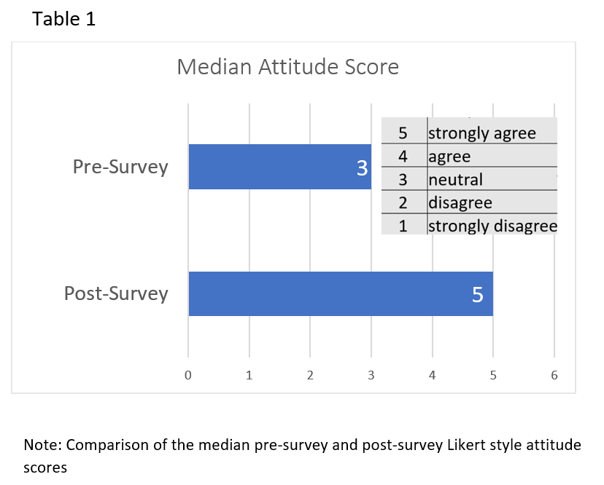
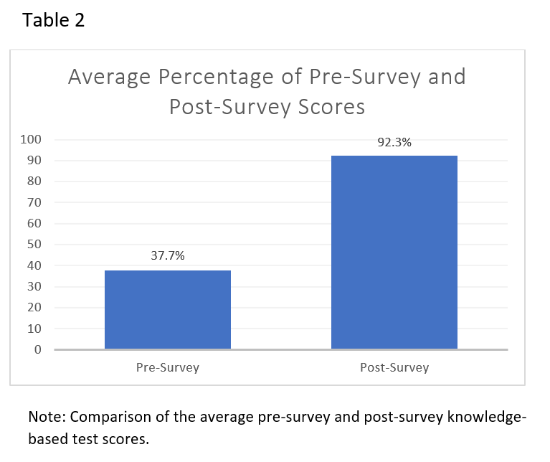
Discussion
The project’s primary objective was to educate CRNAs about the pathophysiology, recognition, and treatment of LAST through a web-based educational module. The module included pre-education material followed by an interactive patient scenario in which the patient was experiencing LAST. The participants completed a pre-module survey which included three Likert-style questions to assess their attitudes and self-efficacy in LAST management followed by nine knowledge-based questions on LAST. After the educational module, the participants completed an identical post-module survey.
LAST is a rare event that is not frequently encountered in daily practice. The low pre-module survey test scores (x̄ = 37.7, SD= 16.68) indicated that CRNAs could benefit from a review of LAST management. The participants significantly improved from pre-module survey to post-module survey scores (z =-4.2, p <.001). The scores increased from an average of 37.7% on the pre-survey to 92.3% on the post-survey. In addition, the participants saw increased self-efficacy in LAST management as evidenced by improved attitude scores (z=-4.21, p<.05). This study's results suggest that CRNAs could increase their knowledge and self-efficacy in LAST management after participating in a web-based educational module.
A similar study was conducted by Ferry and Cook (2020) to assess whether an interactive web-based educational module could increase nurses' knowledge of LAST at a local hospital. The nurses' post-test scores improved, with at least 76% of the nurses being able to identify signs and symptoms and 75% able to identify the treatment of LAST after the intervention (Ferry & Cook, 2020). A six-month re-evaluation completed to determine knowledge retention found an average of 74% correctly identifying the signs and symptoms and 67% identifying the correct treatment of LAST. The presented study differs from Ferry and Cook’s because it did not measure long-term knowledge retention. The presented study also focuses on CRNAs and evaluates CRNAs’ self-efficacy and confidence in treating LAST before the intervention, while Ferry and Cook evaluated registered nurses.
Barriers and Limitations
Several barriers and limitations were identified during this educational project’s implementation. One notable barrier was technology challenges. The educational module did not consistently load on different computers and at internet speeds. The researchers attempted to access the module on the Oakland University laptop computers before the conference. Still, they had difficulty running the module on all ten computers on the day of the conference. To combat this challenge, a backup version of the module was available on a USB flash drive which could be downloaded to the computers by the Lumis team. A downside to this option was that the data would not be immediately available to the researchers and was required to be downloaded later by the Lumis team. Another barrier identified was the comfort level of participants utilizing technology. Clear directions were communicated via PowerPoint and written directions were provided to the participants on accessing the module, logging onto the user accounts, and navigating the module. However, many participants had trouble logging onto their accounts and advancing through the module. Technology assistance was provided to assist participants in completing the module during the one-hour session.
A major limitation of the project was a limited sample size due to low turnout to the educational sessions. There were 40 pre-registered spots; however, only 23 CRNAs participated. This may be attributed to the first educational session being held early in the morning. In addition, the session conference rooms were on a different floor from the main conference space with limited signs to direct participants.
Another limitation to the project was a lack of true research design, including a control group, which threatened the study's internal validity. The study's validity could have been improved by providing the pre-test to a control group that received no educational intervention and comparing it to a study group that received the educational intervention. Another limitation of the study, which limited the validity, was not providing a post-test follow-up (three to six months following the intervention) to assess for long-term knowledge retention. Lastly, the small sample size of CRNAs made it challenging to generalize the findings to the population as a whole and is a threat to the study’s external validity.
Implications for Practice
With the increasing use of local anesthetics in anesthesia practice, the provider’s ability to recognize and treat LAST is paramount. A web-based educational module on LAST is an effective intervention to educate providers on the signs, symptoms, and treatment of LAST, including modifications to the ACLS algorithm during the treatment of a LAST-related cardiac arrest. A web-based educational module will improve the safety of care for patients receiving local anesthetics, ultimately leading to improved clinical outcomes. The CRNAs who participated in the LAST module had a statistically significant increase in their self-efficacy in LAST identification and management (z=-4.21, p<.05). They felt more confident in recognizing and treating LAST after participating in the web-based module. A web-based LAST module can be used to educate CRNAs at future conferences or as continuing education taken at home.
A web-based educational module on LAST can be utilized in numerous settings where local anesthetics are administered, and therefore may be beneficial to other healthcare professionals. Settings may include but are not limited to preoperative areas and labor and delivery units. As noted previously, web-based education has numerous benefits including flexibility, convenience, and accessibility to learners (Kalaitzoglou et al., 2020). Web-based education also provides a cost-effective and interactive platform for meeting learning objectives (Buhl et al., 2021; Hawa et al., 2017; Lean et al., 2018). These features allow a web-based module to be easily utilized in other practice settings.
Contribution of the Project in Achieving DNP Essentials
The American Association of Colleges of Nursing (AACN) developed eight essentials that must be present in DNP program curriculums. This project met AACN Essentials for DNP Education - I. Scientific Underpinnings for Practice, II. Organization and Systems Leadership for Quality Improvement and Systems Thinking, III. Clinical Scholarship and Analytical Methods for Evidence-Based Practice, and VI. Interprofessional Collaboration for Improving Patient and Population Health Outcomes. These essentials were met by developing a web-based educational tool utilizing evidence from nursing science, including the science of therapeutics and human biology; translating evidence-based research during project development; using the developed tool to improve the quality of care for a specific patient population and assessing its effectiveness; and through effective interprofessional collaboration with software development and information technology specialists. This educational project has provided the authors with valuable experience in recognizing a knowledge gap in clinical practice and utilizing an evidence-based approach to improve the quality of care. Translating research into practice is a core competency of doctorally prepared advanced practice nurses. The authors can use the strong foundation they have built to improve clinical practice in nurse anesthesiology. They will also utilize the knowledge gained from this project in their practice and continue to educate other providers regarding the identification and management of LAST.

References
Ahmed, S. U., Burke, M., McGuire, M., Massare, J., Boyd, C. M., Pollack, C. E., Lentz, C., & Schoenborn, N. L. (2021). A novel curriculum on using life expectancy to inform cancer screening in older adults. Journal of the American Geriatrics Society, 69(2), 524-529. https://doi.org/10.1111/jgs.17016
Armson, H., Roder, S., Wakefield, J., & Eva, K. W. (2020). Toward practice-based continuing education protocols: Using testing to help physicians update their knowledge. Journal of Continuing Education in the Health Professions, 40(4), 248-256. https://doi.org/10.1097/CEH.0000000000000316
Avery, J., Knoepflmacher, D., Mauer, E., Kast, K. A., Greiner, M., Avery, J., & Penzner, J. B. (2019). Improvement in residents' attitudes toward individuals with substance use disorders following an online training module on stigma. HSS Journal : The Musculoskeletal Journal of Hospital for Special Surgery, 15(1), 31-36. https://doi.org/10.1007/s11420-018-9643-3
Bevil, K. M., Klesius, L. L., Chambers, T., & Borden, S. B. (2020). Educating perioperative nurses about local anesthetic systemic toxicity using high-fidelity simulation. Pain Management Nursing, 21(3), 271-275. https://doi.org/10.1016/j.pmn.2019.09.007
Bowsher, G. M., Deepak, S., & Edwards, A. (2018). Multidisciplinary knowledge of local anaesthetic systemic toxicity in maternity care: A pilot study. British Journal of Midwifery, 26(2), 103-108. https://doi.org/10.12968/bjom.2018.26.2.103
Briese, P., Evanson, T., & Hanson, D. (2020). Application of Mezirow’s transformative learning theory to simulation in healthcare education. Clinical Simulation in Nursing, 48, 64–67. https://doi.org/10.1016/j.ecns.2020.08.006
Buhl, L. K., Wong, V., & Jones, S. B. (2021). Teaching medical students to create anesthetic plans using a branched-chain learning module. A&A Practice, 15(4), e01446. https://doi.org/10.1213/XAA.0000000000001446
El-Boghdadly, K., & Chin, K.J. (2018). Local anesthetic systemic toxicity: Continuing professional development. Canadian Journal of Anesthesia, 63, 330–349. https://doi.org/10.1007/s12630-015-0564-z
Ferguson, W., Coogle, C., Leppert, J., & Odom-Maryon, T. (2019). Local anesthetic systemic toxicity (LAST): Designing an educational effort for nurses that will last. Journal of Perianesthesia Nursing, 34(1), 180-187. https://doi.org/10.1016/j.jopan.2018.02.006
Ferry, S. L., & Cook, K. R. (2020). Local anesthetic systemic toxicity (LAST): Increasing awareness through education. Journal of Perianesthesia Nursing, 35(4), 365-367. https://doi.org/ 10.1016/j.jopan.2020.02.013
GCiler, O., Hakkoymaz, H., Yaman, F., & Ekingen, E. (2020). Knowledge of emergency medicine physicians about local anesthetic toxicity and intravenous lipid treatment. Gazi Medical Journal, 31(3), 371-374. https://doi.org/10.12996/gmj.2020.90
Hallas, D., Haber, J., Biesecker, B., Hartnett, E., Toft Klar, R., Djukic, M., Apold, S., Vetter, M. J., McMillan, A., Brilliant, M., Baldyga, J. A., Waingortin, R., & Fletcher, J. (2021). Design and outcomes of a nurse practitioner preceptor development program. Journal of the American Association of Nurse Practitioners, 33(11), 1007-1016. https://doi.org/10.1097/JXX.0000000000000570
Hansen, M. L. ü, Rasmussen, M. I., Rubin, S., Pellicer, A., Cheng, G., Xu, X., Zhaoqing, Y., Zoffmann, V., & Greisen, G. (2020). Pilot test of an online training module on near-infrared spectroscopy monitoring for the randomized clinical trial SafeBoosC-III. Trials, 21(1), 1-13. https://doi.org/10.1186/s13063-020-4206-6
Hawa, R., Van Exan, J., Sockalingam, S., & Marcangelo, M. (2017). Binge-eating disorder: An interactive self-learning module. MedEdPORTAL : The Journal of Teaching and Learning Resources, 13. https://doi.org/10567-8265.10567. 10.15766/mep_2374-8265.10567
İlhan, B., & Demir, M. C. (2020). Knowledge of local anesthetic systemic toxicity among emergency medicine physicians: A cross-sectional study. Signa Vitae, 16(2), 148-154. https://doi.org/10.22514/sv.2020.16.0040
Jackson, L., Cichon, M., Kleinert, H., & Trepanier, A. (2020). Teaching medical students how to deliver diagnoses of Down syndrome: Utility of an educational tool. Patient Education & Counseling, 103(3), 617-625. https://doi.org/10.1016/j.pec.2019.10.011
Kalaitzoglou, E., Majaliwa, E., Zacharin, M., de Beaufort, C., Chanoine, J. P., van Wijngaard-DeVugt, C., Sperla, E., Boot, A. M., & Drop, S. L. S. (2020). Multilingual global e-learning pediatric endocrinology and diabetes curriculum for front line health providers in resource-limited countries: Development study. JMIR Formative Research, 4(11). https://doi.org/e18555. 10.2196/18555
Kelahan, L., Cheng, S. N., Kagoma, Y. K., Horowitz, J. M., Miller, F. H., Guo, H. H., & Chow, L. (2021). Using online survey software to enhance radiology learning. Academic Radiology, 28(12), 1799-1809. https://doi.org/10.1016/j.acra.2020.08.032
Lean, Q. Y., Ming, L. C., Wong, Y. Y., Neoh, C. F., Farooqui, M., & Muhsain, S. N. F. (2018). Validation of online learning in pharmacy education: Effectiveness and student insight. Pharmacy Education, 18(1), 135-142. https://www.scopus.com/inward/record.uri?eid=2-s2.0-85045124931&partnerID=40&md5=0b30f4e86734cc89aceba98affc0a881
Macfarlane, A., Gitman, M., Bornstein, K. J., El-Boghdadly, K., & Weinberg, G. (2021). Updates in our understanding of local anaesthetic systemic toxicity: A narrative review. Anaesthesia, 76(1), 27–39. https://doi.org/10.1111/anae.15282
Mascarenhas, W., Richmond, D., & Chiasson, G. (2019). CT Read-a revolutionary approach to training residents in computed tomography facial bone interpretation. Journal of Oral & Maxillofacial Surgery, 77(9), 1841-1846. https://doi.org/10.1016/j.joms.2019.04.016
Mezirow, J. (1997). Transformative learning; Theory to practice. New Directions for Adult and Continuing Education, 74, 5-12. https://doi.org/ 10.1002/ace.7401
Mogler, S. K., Cochrane, J. A., Wieme, L. J., & Shirk Marienau, M. E. (2020). Feasibility and acceptability of a low-tech simulation using local resources in a rural community hospital. AANA Journal, 88(6), 445-451. https://www.scopus.com/inward/record.uri?eid=2-s2.0-85096814467&partnerID=40&md5=755c74ef312652e2961251364fc00a5b
Nagelhout, J. J., & Elisha, S. (2018). Nurse anesthesia (6th ed). Elsevier Saunders.
Neal, J. M., Neal, E. J., & Weinberg, G. L. (2021). American society of regional anesthesia and pain medicine local anesthetic systemic toxicity checklist: 2020 version. Regional Anesthesia & Pain Medicine, 46(1), 81-82. https://doi.org/10.1136/rapm-2020-101986
Nedialkov, A. M. (2018). Intravenous fat emulsion for treatment of local anesthetic systemic toxicity: Best practice and review of the literature. AANA Journal, 86(4), 290-297.
Oh, Y., Kang, H., Song, Y., & Lindquist, R. (2021). Effects of a transformative learning theory based debriefing in simulation: A randomized trial. Nurse Education in Practice, 50, 102962–102962. https://doi.org/10.1016/j.nepr.2020.102962
Oksuz, G., Urfalioglu, A., Sekmen, T., Akkececi, N., Alpay, N., & Bilal, B. (2018). Dentists' knowledge of lipid treatment of local anaesthetic systemic toxicity. Nigerian Journal of Clinical Practice, 21(3), 327-331. https://doi.org/10.4103/njcp.njcp_12_17
Sinclair, P. M., Kable, A., Levett-Jones, T., Holder, C., & Oldmeadow, C. J. (2019). The CKD-DETECT study: An RCT aimed at improving intention to initiate a kidney health check in Australian practice nurses. Journal of Clinical Nursing, 28(15-16), 2745-2759. https://doi.org/10.1111/jocn.14882
Suppan, L., Stuby, L., Gartner, B., Larribau, R., Iten, A., Abbas, M., Harbarth, S., & Suppan, M. (2020). Impact of an e-learning module on personal protective equipment knowledge in student paramedics: A randomized controlled trial. Antimicrobial Resistance and Infection Control, 9(1), 185. https://doi.org/10.1186/s13756-020-00849-9
Suppan, M., Stuby, L., Carrera, E., Cottet, P., Koka, A., Assal, F., Savoldelli, G. L., & Suppan, L. (2021). Asynchronous distance learning of the National Institutes of Health Stroke Scale during the COVID-19 pandemic (e-learning vs video): A randomized trial. Journal of Medical Internet Research, 23(1), Article e23594. https://doi.org/10.2196/23594
Tenkku Lepper, L. E., Cleveland, T., DelRosario, G., Ervie, K., Link, C., Oakley, L., Elfagir, A., & Sprague, D. J. (2019). A web-based alcohol screening and brief intervention training module within physician assistant programs in the midwest to increase knowledge, attitudes, and confidence: Evaluation study. JMIR Mental Health, 6(10), Article e11963. https://doi.org/10.2196/11963
Urfalıoğlu, A., Urfalıoğlu, S., & Öksüz, G. (2017). The knowledge of eye physicians on local anesthetic toxicity and intravenous lipid treatment: Questionnaire study. Turkish Journal of Ophthalmology, 47(6), 320-325. https://doi.org/10.4274/tjo.79446
Waldinger, R., Weinberg, G., & Gitman, M. (2020). Local anesthetic toxicity in the geriatric population. Drugs & Aging, 37(1), 1-9. https://doi.org/10.1007/s40266-019-00718-0
Vasques, F., Behr, A., Weinberg, G., Ori, C., & Di Gregorio, G. (2015). A review of local anesthetic systemic toxicity cases since publication of the American Society of Regional Anesthesia recommendations. Regional Anesthesia and Pain Medicine, 40(6), 698-705. https://doi.org/10.1097/AAP.0000000000000320
Zeltzer, S., Vanderhoof, M., & Garvey, B. (2021). Improving hierarchical condition category coding by family medicine residents using a web-based, interactive module. Family Medicine, 53(3), 220-222. https://doi.org/10.22454/FamMed.2021.880003

Appendix A
LAST Web-Based Educational Module
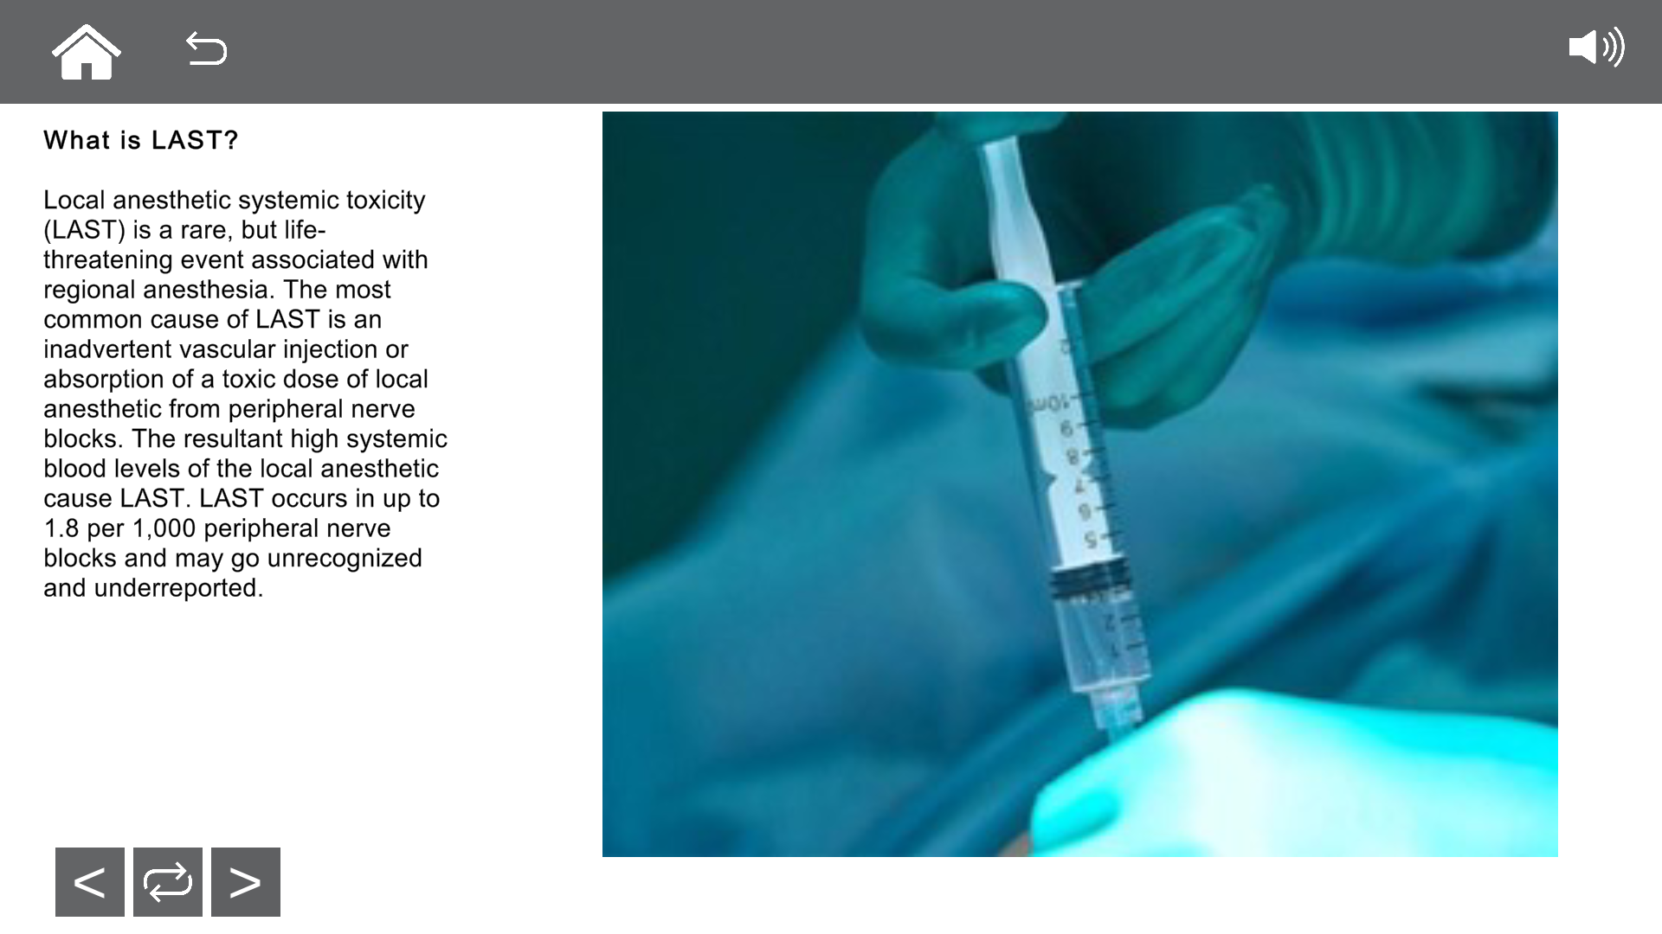
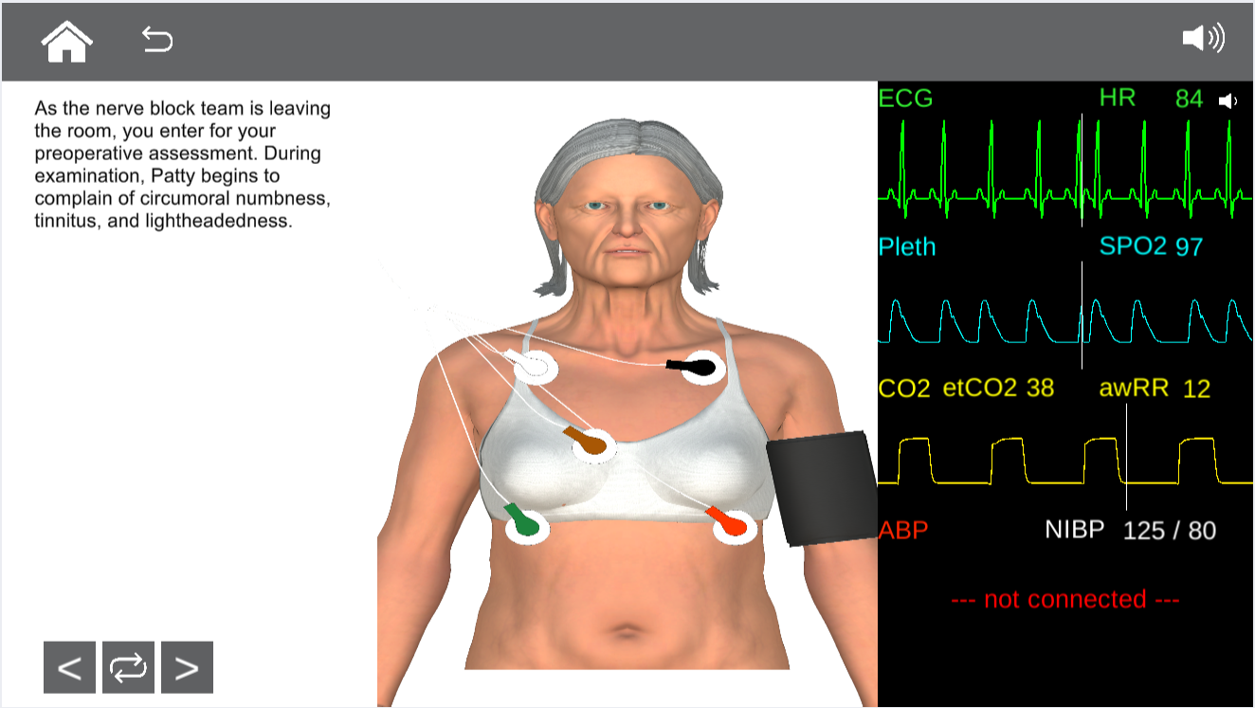

Appendix B
Pre-survey/ Post-survey
1. What is the maximum recommended dose of bupivacaine patients can safely receive?
- 8 mg/ kg
- 3 mg/kg
- 4.5 mg/kg
- 12 mg/kg

2. What are early signs and symptoms of LAST?
Select all that apply
- coma
- Seizures
- Circumoral numbness
- Tinnitus

3. What are late signs and symptoms of LAST?
Select all that apply
- Respiratory depression
- Lightheadedness
- Hypotension
- Ventricular tachycardia or ventricular fibrillation
- nausea/vomiting

4. What comorbidities increase the risk of developing LAST?
Select all that apply
- Diabetes
- Cardiac disease
- Osteoarthritis
- Chronic kidney disease
- Advanced age

5. What is the preferred first line treatment for seizure suppression in a patient experiencing LAST?
- A benzodiazepine
- A bolus dose of propofol
- A propofol infusion
- None of the above

6. In a patient less than 70 kg what is the appropriate dose of lipid emulsion therapy during a LAST event?
- 10% lipid emulsion, 1.5 mL/kg bolus given over 2-3 minutes followed by 0.25 ml/kg/minute infusion
- 20% lipid emulsion, 1.5 mL/kg bolus given over 2-3 minutes followed by 0.25 ml/kg/minute infusion
- 10% lipid emulsion, 20 ml/kg bolus given over 2-3 minutes followed by 0.5 ml/kg/minute infusion
- 20% lipid emulsion, 20 ml/kg bolus given over 2-3 minutes followed by 0.5 ml/kg/minute infusion

7. In a patient greater than 70 kg what is the appropriate dose of lipid emulsion therapy during a LAST event?
- A bolus of 300 ml over 2-3 minutes followed by an infusion of 500 ml over 15-20 minutes
- A bolus of 50 ml over 2-3 minutes followed by an infusion of 100 ml over 15-20 minutes
- A bolus of 150 ml over 2-3 minutes followed by an infusion of 300 ml over 15-20 minutes
- A bolus of 100 ml over 2-3 minutes followed by an infusion of 250 ml over 15-20 minutes

8.What is the initial resuscitation bolus dose of epinephrine that should be administered in a LAST related cardiac arrest?
- 1 mg
- .5 mg
- 2 mcg/kg
- ≤ 1 mcg/kg

9. All of the following medications should be avoided in a LAST related cardiac event except.
- Lidocaine
- Vasopressin
- Calcium channel blockers
- Amiodarone
- Beta blockers

10. I feel confident in treating a LAST event

Strongly disagree, disagree, neutral, agree, strongly agree

11. I feel confident in identifying the signs and symptoms of LAST.

Strongly disagree, disagree, neutral, agree, strongly agree

12. I feel confident identifying the modifications to the ACLS algorithm during a LAST related cardiac event.

Strongly disagree, disagree, neutral, agree, strongly agree

Answer key:1) b 2) c,d 3) a, c,d 4) b, d, e 5) a 6) b 7) d 8) d 9) d

Appendix C
IRB Approval Letter
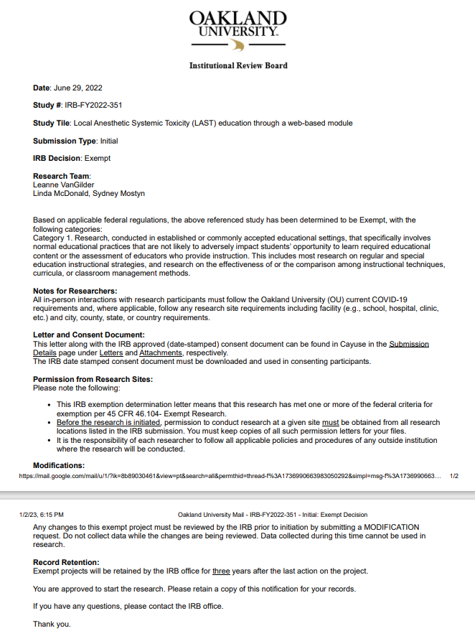
Appendix D
Participant Consent Form
Study Title: Local Anesthetic Systemic Toxicity (LAST) Education through a Web-Based Module

Principal Investigator: Leanne VanGilder

Address: 18102 Ventura Court, Livonia, MI 48152

Location: Michigan Association of Nurse Anesthetists (MANA) Fall Conference in Williamsburg, MI

Purpose: You are being asked to participate in a study to obtain information regarding Certified Registered Nurse Anesthesiologists’ knowledge on local anesthetic systemic toxicity (LAST). The study will assess the participants’ ability to identify the signs, symptoms, and treatment of LAST, and modifications to the ACLS algorithm during a LAST-related cardiac arrest. Additionally, the pre-module and post-module survey will assess the participants' self-efficacy in LAST management.

Study Procedures: If you choose to take part in the study, you will be asked to do the following:
- Complete a pre-module survey on identifying the signs, symptoms, and treatment of LAST, and modifications to the ACLS algorithm during a LAST related cardiac arrest.
- Agree to participate in a web-based learning module on LAST.
- Complete a post-module survey on LAST management and self-efficacy in treating a LAST event.
- The time frame necessary for involvement will be approximately 60 minutes.
The decision to participate is up to you. You may refuse to take part in the study at any time without affecting your participation in the workshop.

Benefits: As a participant in this study, the direct benefit for you would be gaining new knowledge on LAST management.

Risks: There are no foreseeable risks.

Costs: There will be no costs to you for participating in this research study.

Compensation: There will be no compensation for participating in the study.

Confidentiality: All aspects of the study including pre and post-survey will be confidential with the use of randomized participant numbers.

Voluntary participation/withdrawal: Taking part in this research study is voluntary. You may withdraw from the study at any time.

Questions: Any questions about this study now or in the future can be answered by Leanne VanGilder at lvangilder@oakland.edu or by telephone at 734-679-7781 or contact the investigator’s faculty, Dr. Linda McDonald at lamcdonald.oakland.edu. If you have questions or concerns about your rights as a participant, please contact the Institutional Review Board at 248-370-4898. The institutional Review Board oversees all human participant research conducted through Oakland University.

Participation: By registering for the LAST web-based education module at the 2022 MANA Fall Conference and signing the consent form, you are agreeing to participate in the study.
